**WEB-BASED APPOINTMENT BOOKING SYSTEM WITH SMS FOR THE STARWHEAL MEDICAL CLINIC**

**ALLAN C. BERNARDO**

**ROBERT B. ABON**

**CARL ANTHONY J. UNADIA**

**RESTITUTO G. VILLANUEVA**

A Capstone Project

Presented to the Faculty of the

**Computer Studies Department**

College of Science

Technological University of the Philippines

Ayala Blvd., Manila

**In Partial Fulfillment of the**

**Requirements for the Degree**

**Bachelor of Science in Information Systems**

**June 2023**

**ACKNOWLEDGEMENT**

First and foremost, we want to express our deepest gratitude to God for His unending guidance during the creation of this study, and for giving us strength, knowledge, and wisdom.;

To our parents, who helped us financially, mentally, and emotionally. We want to thank you for inspiring and motivating us; without you, we would not be able to achieve our aspirations.

To Mr. Peragrino Amador Jr. our kind, considerate, and motivating thesis adviser, who never ceased to offer suggestions and encouragement throughout the entire study;  
 To Prof. Melbern Rose Maltezo, our subject adviser, for providing guidance throughout the process, without you our journey would not have been possible.

To Prof. Edward Cruz, chair of the defense panel, for allowing us to present our work. We appreciate your patience and candor in sharing your thoughts with us so we can improve our research.

To the Starwheal Medical Clinic, especially to Dr. Arcenio Cortez. For sharing their experiences and allowing us to test our system.

To our participants, your willingness to share your time and insights made this thesis valuable. We appreciate your kindness and efforts.

To our colleagues and friends for their unending love and support.

**ABSTRACT**

Clinics play a crucial role in providing healthcare without visiting hospitals, and appointment systems, since their introduction has provided convenience. However, Clinics often face challenges such as overcrowding, lengthy process times, and manual processes. The "WEB-BASED APPOINTMENT BOOKING SYSTEM WITH SMS FOR THE STARWHEAL MEDICAL CLINIC" offers a solution to these issues. The system allows patients to book appointments from their browsers, and doctors can manage their schedules through creating or editing them. It also offers patient record management, fully automating the manual process of recording appointments using pen and paper. The system is mobile responsive and can be used on various devices with internet browsers installed. Patients can monitor their appointments, receive notifications for updates, and use a chat module for clarifications and questions. The doctor is the one who can approve and reject the appointments made by the patients. The application was evaluated by Doctors, Clinic Staff, Patients, and IT professionals. This system is developed with MERN stack which consists of od MongoDB for database Express js for framework, React js for JavaScript framework and Node js for server. The system was tested using usability and functional suitability tests. The applications were evaluated by Doctors, Clinic Staffs, Patients, and IT professionals. The results gathered from 25 respondents was the grand mean of 3.54 which means “Very Acceptable”. The study showed the system increases patient satisfaction making appointments easier and the system reduces the clinic's workload.

**TABLE OF CONTENTS**

|  |  |
| --- | --- |
|  | **Page** |
| Title Page | i |
| Approval Sheet | ii |
| Acknowledgement | iii |
| Abstract | iv |
| Table of Contents | v |
| List of Tables | vii |
| List of Figures | viii |
| List of Appendices | xii |

**CHAPTER 1 INTRODUCTION**  **1**

Introduction 1

Background of the Study 2

Objective of the Study 3

Scope and Limitation of the Study 5

Significance of the Study 7

**CHAPTER 2 CONCEPTUAL FRAMEWORK 9**

Review of Related Literature and Studies 9

Conceptual Model of the Study 32

Operational Definition of Terms 34

**CHAPTER 3 METHODOLOGY 36**

Project Design 35

Project Development 52

Operation and Testing Procedure 56

Evaluation Procedure 61

**CHAPTER 4 RESULT AND DISCUSSION 64**

Project Description 64

Project Structure 65

Project Capabilities and Limitations 86

Test Results 87

Evaluation Results 92

**CHAPTER 5 SUMMARY OF FINDINGS, CONCLUSION, AND 102**

**RECOMMENDATION**

Summary of Findings 102

Conclusions 103

Recommendations 105

REFERENCES **106**

APPENDIXES **109**

RESEARCHERS’ PROFILE  **149**

**LIST OF TABLES**

|  |  |  |
| --- | --- | --- |
| **Table** |  | **Page** |
| 1 | User Accounts table | 41 |
| 2 | Doctor Account table | 42 |
| 3 | Booking Appointment table | 43 |
| 4 | Clinic Services table | 44 |
| 5 | Chat Conversation table | 44 |
| 6 | Message table | 45 |
| 7 | Patient Record table | 46 |
| 8 | Consultation History table | 46 |
| 9 | Likert Scale | 62 |
| 10 | Descriptive Interpretation of the Mean | 63 |
| 11 | Functionality and Usability Test Result | 87 |

**LIST OF FIGURES**

|  |  |  |
| --- | --- | --- |
| **Table** |  | **Page** |
| 1 | Conceptual Model of the Study. | 32 |
| 2 | Top Level Diagram. | 35 |
| 3 | Data Flow Diagram of Web-based Appointment Booking System. | 37 |
| 4 | Entity Relationship Diagram. | 40 |
| 5 | Use Case Diagram - Top-level. | 49 |
| 6 | The Hierarchy of modules of the Administrator side in the Web-based system for StarWheal Medical Clinic. | 50 |
| 7 | Agile Model. | 52 |
| 8 | Process Requirements for Scheduling. | 54 |
| 9 | Process Requirement for Patient Record. | 55 |
| 10 | Process Requirement for Chat. | 55 |
| 11 | Welcome Screen. | 65 |
| 12 | Register Screen. | 66 |
| 13 | Register page Terms and conditions Modal. | 66 |
| 14 | Admin Dashboard. | 67 |
| 15 | Admin Dashboard Today’s Appointment View More Modal. | 67 |
| 16 | Admin Patient Demographics No. of Male, Female, Seniors, Children. | 68 |
| 17 | Doctor accounts screen. | 68 |
| 18 | Doctor Accounts Screen Doctor account Creation modal. | 69 |
| 19 | Users list screen. | 70 |
| 20 | Consultation History screen. | 70 |
| 21 | Clinic service screen. | 71 |
| 22 | Clinic Service Screen Add Clinic Service Modal. | 71 |
| 23 | Clinic Service Screen Edit Clinic Service Modal. | 72 |
| 24 | Clinic Service Screen Delete Confirmation Modal. | 72 |
| 25 | Setting Customization screen. | 73 |
| 26 | Doctor Account Homepage. | 73 |
| 27 | Doctor Account Homepage View more Modal for Today’s Done Appointment, Pending Appointment, Approved Appointment, and Today’s Canceled appointment. | 74 |
| 28 | Doctor Schedule Calendar Screen. | 74 |
| 29 | Doctor Notification Screen. | 75 |
| 30 | Doctor Notification Seen Screen. | 76 |
| 31 | Doctor Chat Screen. | 76 |
| 32 | Medical Records Screen. | 77 |
| 33 | Patient Record Screen. | 77 |
| 34 | Patient Record Screen Add Consultation Data Modal. | 78 |
| 35 | Patient Record Screen Edit Consultation Details Modal. | 78 |
| 36 | Patient Record Screen Delete Confirmation Modal. | 79 |
| 37 | Patient Record Screen Consultation Details Modal. | 79 |
| 38 | Doctor Schedule screen. | 80 |
| 39 | Appointments History screen. | 80 |
| 40 | Appointments History Screen Export Modal. | 81 |
| 41 | Doctor Profile screen. | 81 |
| 42 | Patient Home Screen. | 82 |
| 43 | Patient Notification Screen. | 82 |
| 44 | Patient Notification Seen Screen. | 82 |
| 45 | Calendar Book Appointments screen. | 83 |
| 46 | Appointment Creation Modal. | 84 |
| 47 | Patient Chat Screen. | 84 |
| 48 | Patient Appointment Status screen. | 85 |
| 49 | Patient Profile screen. | 85 |
| 50 | Functional Suitability. | 94 |
| 51 | Performance Efficiency. | 95 |
| 52 | Compatibility. | 96 |
| 53 | Usability. | 97 |
| 54 | Reliability. | 98 |
| 55 | Maintainability. | 99 |
| 56 | Portability. | 100 |
| 57 | Security. | 101 |
| 58 | Web application usability test result on Login Page. | 120 |
| 59 | Web application usability test result on Book Appointment page. | 121 |
| 60 | Web application usability test result on Chat Page. | 123 |
| 61 | Web application usability test result on Appointments List Page. | 124 |
| 62 | Web application usability test result on Patient Profile page. | 124 |
| 63 | Web application usability test result on Notification page. | 126 |
| 64 | Web application usability test result on Logout feature. | 127 |
| 65 | Web application usability test result for doctor on Login page. | 127 |
| 66 | Web application usability test result on Create page. | 129 |
| 67 | Web application usability test result on My Appointments page. | 130 |
| 68 | Web application usability test result on Medical Records page. | 131 |
| 69 | Web application usability test result on Notification page. | 134 |
| 70 | Web application usability test result on Chat page. | 135 |
| 71 | Web application usability test result on Doctors Profile page. | 136 |
| 72 | Web application usability test result on Logout feature. | 136 |
| 73 | Web application usability test result on Login page. | 137 |
| 74 | Web application usability test result on Admin Dashboard page. | 137 |
| 75 | Web application usability test result on Doctors List page. | 138 |
| 76 | Web application usability test result on Patient List page. | 140 |
| 77 | Web application usability test result on Clinic Services page. | 142 |

**LIST OF APPENDICES**

|  |  |  |
| --- | --- | --- |
| **Appendix** |  | **Page** |
| A | Sample Evaluation Test | 109 |
| B | Documentation | 114 |
| C | Correspondence | 115 |
| D | Profile of Respondents | 117 |
| E | Sample Usability Test Instruments | 119 |
| F | Profile of Respondents | 143 |
| G | Terms and Conditions for the Application | 145 |
| H | Thesis Grammarian Certificate | 147 |
| I | URDS Certification | 148 |
| J | Certificate Of Similarity Index Using Turnitin | 149 |

**Chapter 1**

**THE PROBLEM AND ITS SETTINGS**

**Introduction**

Appointment booking systems have been great for its users, making booking appointments easier, and can be applied to many businesses and services. It also piques people's curiosity about where it can be applied. The healthcare sector is hardly an exception to how quickly technology has changed other industries. Clinics are the go-to when people want medical services without going to the hospitals. Booking systems streamline operations by automating the process of booking appointments, reservations, or services. This eliminates the need for manual coordination. Businesses benefit because it saves them time and effort so they can concentrate on other important duties.

Booking systems can help businesses that provide services, such as spas, salons, healthcare facilities, consultants, or personal trainers, manage client appointments. It supports them in keeping a well-organized schedule and in streamlining their work. Customer information, such as contact information, preferences, and booking history, is collected and stored by it. Building a client database, personalizing services, and learning about consumer behavior are all possible with this data. Businesses may improve their interactions with customers and adjust their product offers as a result.

Clinics can integrate appointment booking systems for their own gain making it easier to increase patient satisfaction. This study aims to fully automate the clinic processes and make their appointments system easier to use by allowing patients book appointments through their internet browser.

**Background of the Study**

Appointment booking applications have been helpful for modern-day people. It saved a lot of time and energy for patients who made advanced appointments. This application booked appointments in advance as per the user's requests. It checked the doctor’s calendar, managed their record, and changed their status. (Kholin, 2022). Having these features can be of significant use for a clinic like the StarWheal Medical Clinic, it also helped the customers. Medical clinics, in general, had the main purpose of supplying instant medical services to whoever needs them

The clinic offered many services, like vaccinations, anti-rabies vaccination, circumcision, ear piercing, pediatric check-up, and Obgyn check-up. Many parents would love to make their children healthy. Many patients often went to clinics because it is near to them. So sometimes they come simultaneously but for different purposes. Patients usually waited a long time because they need more booking services. Also, clinics were in chaos due to having to satisfy their customers who came to their clinics in groups.

Overcrowded clinics are a norm, especially the StarWheal medical clinic. This problem also affected patients' health. Record management was also a concern for the clinic as doing it on paper is time-consuming. Another manual process is the clinic’s transactions, and it also caused problems. Medical clinics often have small places but had large demands and they managed them by scheduling consultations and treatments as appointments. (Kuiper, de Mast, Mandjes, 2019). Even if the appointment demands are still larger, then it will still lead to problems with appointment scheduling.

The evidence of the issue in the clinic was the use of an antiquated and inefficient system for scheduling appointments, and patients must contact the doctor for an appointment time and wait for the doctor's response about the time they should arrive at the clinic. Another issue was the patients' records are kept on paper, which made it difficult and time-consuming for the secretary to find a patient's record.

Overcrowded clinics left customers unsatisfied; as a business, it is bad for the clinic. Customers are unsatisfied because they must wait long in lines due to the clinic's overcrowding. Overcrowding happened because of large demand but low ability of the clinic. Manual processes like record management and transactions consumed the clinic more time and energy, eventually leading to less consultation time. The lack of automated systems was the general cause of using manual processes. Large demands were the cause of problems with appointment scheduling that caused overcrowding and it made the customers wait in line for a long time.

This research aimed to develop an Online Appointment Booking App with SMS Notifications so that it can make an appointment online for the check-up of patients at the day and time they want. It was also used to avoid the length of the queue at the medical clinic, and through the system, the patients did not need to rush to the clinic because the doctor could set their available time.

**Objective of the Study**

General Objectives:

The study aimed to develop a Web-based Appointment Booking System. Specifically, it aimed to:

1. Web-based Appointment System with the following features was designed:
   1. Login and register.
   2. Display appointment list of doctors and patients.
   3. Schedule appointment availability with SMS notification.
   4. View and export appointment details.
   5. Clinic services management.
   6. Patient record Management
   7. Patient consultation history.
   8. Chat system functionality was Provided.
   9. Generated dashboard for list of doctors, patients, clinic services, user accounts.
   10. Mobile Responsive
2. The system was created and used the following tools:
   1. ReactJS as scripting language
   2. NodeJS as the primary framework for creating a web-based system
   3. MongoDB for web-based system database
   4. SMS API for sending notification
   5. Bootstrap for user interface/experience designing
   6. CSS as primary tools for styling
   7. GitHub for code hosting platform and version control
   8. Postman for API testing
   9. VSCode as the primary integrated development environment
3. Test and improve the systems in terms of functional suitability and usability.
4. Determine the level of acceptability of the developed system using ISO 25010.

**Scope and Limitation of the Study**

This study focused on designing a web-based applications system that managed the appointment schedule, patient record, and clinic services for the Medical Starwheal Clinic. This web-based application system is a responsive type for a computer or mobile device that can be accessed online.

Moreover, the study's clients were the patients, admin, and medical staff. The Responsive Online Appointment Booking App for the Customers of Starwheal Medical Clinic is the tool that helped the admin organize and record the children's and adults' appointments on their booking schedule to the clinic they applied to avoid crowding. The admin is the person that can handle the system in the clinic and can modify the list of users and doctors. In addition to the system's security, the admin has permission to make the other doctor and staff have the role of admin, which is the patients can pick the given schedule and services to the system.

This system developed a module that can process the appointments. This module was able to approve and cancel appointments from patients. Another developed module can create clinic services. This module created services that the clinic has, like vaccinations, anti-rabies vaccination, circumcision, ear piercing, pediatric check-up, and OB-GYN check-up. There is also a Chat module where patients chat with doctors and ask questions and clarifications. Only patients can start chat conversations with doctors and doctors can only reply but not start a chat conversation. A module called Doctor Accounts was developed and allowed the admin to manage and create doctor accounts. This module is for the admin to create accounts for doctors. A module was developed as the dashboard for admin, showing the clinic's overall status. A module for doctors where they can create their own schedule. A specific module has been developed and it is called Appointment creation. In this module, the patient can set an appointment with the doctor of his/her choice and choose the available schedule set by the doctor. The Patient Record Management Module was made to save all patient record logs. The Rescheduling for appointment was made for patients to agree on a new and later date for something to happen. to develop a system that is responsive so that it can be opened on all devices, but the structure of the User Interface is still good.

The study used MongoDB, Express, React JS, and Node JS. The system was composed of a server and database for storing information, a responsive web-based design where the doctors, patient and admins could access the system.

First, and foremost, the researchers of this study interviewed the system's beneficiaries about their problems. The Current setup in the clinic is being done manually, such as Patient Records, Appointment Scheduling, and Transactions based on the pen, paper, and folder methods.

The system was evaluated with the participation of three licensed doctors, staff, and ten patients to test the system and compute the review of the overall correspondent.

**Limitation**

The proposed system will not do the following functions/services:

* The system does not include payment gateway.

**Significance of the Study**

The study helped reach the need for the clinic to digitalize the appointment and patient records and set a proper current setup.

The results of the study will be of great benefit to the following:

**Patients.** That will provide them to see the available doctors and set an appointment based on the doctor's time availability.

**Doctors.** They can easily manage appointments coming from the patient such as approval and cancellation.

**Admin/Owner.** Which can easily manage the users of the system, can access the doctors and users module, and create clinic services.

**Chapter 2**

**REVIEW OF RELATED LITERATURE AND STUDIES**

This chapter presents an overview of articles and documents that focus on the same related subject matter and other concepts of the study. Furthermore, this also contains the corresponding model of the study and the operational definition of terms.

According to (Samadbeik, 2018), reservation means planning for the date, time, and place of a clinical visit to receive healthcare services. In general, there are 2 types of medical appointments, including scheduled and unscheduled appointments. Making an unscheduled appointment needs no reservation and only requires the patient to visit the medical center, while a scheduled appointment is made via the phone, SMS, or the Internet. Since patient flow management requires attention to 3 important aspects of arrival of patients, the service process, and queuing process in an outpatient unit, receiving healthcare services is one of the essential elements of managing patient workflow and a key tool for lowering patient wait times. Appointment scheduling is one such essential element. The waiting time to visit a physician is considered one of the most important indicators of patients’ access to healthcare services. Also, the simultaneous activities of several physicians in a hospital outpatient ward necessitate the need to share resources, such as space, personnel, and equipment, and setting appointments in the outpatient ward is of special importance.

Based on the article of (Ismail, 2017) claims that all sizes of organizations, from firms and giant corporations to service-based small businesses, have critical tasks in their operations that involve arranging appointments and reservations. While the method of scheduling appointments has changed over time, moving from taking phone appointments and writing them down in a paper appointment book to using an electronic calendar like those provided by Google or Microsoft Outlook, the task itself still takes a lot of time and effort for organizations that continue to rely on these antiquated and ineffective techniques. A medical appointment is a meeting between a patient with a physician or doctor to get health advice or treatment for a symptom or condition. Appointments are strongly encouraged so that Medical Services staff may be sensitive to time constraints.

Based on the article by (Samadbeik, 2018) explains that two common ways to make appointments are over the phone and in person. These appointment scheduling systems are linked to several issues, including lengthy wait times, subpar service, squandering the time of patients and doctors, patient dissatisfaction, a lack of system integration, ineffective use of human resources, and poor management of healthcare facilities. Today, computer programs and telecommunications are offered to improve the quality of healthcare services in developing countries. Because of their flexibility in planning and time efficiency, online appointment booking systems are a successful solution for physicians and patients in setting clinical appointments. This system has advantages and features, including access to the system at any time and place, allowing the user to see the physicians’ appointments, select the desired option, edit the recorded information, and have a more favorable relationship between physician and patient.

According to Zadeh (2021) medical appointment scheduling software not only allows for online reservations but also aids in maintaining order. It simplifies the appointment booking procedure from the patients' point of view with only a few clicks. From the clinic's point of view, it streamlines staff productivity by automating manual tasks. The online approach for scheduling medical appointments is also excellent for tracking client visits and fostering better patient-clinic relationships. Online medical appointment scheduling is available around-the-clock. Patients who work or have other obligations during working hours can find it difficult to contact them during such times. Even when clinics are closed, online scheduling enables consumers to select a convenient time.

This also applies to medical personnel. Doctors will only use the system to check their calendars, see if appointments have changed, or enter necessary information. Stop bothering the front desk with your constant inquiries.

Every day, individuals everywhere work to improve their quality of life through technical developments. Nobody plans to waste their time, energy, or money by queuing up at a counter, especially while visiting the hospital. Henceforth, this paper proposed web development as a solution for patients to schedule hospital appointments online, with doctors approving them based on availability. The system that has been created attempts to control patient knowledge based on doctor availability, hospital and specialist schedules, and patient appointments. The proposed system has been designed within the ASP to automate the day-to-day activities in a hospital, like room activities, admission of the latest patient, and doctor visits. The suggested distributed resource allocation method looks for available appointments at close-by hospitals. A confirmation email will also be sent to the user after they have scheduled an appointment and the appropriate doctor has approved it. (Jebamani, 2021).

To account for resolution, picture size, and scripting capabilities as the user moves from their laptop to an iPad. The settings on the user's devices may also need to be taken into consideration; for example, if the user has an iOS VPN installed on their iPad, the website shouldn't block them from viewing the page. To put it another way, the website should be fitted with the tools required to respond to user preferences automatically. This would do away with the requirement for a distinct design and development stage for each new device introduced to the market (Friedman 2018).

***Appointment System***

The term “appointment” refers to the period of time allocated in the schedule to a particular patient’s visit, and “service time” refers to the amount of time the physician actually spends with the patient.

It is possible to divide appointment scheduling into two main types.

Static. All decisions must be made prior to the beginning of a clinic session, which is the most common appointment system in clinics.

Dynamic. The timetable of upcoming arrivals is regularly updated throughout the day based on the system's state. This is relevant when patients who have already been admitted to a hospital or clinic can have their arrivals in the service area dynamically controlled.

According to Eysenbach (2017.) web-based appointment systems change the method of communicating with providers' management systems. In contrast to the current appointment methods, web-based appointment scheduling has different and diverse advantages and disadvantages.

Web applications have helped streamline many of the tasks people perform on a daily basis and have made our lives easier. These programs are frequently utilized to help us resolve issues with student learning and appointment scheduling. Due to the manual nature of these appointment procedures in the past, there were several cases of overbooking or neglecting to cancel an appointment, which might free up space. to schedule another in its place. A web application will be created to streamline the scheduling process in order to reduce human error caused by manually arranging appointments. Additionally, an online appointment management system at a university makes perfect sense considering the busy lives that many of us lead nowadays because it frees up significant time, not to mention only for students but also for lecturers and university staff members (Qaffas , Barker, n. d)

***Clinic Management System***

CMS is designed for both patients and practitioners. It will allow patients to create an appointment, print an appointment card, generate medical reports, search for health tips, view doctor’s profiles, send emergency reports, and chat with doctors online. The system will, however, allow practitioners to confirm, edit or cancel patient appointment requests, diagnose patients, prescribe medicines to the patient, manage inventory, and manage both patient and clinic staff records. As a step toward integrating the clinic operations, the proposed system composes various modules dependent on one another.

An organization's established procedures, processes, and policies to placate its people can complete the work required to accomplish the company’s objectives is the definition of a management system. (Mondayblog.com, 2021)

Clinic management systems simplify the job of medical professionals including physicians, nurses, administrators, and financial personnel. They manage drugs and contribute to the production of medical records. They can also oversee funds, from processing to payment. Even maximizing your work hours is possible with clinic management systems! In terms of appointments and referrals, it also functions as a patient tracking system (Labis, 2021).

There are many benefits of a management system: help leadership, promote customer-led business, improves company culture, improves the bottom line, ensures new innovations are managed, and it helps you see why things are not going well (Miles, 2022.).

Medical practice management frameworks permit doctors and office staff to rapidly book and affirm arrangements and oversee plans over numerous suppliers, areas and days of the week. Numerous frameworks too permit patients to book their claim arrangements online.

One of the greatest obstacles clinic staff confront when it comes to planning is the got to at the same time guarantee each physician's time is fittingly apportioned for persistent visits as well as conference calls and other different gatherings. Restorative hone administration frameworks donate staff individuals real-time understanding into each provider's accessibility, permitting them to immediately recognize potential planning clashes. The program too makes a difference clinic staff dodge (or decrease) double-bookings. A restorative hone administration framework lets doctors and their staff rapidly enter and get to not as it were fundamental persistent data — for case, the patient's title, address, phone number, birthdate, manager and protections supplier — but too broad clinical information, such as restorative history, solutions and reasons for past visits.

Moreover, medical practice management frameworks can naturally confirm a patient's protection scope before the patient's visit (Nock, 2017).

***Patient Record Management System***

Patient Record Management refers to the collection of all personal health information and necessary personal data of a patient. A person's health care information is among the data that is stored on computers and the Internet. According to a clear statement from the national government's oversight department, health records are the most crucial, fundamental, and vital information in determining whether a person will accept any type of medical treatment. It is a comprehensive collection of all essential health services, comprehensive records of all past medical visits from the patients, and officially recognized medical record information. Zhao et al. (2020)

***Electronic Patient Records***

According to Stephens (2020), the need for stronger medical information systems became apparent as information grew. Healthcare providers are phasing out paper-based medical records, making patient privacy more important. The Federal Health Insurance Portability and Accountability Act of 1996 and other legislative enactments must ensure the confidentiality and security of medical information.

Finally, under Obamacare (nicknamed the Patient Protection and Affordable Care Act, a sweeping overhaul of America's healthcare system enacted by President Barack Obama in 2010), health care providers where initially more High reimbursements encouraged the adoption of electronic medical records because later medical costs were less burdensome. Adoption is penalized with reduced Medicare payments.

Electronic patient records are now accepted as a standard. The vast majority of healthcare providers and healthcare systems use some form of computerized medical record. A digital patient record promises comprehensive benefits for personalized, safe, and trusted care and care.

According to Rotmensch et al. (2017), The outcomes of patients' care will be significantly impacted by the effective management and use of information within integrated care delivery systems. Electronic health information management systems must ensure the accuracy of clinical data collection and processing to provide useful information to healthcare practitioners at the point of care. Generic tools and evaluation frameworks are required for a wide range of stakeholders, including end-users like health professionals and patients, healthcare organizations, and policymakers. They provide a summary of electronic health system data and information quality assessment. To explain how problems with poor data quality and information mismanagement affect clinical interaction, they employ the patient/clinician encounter model developed. Then, using the six dimensions model of information system quality originally put forth, researchers offer a detailed explanation of the problems with data quality in eHealth.

Patients looking for information about their symptoms as well as physicians dealing with challenging cases or trying to avoid narrowing their emphasis to a small number of possible diagnoses use automated tools to enhance medical diagnostic reasoning. Building diagnostic reasoning systems and encoding pertinent data to power their inference skills have taken a lot of work. These cars greatly succeeded in enhancing didactic methods, aiding in diagnosis, and occasionally even outperforming skilled medical professionals.

***Chat System***

Robinson (2022) claims that using a live chat system, customers may multitask while doing their online purchases and waiting for chat support. The wait time in a call center is longer. It's crucial to provide support and address issues immediately because 60% of customers detest having to wait longer than a minute.

Studies on the benefits and drawbacks of e-consultations for all questions in primary care in the form of chat services have emphasized the perspective of healthcare professionals (HCPs) rather than that of end users (patients).

The program offered a simple method for patients to communicate with HCPs via written correspondence, which was deemed useful for some patients and situations but less appropriate for others (acute or more complex cases). Although the automated medical history-taking service was thought to have potential, it was still based on what HCPs needed to know and how they addressed and communicated health and medical issues. Patients nevertheless voiced concern for those with less digital literacy, despite the fact that technical abilities were not viewed as being as important for using a mobile phone as they were for using a computer. Patients thought that it might be the case because they had the chance to take their time and consider their condition before responding to questions from the HCPs, which was observed to lower stress and prevent mistakes. Nilsson E, Sverker A, and Bendtsen P. (2021).

The project's objectives were to create a chat platform. application to help doctors and patients communicate is designed for the any operating system. The idea behind this Application is a crucial and successful method of obtaining medical care. counsel that is easily obtained. To sum up, the researchers think that, given additional development from upcoming programmers, this is helpful Our developed application was fully functional with a system of the health sector. Mohammed. M. A et al. (2017)

Customer chat support takes care of one aspect: time is money. It lowers average interaction costs and costs per person per hour associated with phone calls. Because a single agent can handle multiple chats at once, using a live chat is more cost-effective than calling. It is even 17-30% less expensive than calling. With a deflection rate of 70% from calls to live chat, the waiting line can be reduced to a fraction of the time required for phone support.

The number of messaging and chat apps is on the rise. This is due to the fact that people enjoy chatting. Whether you're collaborating with a coworker or checking in on a loved one, it's the preferred method of communication. Applications for messaging and chat help create a sense of community and connection that cannot be replicated by other forms of communication. It can be difficult to comprehend a real-time chat application's architecture and system design. Fortunately, we are familiar with the task. In order to help you decide how to add chat to your website or app, we're going to break down chat app architecture in this article. (Cressler, 2021).

***Record Management System***

According to Zola (2022), the use of a record system is a data storage and retrieval system that keeps important data on a system or process within an organization. exists at a single site or several locations with remote access and may include data from multiple sources. A record-keeping system can improve organizational effectiveness by effectively eliminating manual operations. Additionally, it can arrange data in a central location for easy access.

Records management involves creating, preserving, using, and losing records. Records management aims to guarantee access to records to support business decisions and keep records while following the law. (Lin, 2022).

Clinical notes and management information are frequently sent to clinics on paper. It is not very dependable to use a paper-based document management system. This is based on the idea that papers are readily damaged and cannot be stored for a very long time. Data anomaly problems could arise because data inaccuracies are not always straightforward to spot. Furthermore, the availability of new technology as well as advancements in technology that are widely used in medical settings around the world make the use of paper-based medical record systems an earlier technique or obsolete technique as far as medical records are concerned.. Gadzama et al. (2020)

According to Joseph (2020). The Federal University Wukari's (FUW) medical record facilities employ paper-based patient folders that include all the pertinent medical information about a specific patient; the manual or paper-based record management system is associated with problems that include but are not limited to inefficiency, inaccuracy, time consumption, inconveniency, laborious and sluggish. The necessity to automate the current manual systems becomes apparent in light of this.

Saving space, and reducing costs affected by storage supplies, document processing, and manual work. Also, security purposes for confidential data are some of the benefits of efficient records management. An electronic document management system allows you to apply different access restrictions for different team members. This way, you can manage who sees what an.d prevent data hacking, which is the benefit of record management. (Picincu, 2020).

According to Indeed Editorial Team (2022), the proof of transactions, activities, and decisions provides legal protection is the reason why records management is important. Archived documents can be used by companies as evidence in audits, court cases, or other official government uses. It can also help promote optimal practices within a business, obeying industry regulations and maintaining institutional history. A coherent records system may allow for the safe control and access of company resources while implementing ease of use for those with active or inactive records.

***Persons involved in the Web-based System***

***Doctor***

A Doctor is licensed to practice medicine as a physician, surgeon, dentist, or pediatrician. There is the one to give medical treatment to patients, and they're the ones who will accept the request approval appointment of patients.

***Medical Staff***

Medical Staff is healthcare professionals who examine, treat, and prevent injuries, illnesses, and other impairments, and there are the ones who will assist the doctor in the clinic

***Patients***

A patient who is getting or has a need for medical care. And needs regular checkups or is cared for by a particular doctor or other specialists in medicine.

***Clinic***

A clinic is a facility focused on outpatient services—being an outpatient means. Medical facilities may be run by the government, the commercial sector, or the public sector. Frequently, patients must schedule an appointment before visiting a clinic. Some clinics may also accept walk-ins.

***Admin***

The admin is the owner of the system. These accounts have higher permissions and privileges and can make big changes or modifications in the system. They are the ones who will handle the system. In this system, admins are also responsible for accepting doctor’s appointment schedules. admins will be the owner of the clinic.

***SMS Notification***

Notification is the means of informing someone formally, maybe a vocal or document. In technological terms, however, it is a message or a pop-up on your screen sent to your device.

Fixed protocols and procedures that can involve both humans and technology are the components of a notification system. Generating and sending scheduled messages to a person or group of people is the primary purpose of a notification system. There are different types, first is simple, where the system only uses email or text messages. Another one is complex, where it is designed to send out critical information and uses many types of communications to ensure that each receiver gets notified. (Laukonnen, 2022).

According to Lemzy (2021) 86% of US consumers go for SMS notifications because it informs the receiver about events, updates, or service alerts. This communication method is widely preferred by customers. They function like normal text messaging, sent to the recipient's text inbox. It will also count as regulations, the same as business texts. These notifications have character limitations of 160 characters.

According to Seferian (2021), SMS has evolved as the preferred form of communication for large corporations and one-person organizations. Additionally, it makes perfect sense with a 98% open rate. Texting has a lot to offer, including the ability to send SMS notifications and use them for text message marketing.

It probably gets daily notifications, whether SMS alerts, reminders, or other types of texts. This marketing channel is used by companies all around the world to, among other things, notify consumers of transactions and offer time-sensitive information. Furthermore, even though it looks like a push notification, it's pretty different.

***Developmental Tools***

***ReactJS***

According to Surve (2021) React is incredibly adaptable. Once you get it down, you may utilize a variety of platforms to produce user interfaces of the highest caliber. React is a library, not a framework. React's library-based methodology has allowed it to grow into such a remarkable tool. For the purpose of creating web application components, React was created. A React component can be any element in your web application, including a Grid, Text, Label, or Button. React's ecosystem, however, has expanded along with its popularity and now covers a variety of use cases. Using technologies like Gatsby, you can construct a static website with React. You may create mobile apps with React Native. Using a framework like Electron, you can even design desktop programs that can run on, It is more feasible to utilize React to construct full-fledged web applications rather than just adding minor elements of an interface to an already-existing web application. On the other hand, React does potentially have significant tools setup needs that are sometimes difficult and time-consuming to set up when developing new React apps.

Fortunately, you don't have to become familiar with this build configuration or set up the build tools yourself. To assist you in creating a boilerplate version of a React application, Facebook developed a Node package command-line utility called create-react-app. With this package, you can get started immediately and enjoy using React apps that have a recognizable structure across all your React projects (Herbert, 2022 para 17 - 18).

.CSS is a stylesheet language used to specify how a document is presented in HTML or XML (including XML dialects like SVG, MathML, or XHTML). CSS outlines how components should be shown in various media, including speech, paper, screens, and other media. (MDN Web Docs, 2022).

***ExpressJS***

Express is a popular opinionated web framework written in JavaScript and hosted within the Node.js runtime environment. This module covers setting up your development environment, performing combined web development and deployment chores, and some of the framework's key advantages. (MDN Web Docs, 2022, para 1).

***NodeJS***

An open-source, cross-platform runtime environment called Node (or more officially Node.js) enables programmers to construct a variety of server-side tools and apps in JavaScript. The runtime is designed to operate outside of a browser environment (on a PC or server OS directly). As such, the environment omits browser-specific JavaScript APIs and adds support for more traditional OS APIs, including HTTP and file system libraries (MDN Web Docs. 2022).

***MongoDB***

MongoDB is an open-source NoSQL database management program.NoSQL databases are used in place of conventional relational databases. NoSQL databases may be quite helpful when working with huge dispersed data sets. MongoDB is a system that can handle document-oriented data and store or retrieve data.. Ad-hoc queries, indexing, load balancing, aggregation, server-side JavaScript execution, and other functionalities of MongoDB are available to businesses (Botelho, para. 1).

***Socket.IO***

An event-driven library for real-time web applications is Socket.IO. It makes it possible for web clients and servers to communicate in real time and in both directions. Creating a chat program using well-known online apps. It takes far longer than it should to complete since it polls the server often for updates and keeps track of timestamps.   
Alternatively put, the server has the ability to push messages to clients. When you compose a message in chat, the server will automatically read it and transmit it to every connected client. (G. Rausch, 2021)

***Semaphore***

Semaphore allows businesses to send SMS messages to customers and manage their campaigns from a single dashboard, and it automates SMS workflows, such as sending messages triggered by user behavior or events. Businesses can track and evaluate the effectiveness of their SMS campaigns by looking at metrics like open rates, click-through rates, and conversion rates using SMS analytics tools like Semaphore. Semaphore can collect customer feedback and insights via SMS using tools like SurveyMonkey and Qualtrics, enabling them to enhance their product or service offerings. (Semaphore, 2023).

***Node CRON***

Node.js's node-cron module is a small GNU crontab-based job scheduler written entirely in JavaScript. Task scheduling allows you to plan the execution of any arbitrary code (methods/functions) and instructions at a set time and date, repeatedly, or only once after a certain interval. The asterisks (*), which stand for "every minute," "every hour," "every day of the month," "every month," and "every day of the week," respectively, at positions 2, 3, 4, 5, and 6 of the time specification act as file globs, or wildcards, for time divisions.

**ISO 25010**

The International Organization for Standardization (ISO) and the International Electrotechnical Commission (IEC) are the two organizations that make up the global standardization system. Based on the ISO/IEC 25010 Manual,

The quality of a system is the degree to which it satisfies the stated and implied needs of its various stakeholders and thus provides value. An essential aspect of ensuring value to stakeholders is the comprehensive specification and evaluation of software and software-intensive computer systems. This may be done by outlining the desirable and necessary quality qualities with respect to the aims and objectives of the system's stakeholders.

The ISO 25010 describes two quality models: the quality in-use and product models. The software quality product relates to the software's static properties and the computer system's dynamic properties (Britton, 2021). It comprises eight quality characteristics: functionality, performance, compatibility, usability, reliability, security, maintainability, and portability. These characteristics are further subdivided into sub-characteristics. The main can be defined as follows:

**• Functionality.** When used under certain circumstances, it refers to the extent to which a product or system delivers functionalities that satisfy both explicit and implicit demands.

•  **Efficiency**. It displays how well something performs in relation to how many resources are being consumed under specific circumstances.

**• Compatibility.** It refers to the degree to which a product, system, or component can communicate with other products, systems, or components and perform its functions while sharing the same hardware or software environment.

**• Usability.** the extent to which a product or system may be used by certain users to efficiently, effectively, and satisfactorily accomplish specified goals in a particular situation.

• **Reliability**. The degree to which a product or system may be improved, corrected, or adjusted to changes in the environment is indicated by this attribute.

**• Security.** It refers to the degree to which a product or system safeguards information and data so that people, other products, and systems have the right level of data access for their types and levels of authorization.

**• Maintainability.** The degree to which a product or system may be improved, corrected, or adjusted to changes in the environment is indicated by this attribute.

**• Portability.** It is the degree to which a system, product, or component can be transferred effectively and efficiently from one hardware, software, or other operational or consumption environment to another.

Meanwhile, the quality-in-use model relates to the outcome of interaction when a product is used in a particular context. It is composed of five characteristics and can be further subdivided into sub-characteristics. The main characteristics are

**• Effectiveness.** It speaks to the precision and thoroughness with which users accomplish particular objectives.

• **Efficiency**. relates to how precisely and completely people execute their tasks.

• **Satisfaction.** the extent to which user demands are met when a system or product is employed in a certain situation.

**• Freedom from risk.** the extent to which a product or method reduces the threat to the environment, human life, or economic position.

• **Context coverage.** The extent to which a product or system may be utilized effectively, efficiently, risk-free, and satisfactorily in both expressly stated situations and circumstances that are not explicitly indicated.

**Conceptual Framework of the Study**

Figure 1 shows the study's conceptual model, which depicts how the study will be conducted. The input enumerates the requirements for the development, while the process enumerates how the study and development must be done. The output is the Web-Based Appointment Booking System With SMS For The Starwheal Medical Clinic.

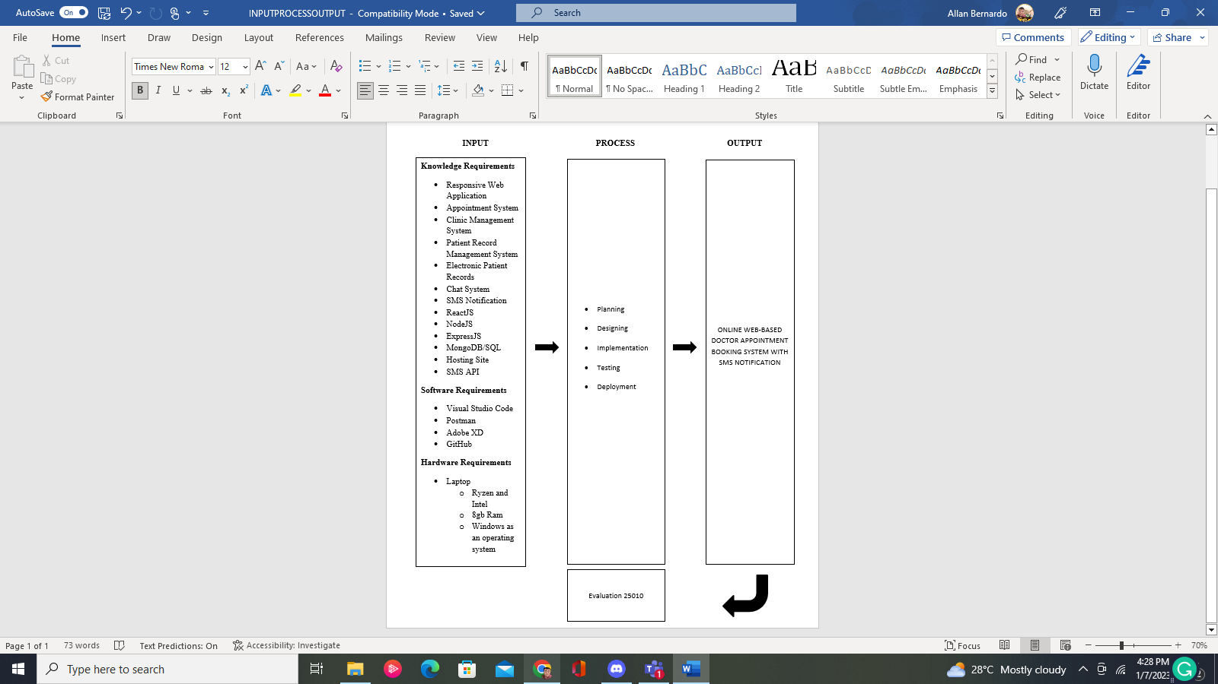

***Figure 1****.* Conceptual Model of the Study

**Operational Definition of Terms**

**Administrator** is theperson in charge of running a computer system or network. is the person who handles the system, and they can accept the availability schedule of the doctors, they are authorized to modify and block accounts.

**Appointment** refers to the commitment to meet someone at a specific time and location. refers to the scheduled appointment provided by the doctor's availability.

**Clinic** refers to the medical setting that treats common ailments and illnesses for individuals on an outpatient basis.

**Doctor** is a person who handles their patients' concerns and provides their availability to schedule appointments.

**Management** refers to the business of managing: the act of directing or controlling tasks to achieve specific goals in a medical clinic.

**Medical staff** are licensed healthcare professionals (doctors, nurses, allied health professionals, and other healthcare employees) permitted to give medical care inside a healthcare facility by state legislation and hospital regulations. They can also assist doctors and will have the authority to inform and approve doctor appointments.

**Notification** isthe act of telling someone [officially](https://dictionary.cambridge.org/us/dictionary/english/officially) about something, or a [document](https://dictionary.cambridge.org/us/dictionary/english/document), etc. it will be made by the system to inform the doctors about new appointment bookings.

**Patient** is the person involved in the project; an individual awaits a personal concern. They are the ones who will book appointments for the clinic.

**Record** refers to the data information provided by a patient. It also contains previous consultation data.

**Reschedule** refers to move or change of booked appointment made by the patients.

**Chat** refers to the conversation about concerns of the patients to their doctor.

**Responsive** refers to thequick to respond or react appropriately or sympathetically. the system will have a responsive view whether on mobile or desktop.

**SMS** is the technology for sending short text messages between mobile phones. it is used for notifying the doctor that the patient booked an appointment.

**Chapter 3**

**METHODOLOGY**

This chapter contains the study's Project Design, Project Development, Operation and Testing Procedure, and Evaluation Procedure.

**Project Design**

The Web-Based Appointment Booking System with SMS for the Starwheal Medical Clinic was a centralized web-based system that was discussed below using Entity Relationship Diagram (ERD), Unified Modeling Language (UML), Data Dictionary, Hierarchical Structure, Top Level Diagram, and System Flowchart to visualize the design and flow of the web-based system.

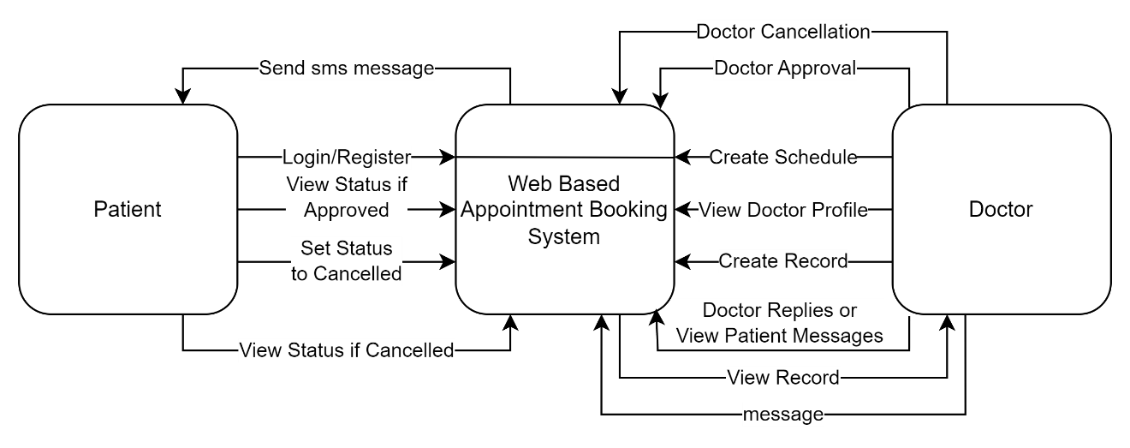

***Figure 2.*** Top Level Data Flow Diagram

In Figure 2, the top-level diagram of the system displayed the key features and the three different users that were involved. The various entities and their connections with other entities were detailed in this diagram. Three users were depicted: Patients, Doctors, and Admin. The chat feature was connected to doctors and patients since only these two users could engage in conversations. Both patients and doctors had their own Profile modules, while admin and doctors had their own dashboards.

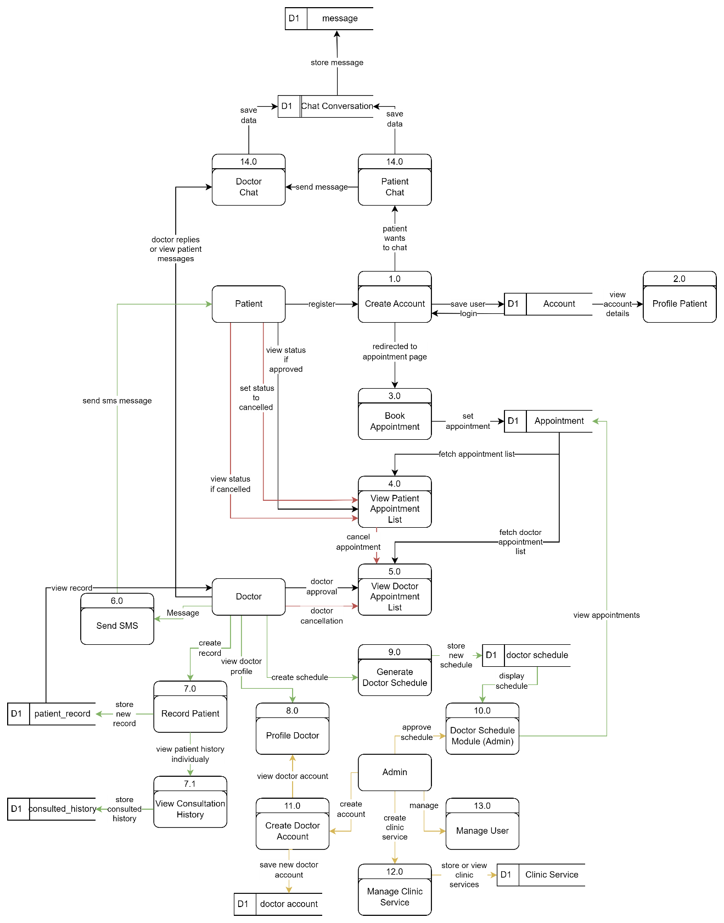***Figure 3.*** Data Flow Diagram of Web-based Appointment Booking System

The Data Flow Diagram of the Web-based Booking System, as shown in Figure 3, consisted of three major processes: booking appointments, patient records, and chat system. It also included the doctor, admin, and patient's involvement in the process.

In module 1.0, the patient needed to register account credentials and information to access the system. After registration, the patient could book an appointment in module 3.0. In module 3.0, the patient could book an appointment with a specific doctor based on their availability and save it to the appointment database. The data in the appointment database was displayed in the patient and doctor appointments lists. In module 4.0, the appointment details sent by the patient to the doctor were displayed. The patient could also print the approved appointment details to bring to the appointment approved by the doctor. In module 5.0, all the doctor's appointments with different patients were displayed. The doctor could view the patient's appointment details and approve, or cancel the appointment, and respond to the patient's appointment list. In module 6.0, the doctor could send messages to the patient on the appointment day to remind them of their scheduled appointment. The patient would then go to the clinic on the appointment day and bring their appointment details. In module 7.0, the patient's record with the doctor, including personal information, was stored. After the consultation, the patient's consultation history was saved in the system within the history section found in module 7.1. In module 7.1, all of the patient's consultation history was saved, crucial information was provided on the patient's progress. In module 8.0, the doctor's profile information was accessible. In module 9.0, the doctors created their schedule based on their availability time at the clinic. Once the schedule has been created, it will be available in the calendar. In module 10.0, the admin managed the schedules made by the doctors. In module 11.0, the admin created a doctors account to grant access to the system. In module 12.0, the admin managed clinic services such as vaccines, check-ups, circumcision and etc. In module 13.0, the doctor and patient could engage in a chat module, where the patient was enabled to communicate with the doctor for any questions or concerns.

**Entity Relationship Diagram**

Figure 4 shows the relationship diagram between collections defining the structure of data elements in the database. In the diagram, one to one relationship denoted that a single document in collection A matched only one document in collection B, and a single document in collection matched only one document in collection A. One-to-many relationships denoted that a document inside collection A matched zero, one, or many documents in collection B, and a document inside collection B matched exactly one document in collection A. Many-to-many relationships denoted that in both collections, it matches zero, one, or many documents with one another. This diagram helped the developers design the schema for development.

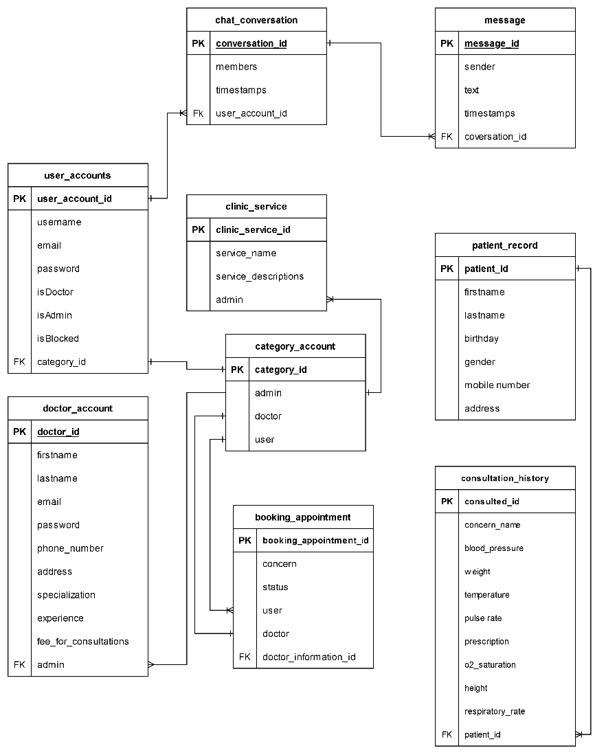

***Figure 4****.* Entity Relationship Diagram

Table 1 showed the types of users that the system can have. It can be a doctor, admin, or patient and if the account is blocked it holds the username, email, and password of each account. It uses category_id and found the type of account.

***Table 1.***

*User accounts table*

|  |  |
| --- | --- |
| **Field Name** | **Data Type** |
| user_account_id  username  email  password  isDoctor  isAdmin  isBlocked  category_id | varchar  txt  varchar  varchar  boolean  boolean  boolean  varchar |

Table 2 displays the doctor's basic information like doctor's specialization, experience, fee consultation and availability hours schedule. it will be checked if the account is a doctor's account.

***Table 2.***

The doctor_account table has data on doctor's accounts like which doctor it belongs to and his basic information. It has admin as foreign key. These are shown in table 2.

*Doctor account table*

|  |  |
| --- | --- |
| **Field Name** | **Data Type** |
| doctor_id  firstname  lastname  email  password  phone_number  address  specialization  experience  fee_for_consultations  admin | varchar  txt  txt  varchar  varchar  num  txt  txt  num  num  varchar |

The booking appointment table has contents that are important for use in appointments. The concern is the patient’s reason for an appointment. The status shows if the appointment is approved or not. This table borrowed data from the doctor and doctor_information_id to check who the doctor checked the patient.

***Table 3.***

*Booking appointment table*

|  |  |
| --- | --- |
| **Field Name** | **Data Type** |
| booking_appointment_id  concern  status  user  doctor  doctor_information_id | varchar  txt  txt  varchar  varchar  varchar |

Table 4 displayed the clinic services available provided by the doctor specialization, and the admin has the authorization to get the data provided by the doctor and post it in the system.

***Table 4.***

*Clinic services table*

|  |  |
| --- | --- |
| **Field Name** | **Data Type** |
| clinic_service_id  service_name  service_descriptions  admin | varchar  txt  txt  varchar |

conversation_id is used to give each conversation identifications. members show which of the users are engaged in each conversation. timestamps record the time and dates of the conversation are created or updated, lastly, it borrows user_account_id as foreign key from user_accounts table. and these components completed the chat_conversation table in table 5.

***Table 5.***

*Chat conversation table*

|  |  |
| --- | --- |
| **Field Name** | **Data Type** |
| conversation_id  members  timestamps  user_account_id | varchar  txt  datetime  varchar |

In table 6, the message table and its contents are shown here. The message_id is used for identification of each message. sender data is where the message was sent from. text is the content of the message. timestamps record the time and date when the message was created or sent. and this table borrows conversation_id from chat_conversation table.

***Table 6.***

*Message table*

|  |  |
| --- | --- |
| **Field Name** | **Data Type** |
| message_id  sender  text  timestamps  conversation_id | varchar  txt  txt  datetime  varchar |

Primary information of patients like the first name, last name and middle name, birthday, age, gender, civil status, and occupation, also contact details are shown in pateint_record table which is needed by the doctor and the patient record by the system.

***Table 7.***

*Patient record table*

|  |  |
| --- | --- |
| **Field Name** | **Data Type** |
| patient_record_id  firstname  lastname  birthday  gender  mobile_number  address | varchar  txt  txt  datetime  txt  num  txt |

The consulted_history table showed valuable information about the patients. This serves as a patient record; the doctor can see the past and latest records about the patient with whom he/she checked up. see table 8.

***Table 8.***

Consultation history table

|  |  |
| --- | --- |
| **Field Name** | **Data Type** |
| consulted_id  concern_name  blood_pressure  weight  temperature  pulse_rate  prescription  o2_saturation  height  respiratory_rate  patient_id | varchar  txt  num  num  num  num  txt  num  num  num  varchar |

**Use Case Diagrams**

The UML use case diagram of the system in figure 5 was presented. The top-level use case diagram showed three types of users of the system, which are Admins, Doctors, and Patients. There are login and register functions that are used by doctors and patients, but admins can only log in and not register because the system already decides the admin accounts. For account creation, admin accounts are automatically made, and users registered then the admin decided the doctor accounts. Login and register are connected to authentication services. manage doctors' schedules, managing user lists, managing clinic services, and managing doctor accounts can only be accessed by higher authorized accounts which are the admin accounts. SMS notifications can only be used on doctor accounts and patient accounts. Doctor accounts are the only accounts that can manage patient records, manage appointments, and create and edit doctor appointments. Doctor and Patient accounts can change or update their profile. Then the patients' accounts view available doctors and chose from those lastly, appointments will be booked.

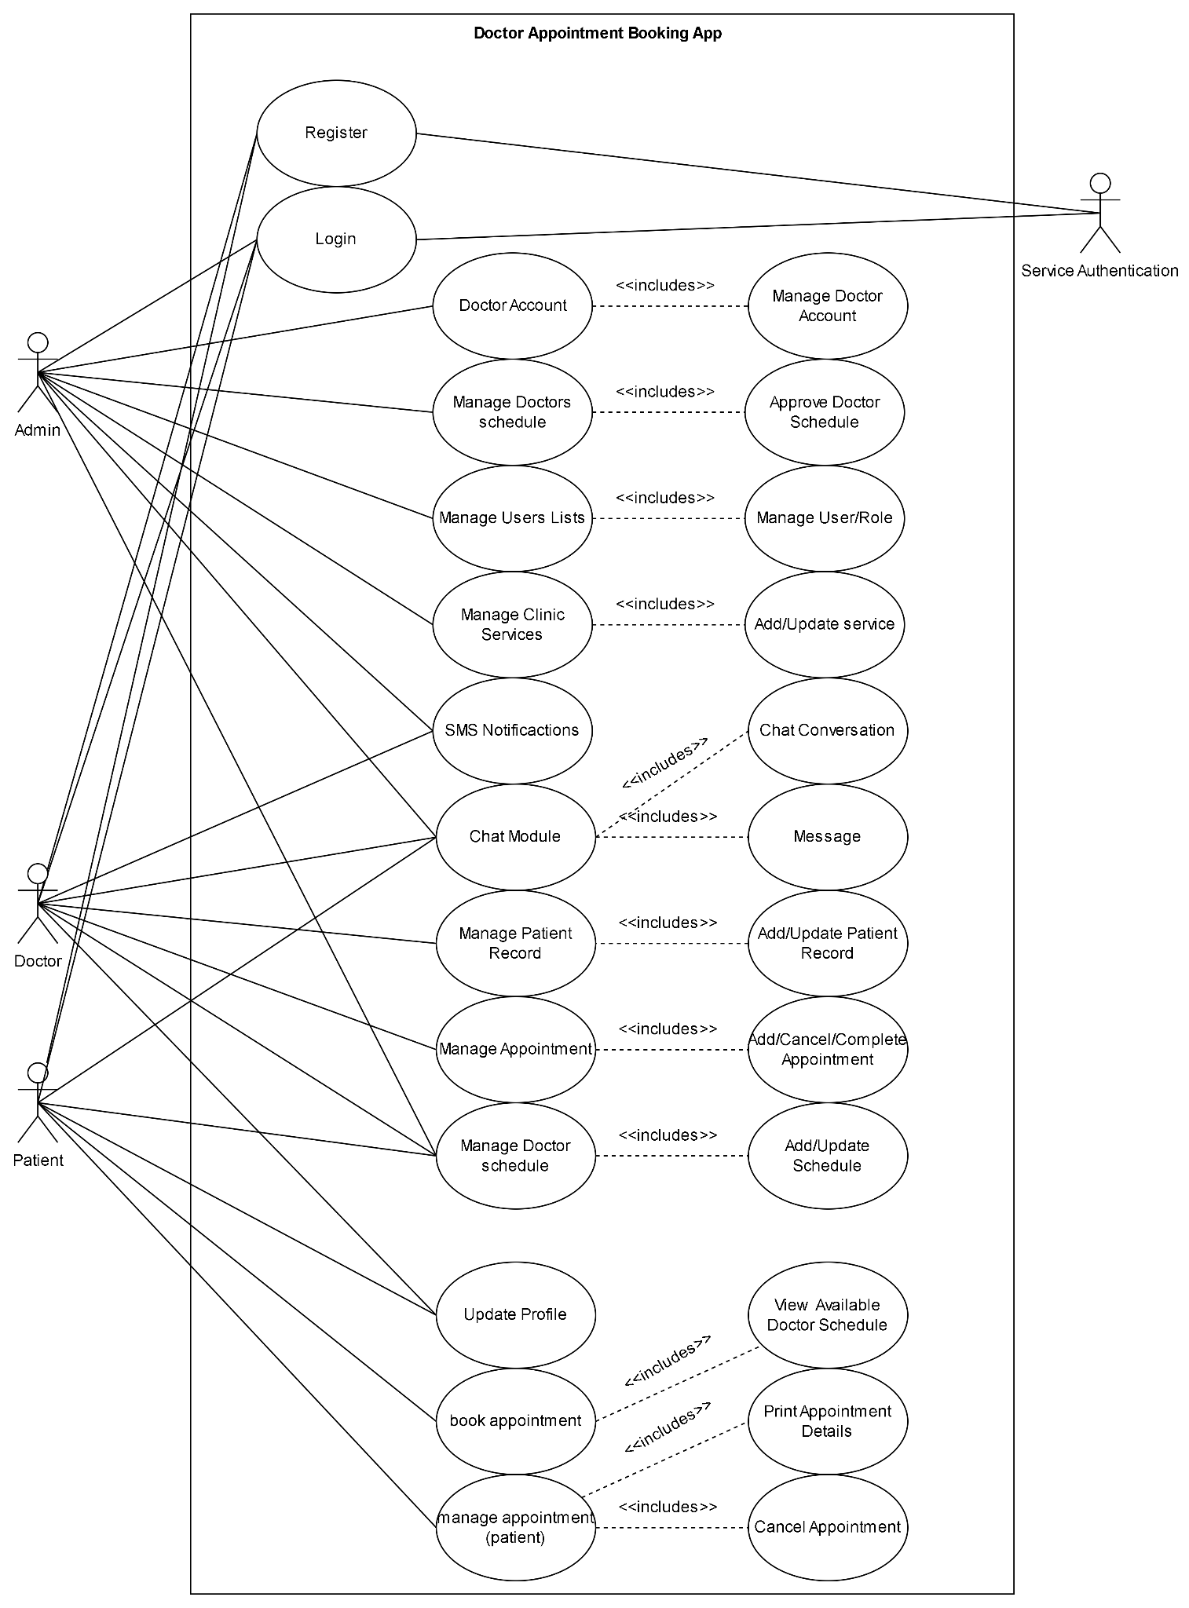***Figure 5***. Use Case Diagram - Top-level

**Hierarchical Structure**

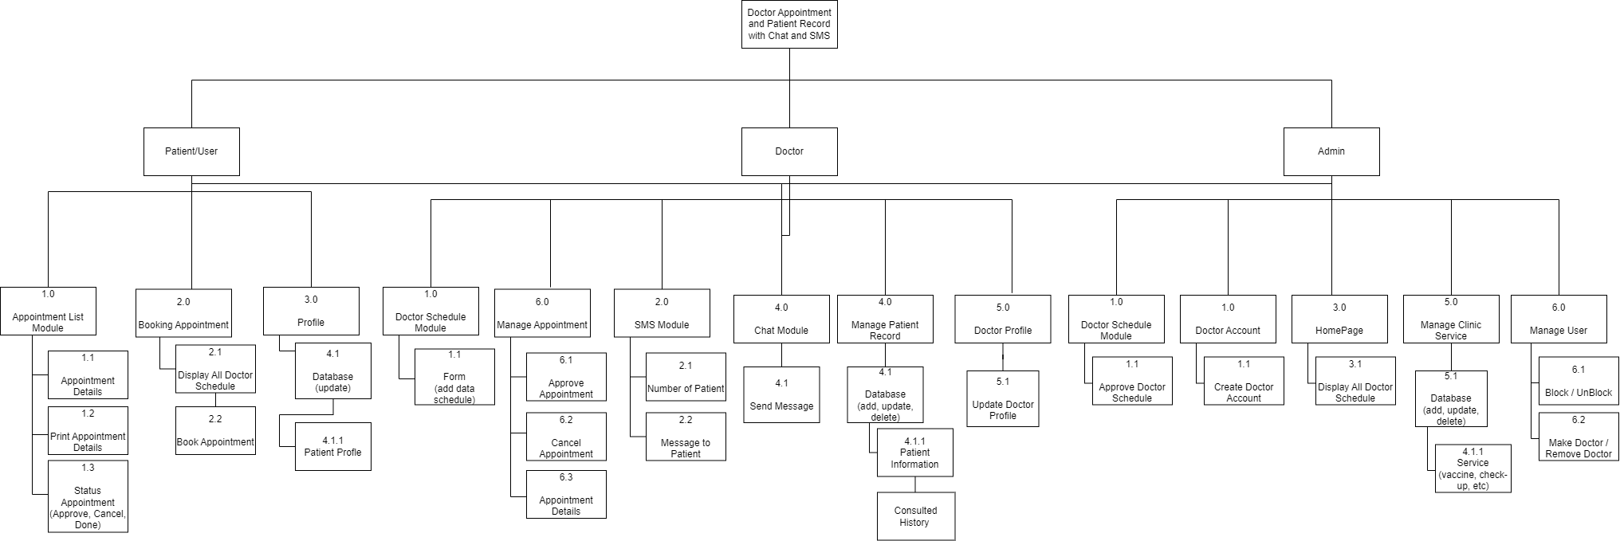

***Figure 6****.* The Hierarchy of modules of the Administrator side in the Web-based system for StarWheal Medical Clinic

Here, in Figure 6 is the hierarchy of the modules to which the System Administrator has authorization for access. The Web-Based Appointment Booking System with SMS For the Starwheal Medical Clinichas features specifically developed for the clinic, patient, and doctors, which helped them to ease the problems brought by appointments, schedules, chat conversations and patient records. module 1.0 of this system is focused on creating an account of the Patient/User. Module 2.0 is the Patient/User Profile, where the user information can be seen. On the Patient/User side, Booking Appointment is module 3.0 where all the doctors displayed their availability schedule. Also, on the Patient/User side, module 4.0 is where the appointment list can be seen. In the Doctor side, the doctor managed their patients book appointment by approving, canceling the module 5.0. Module 6.0 is the SMS or Short Message Service used to message and notify the patients by getting the patient's telephone/cellphone number. In module 7.0 this is where the doctor managed their patient's record and sees the consulted history. On the Doctor side, module 8.0 is the module that updated the Doctor's Profile. Also, in module 9.0 the Doctor's Schedule, the doctor fills up their schedule. In the Admin side, module 10.0 is the module where the admin viewed the doctor schedules. Module 11.0 is the Doctor's Account; the admin is the one that creates the doctor's account. managed the doctor's clinic services like vaccine and check-up, module 12.0 is the one that handles clinic services by the admin. The admin has the authority to manage the user account in module 13.0. Lastly, chat module 15.0 is the feature that can chat the doctors for the concern of the patients.

**Project Development**

The Web-Based Appointment Booking System with SMS for The Starwheal Medical Clinic was developed using the Software Development Life Cycle Agile Model, as shown in Figure 7.

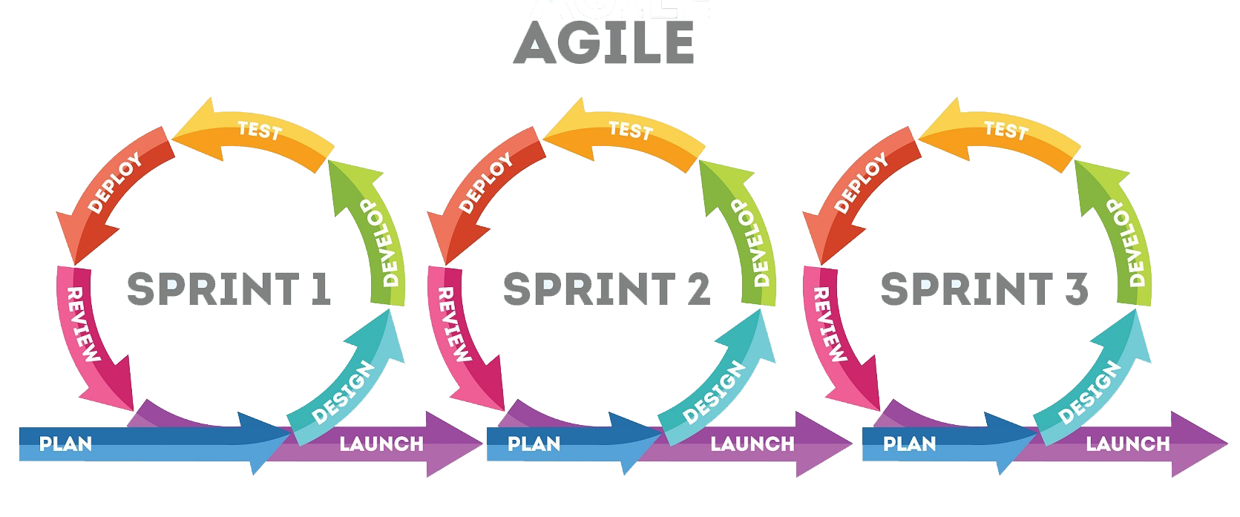

***Figure 7****.* Agile Model

*Source: https://tinyurl.com/agile-method*

* First, Gathering Information and planning was defined in this phase. It described the project’s opportunities, estimated the time and effort required to complete it, and can assess technical and economic feasibility based on this information.
* In the System Design Software, the researchers have used the use case diagram as shown in Figure 5, Data flow as shown in Figure 3, and the Functional requirements described and shown the features and how they worked with the system.
* Develop and Iteration, After the researcher gathered the information needed from the client, the team started to code using MongoDB, ExpressJS, ReactJS, and NodeJS.
* In the testing phase, the developed code is tested thoroughly to detect defects in the software. Defects are logged into the defect tracking tool and are retested once fixed. Bug logging, Retesting, and Regression testing continued until the software was in a go-live state.
* In the Deployment phase, the developed code was moved into production after the sign-off was given by the customer.
* After the product was released, the last step was to collect customer feedback. Here, the team dealt with criticism of the product that has been provided.

The process requirement is shown in Figure 8. Included the date, time, name, specialization, and experience of a doctor, and checked the available schedule and appointment approval of the doctor. If the schedule was available, then patient may book an appointment and checked with the doctor if the requested appointment may be canceled or approved.

**Scheduling**

|  |  |  |
| --- | --- | --- |
| **Input** | **Process** | **Output** |
| booking_appointment database  doctor_information database | * check available schedule * appointment approval | scheduled appointment approved. |

***Figure 8****.* Process Requirements for Scheduling.

The process requirement for Patient Records has the input and consists of databases needed for patient records. Then, it will be processed by checking the records and updating them. The output will be an updated patient record that can be viewed anytime. all of these are shown in figure 9.

**Patient Record**

|  |  |  |
| --- | --- | --- |
| **Input** | **Process** | **Output** |
| information of patients.  consulted_history database.  patient_record database. | * check patient records * update patient records | updated patient records  view patient records |

***Figure 9*** Process Requirement for Patient Record.

Figure 10 showed the Process Requirement for Chat feature of the system. The input required databases in which the data will be fetched are Chat Conversation and Message Databases.

**Chat**

|  |  |  |
| --- | --- | --- |
| **Input** | **Process** | **Output** |
| Chat Conversation Database  Message Database | * create a message * send a message | * message sent * view message |

***Figure 10****.* Process Requirement for Chat.

**Operation and Testing Procedure**

In these Operation and Testing Procedures, the researcher identified the application's modules and tested them in terms of functionality and usability.

**For Patient User**

|  |  |  |
| --- | --- | --- |
| **Modules** | **Steps to be taken** | **Expected Output** |
| 1. Register | 1. In login, click the register link.  2. Enter credentials. | After filling-up the registration form, the user will redirect to login page. |
| 1. Login | 1. Enter the email and password. | Redirects to the patient homepage. |
| 1. Book Appointment | 1. In the book appointment tab, click “Book” button.  2. Choose a schedule and service.  3. Click “Book”  4. Click “Proceed” | After displaying the Calendar. Click the specific date, pick a time schedule and services. After picking a time schedule and services it will show a confirmation then click proceed button. |
| 1. Chat | 1. Click the chat icon on specific doctors in the book appointment tab.  2. Click the textbox area and start conversation.  3. Click the send button. | After typing concerns and clicking the send button, a message will be sent to doctor immediately. |
| 1. Appointments | 1. Click the “Appointment” tab.  2. If the doctor approves the book appointment, “Print Details” will be shown.  3. Click the “Print Details” button. | It will generate print details of the booked appointment via PDF file and be shown to the doctor upon arrival at the clinic. |
| 1. Profile | 1. Click the “Patient Profile” tab. | It will redirect to patient’s account and update some information. |
| 1. Notifications | 1. Click the bell icon in the upper right.  2. In the Unseen tab, click the “Mark all as seen” link.  3. In the Seen tab, click the “Delete All” link. | After clicking “Approve” button, send notification to the patient that the booked appointment has been approved, clicking “Reject” button will result in the status rejected on patient side. |
| 1. Logout | 1. Click the “Logout” tab | Redirects to the login page. |

**For Doctor Users**

|  |  |  |
| --- | --- | --- |
| **Modules** | **Steps to be taken** | **Expected Output** |
| 1. Login | 1. Enter email and password provided by admin. | Redirects to the doctor homepage. |
| 1. Create Schedule | 1. Click the “Create Schedule” tab.  2. Click the “Select date” and under the “Set time” check the boxes.  3. Click the “Add Schedule” button. | Set up Date and Time, after setting up the schedule and click the submit button it will be posted in the digital Calendar. |
| 1. Appointments | 1. Click the Appointment tab.  2. At the end of the column named Action, click “Approve” or “Reject” button.  3. After clicking “Approve” two options will be displayed, click “Done” and “Cancel”. | After clicking the “Approve” button, send notification to the patient that the book appointment has been approved and print details will be available. two options will be displayed after clicking “Approve” button, “Cancel” button will cancel the appointment and “Done” button will put the consultation to medical records, clicking the “Reject” button will result to the status rejected on patient side. |
| 1. Medical Records | 1. Click the “Medical Records” tab.  2. Click the eye icon on the action's column.  3. Click the add icon on top of the list.  4. In the action column, click edit, delete, view icon. | Clicking the add icon will result in adding consultation history of the chosen patients. Clicking the eye icon will redirect and view the records of the chosen patient, and clicking the trash icon will result in removal of history of patients record. |
| 1. Notifications | 1. Click the bell icon in the upper right.  2. In the Unseen tab, click the “Mark all as seen” link.  3. In the Seen tab, click the “Delete All” link. | It will redirect to the notification page, and shows the pending appointments booked by the patients, clicking the delete all in seen tab will removes all the notification. |
| 1. Chat | 1. Click the “Chat” tab.  2. Click the textbox area.  3. Click the send button. | Clicking the chat tab will show the patient's chat and start conversation. |
| 1. Profile | 1. Click the “Profile” tab. | It will redirect to doctor’s account and update some information. |
| 1. Logout | 1. Click the “Logout” tab. | Redirects to the login page. |

**For Admin**

|  |  |  |
| --- | --- | --- |
| **Modules** | **Steps to be taken** | **Expected Output** |
| 1. Login | 1. Enter default email and password. | Redirects to the admin homepage. |
| 1. Admin Dashboard | 1. Click View More for more information on each listed database. | Doctor will be redirected to Users list, doctor page, services page, or will be able to export a list of today’s appointments, number of males, female senior, and child patients. |
| 1. Doctor Accounts | 1. Click the “Doctors” tab.  2. Click the plus icon.  3. Click the block and unblock button in the last column named Action. | Clicking the plus icon will display a popup modal that creates a doctors account. After creating doctors account, admin has an authorization to block and unblock the doctors' account. |
| 1. Patients Record | 1. Click the “Patients” tab. | It will display all the patient’s accounts. |
| 1. Clinic Services | 1. Click the “Clinic Services” tab.  2. Click the plus icon.  3. Click the edit and trash icon in the last column named Action. | Pressing the plus icon will result in displaying a popup modal that inputs the Service name and Service description. clicking edit icon will pre-populate the clinic service form modal. clicking the trash icon will remove the specific clinic services |
| 1. System Customization | 1. Click the “Customization” tab.  2. In the customization tab, click the “Choose file” and choose color from color picker. | Clicking the choose file button will open the file folder of the computer to choose image and Png extension then click open to upload and choosing a color from color picker to change the side bar navigation, clicking the submit button will apply the image and color to the system. |
| 1. Logout | 1. Click the “Logout” tab. | Redirects to the login page. |

**Testing Procedure**

Testing procedure refers to the steps, methods, and techniques followed to perform software testing.

**Compatibility Testing**

The system’s goal was to access various web browsers and devices such as computers, tablets, and cellphones.

**Unit Testing**

It was the process of testing the smallest units of code, such as functions and methods, in isolation to ensure they are working as expected. Unit testing is performed by developers as part of the software development process before the software is integrated and tested. Unit testing is usually automated, making it a quick and repeatable process that can be integrated into development. It was a crucial step in ensuring the reliability and quality of the software.

**Evaluation Procedure**

The system evaluation consisted of two stages: the project demonstration and the final evaluation.

**Project Demonstration**

1. The researcher gathered 25 respondents, which consist of 10 Patients, 10 IT Professionals, 3 Doctors, and 2 Clinic Staff
2. Invitations are sent to participants and present the system to the respondents
3. A system walkthrough encouraged participants to explore the system and use it was conducted.

**Final Evaluation**

1. The researchers used the ISO 25010 evaluation instrument for software to determine the system's acceptability.
2. Functionality and reliability were the criteria for using a 4-point Likert Scale in the rating system.
3. The evaluation form is printed and given to respondents.
4. The respondents are asked in Table 1 to respond to the evaluation tool and rate the method using the Likert Scale for questions about suggestions. No suggestions is automatically 4 in likert scale and if there is it is 2 on the scale.

***Table 9.***

*Likert Scale*

|  |  |
| --- | --- |
| **Numerical Scale** | **Descriptive Rating** |
| 4.0  3.0  2.0  1.0 | Very Good / Very Acceptable  Good / Acceptable  Fair / Fairly Acceptable  Poor / Not Acceptable |

1. The data is calculated and tabulated.
2. The mean score of each criterion and the mean score overall is calculated.
3. Using the equivalent descriptive rating in table 2, the result and acceptability of the system was interpreted.

***Table 10.***

*Descriptive Interpretation of the Mean*

|  |  |
| --- | --- |
| **Numerical Scale** | **Interpretation** |
| 3.51 - 4.50  2.51 - 3.50  1.51 - 2.50  1.00 - 1.50 | Very Good / Very Acceptable  Good / Acceptable  Fair / Fairly Acceptable  Poor / Not Acceptable |

**Chapter 4**

**RESULTS AND DISCUSSIONS**

This chapter presents the project description, project structure, project test results, project capabilities and limitations, and project evaluation results of the study.

**Project Description**

The Web-Based Appointment Booking System with SMS for the StarWheal Medical Clinic as the project name says, is a web based application. It is developed for the purpose of making ease in the aforementioned clinic’s current appointment system by transforming its current manual processes to a new digital and automatic system. The web application allows doctors to create their own schedule and store patients' consultation history. For the patient users the system allows them to book appointments and print the details for the booked appointment. The admin however can approve the doctor’s created schedule, block doctor accounts and customize the appearance of the application. It has additional features like SMS for notifying the doctor about patients appointment requests, another is notification system for any important changes in appointments.

This application is mobile responsive and can run on devices with web browsers. The application is developed with this MERN stack group of tools. It consists of MongoDB for database, Express JS for web framework, React JS for javascript framework client, and Node JS for javascript web server.

**Project Structure**

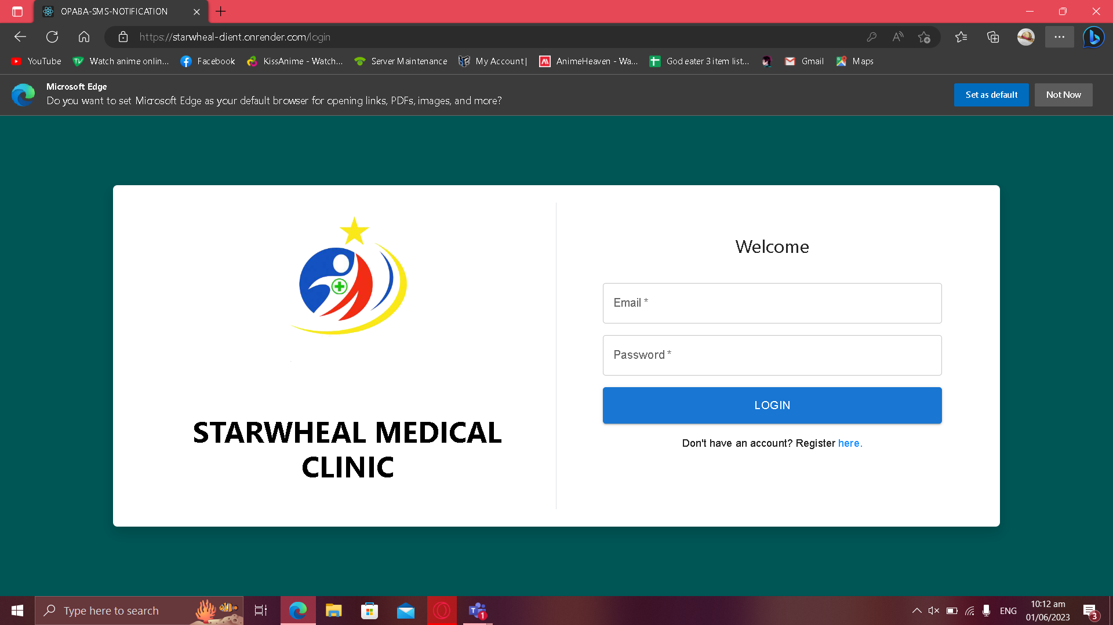

***Figure 11.*** Welcome Screen.

Figure 11 shows the welcome screen where the first page will be seen by the users, here the login and register can be done.

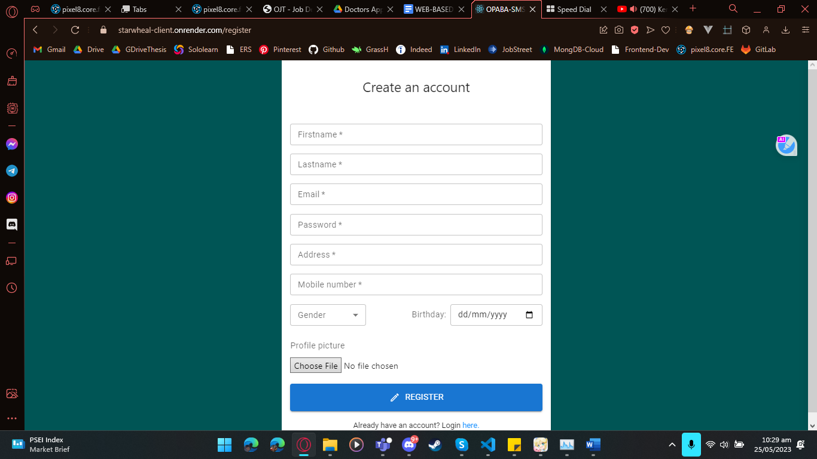

***Figure 12.*** Register Screen.

Figure 12 shows the registration page where users can create accounts.

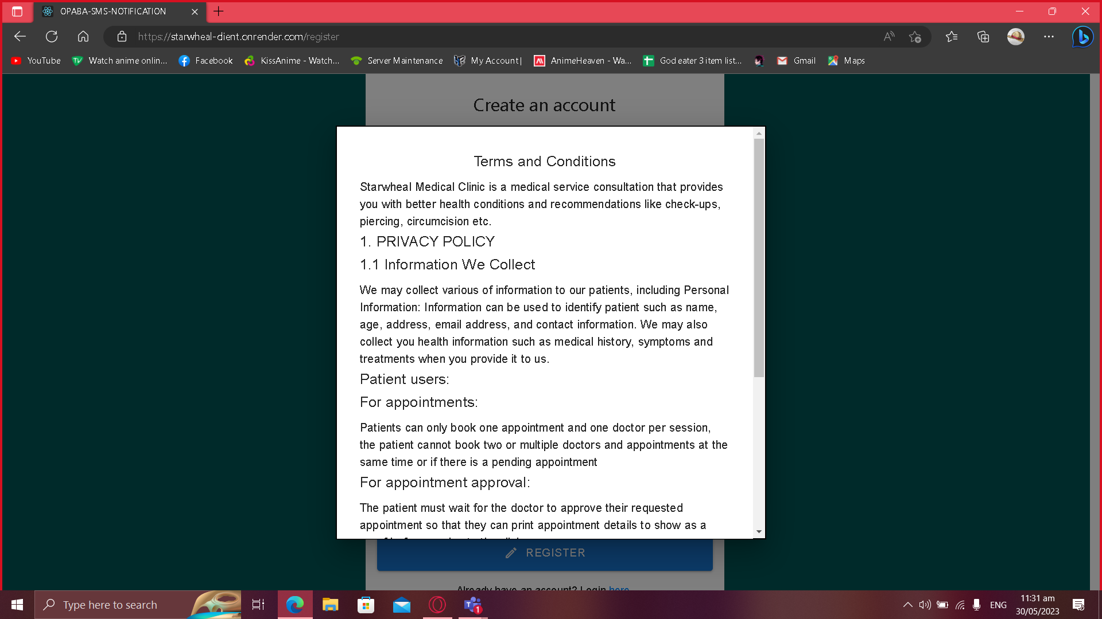

***Figure 13.*** Register page Terms and conditions Modal.

Figure 13 shows the modal terms and conditions in the register page where the user can't register unless they read the terms first.

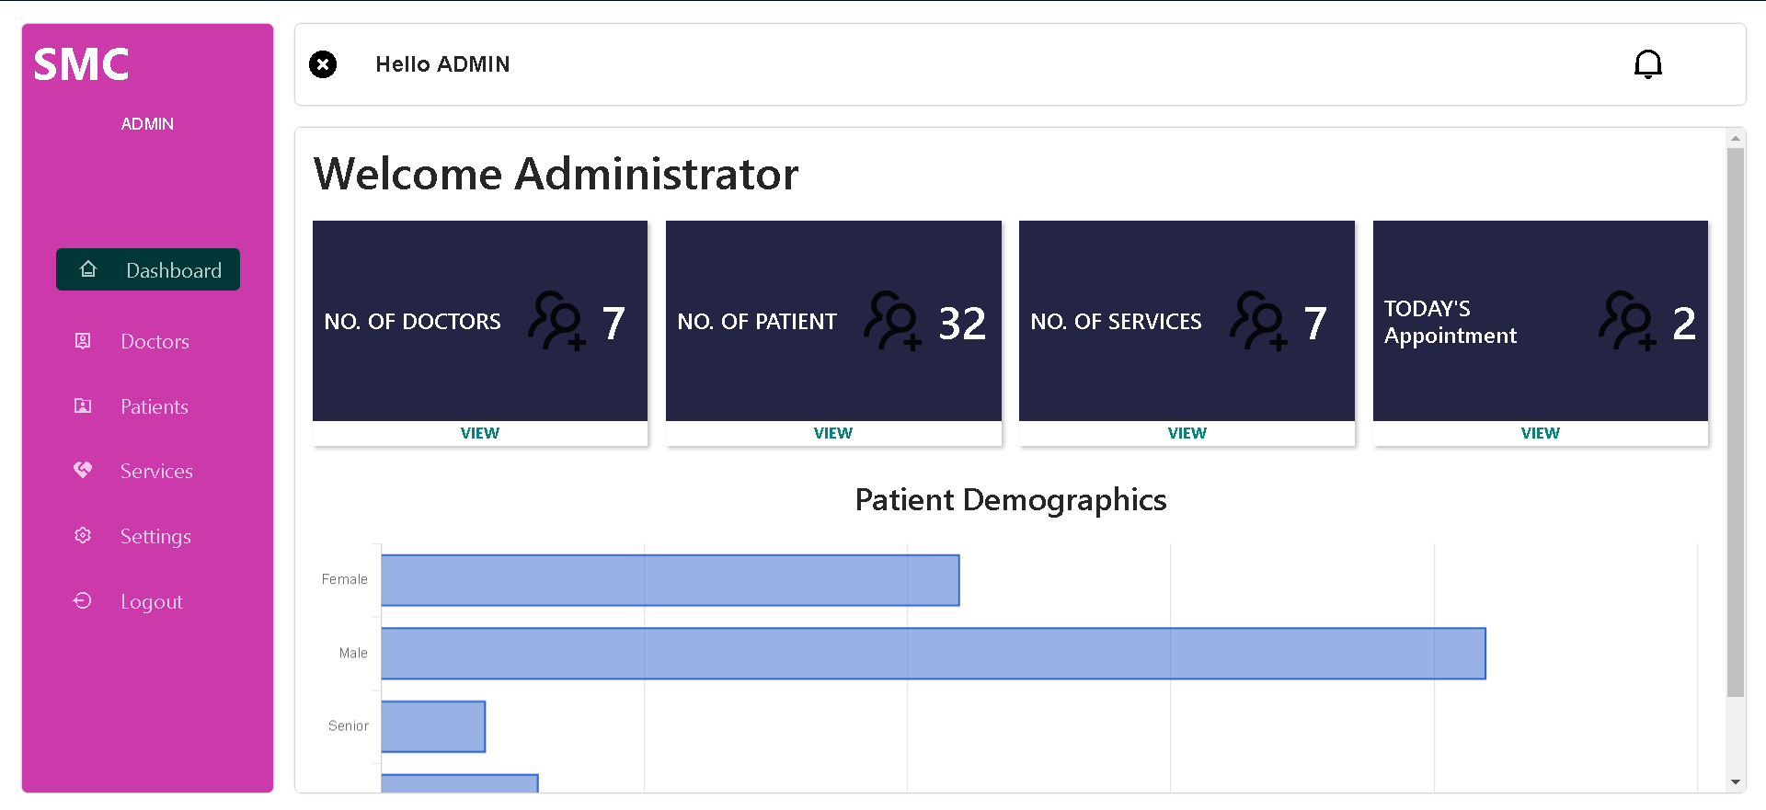

***Figure 14.*** Admin Dashboard.

In this Figure 14 shows the General Information about the status of the clinic and the demographics of the patients.

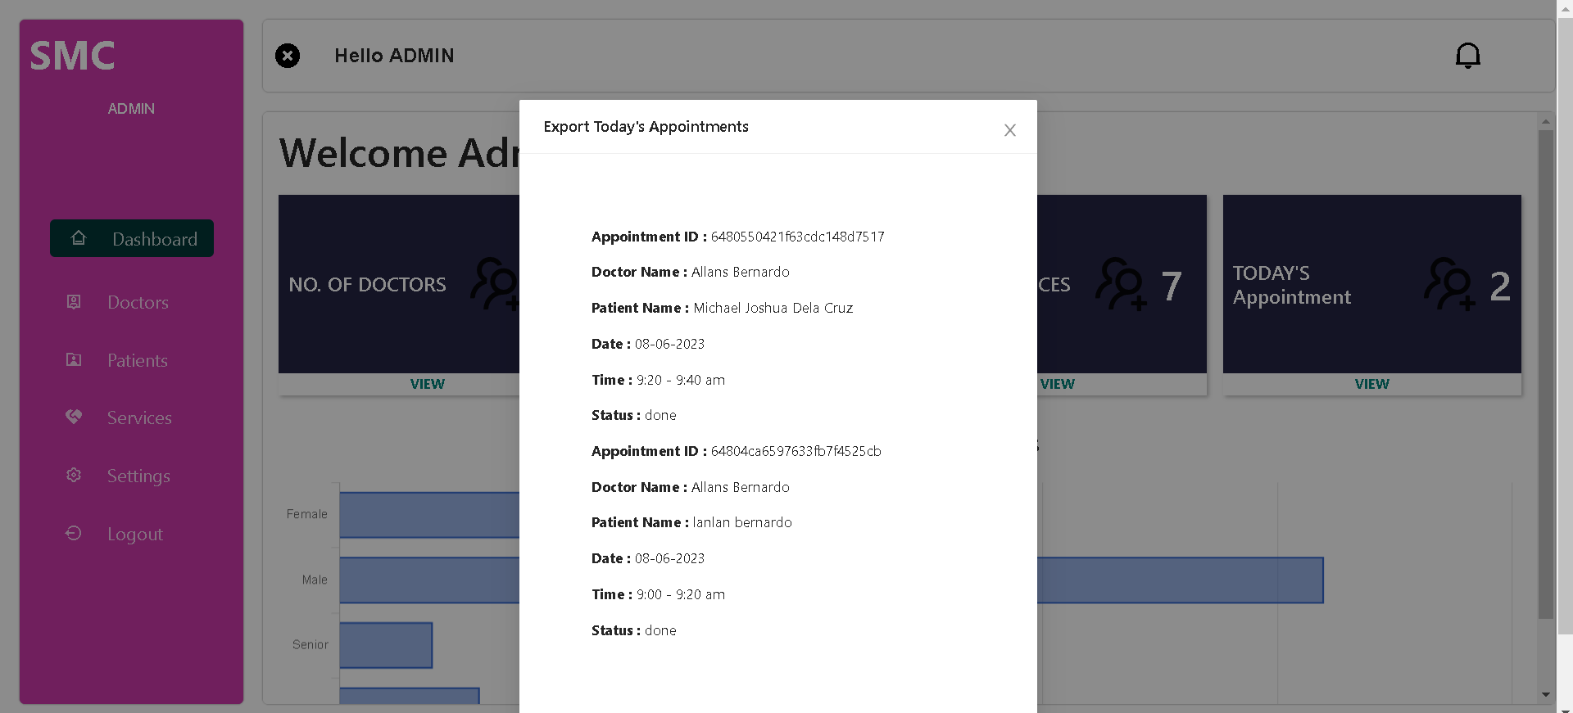

***Figure 15.*** Admin Dashboard Today’s Appointment View More Modal.

Figure 15 shows the modal that shows when the “view more” is clicked on today’s appointment here, the data of today’s appointment can be seen, and it can also be exported.

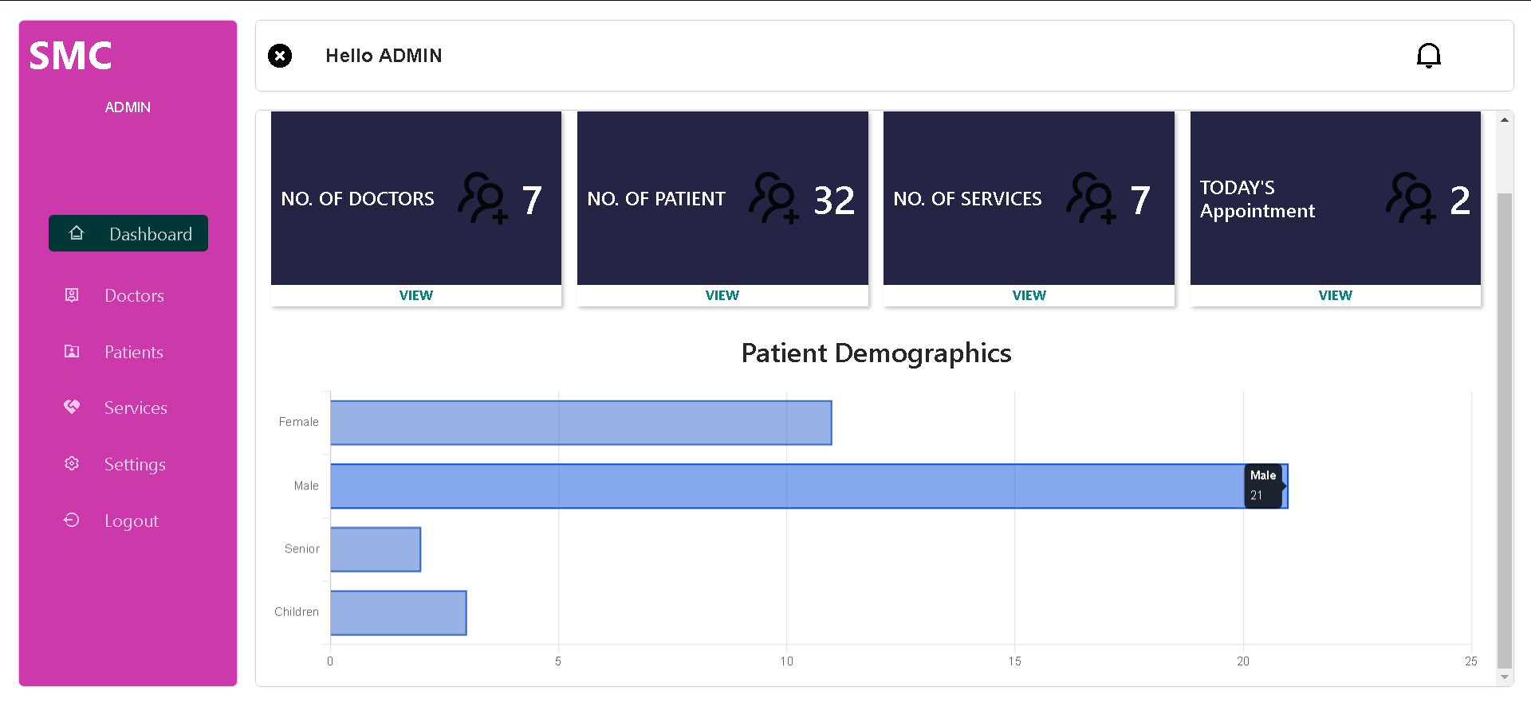

***Figure 16.*** Admin Patient Demographics No. of Male, Female, Seniors, Children

Figure 16 exhibits the modal that showed all the No. of Male, No. of Female, No. of Seniors, No. of Children when hovered in the graph

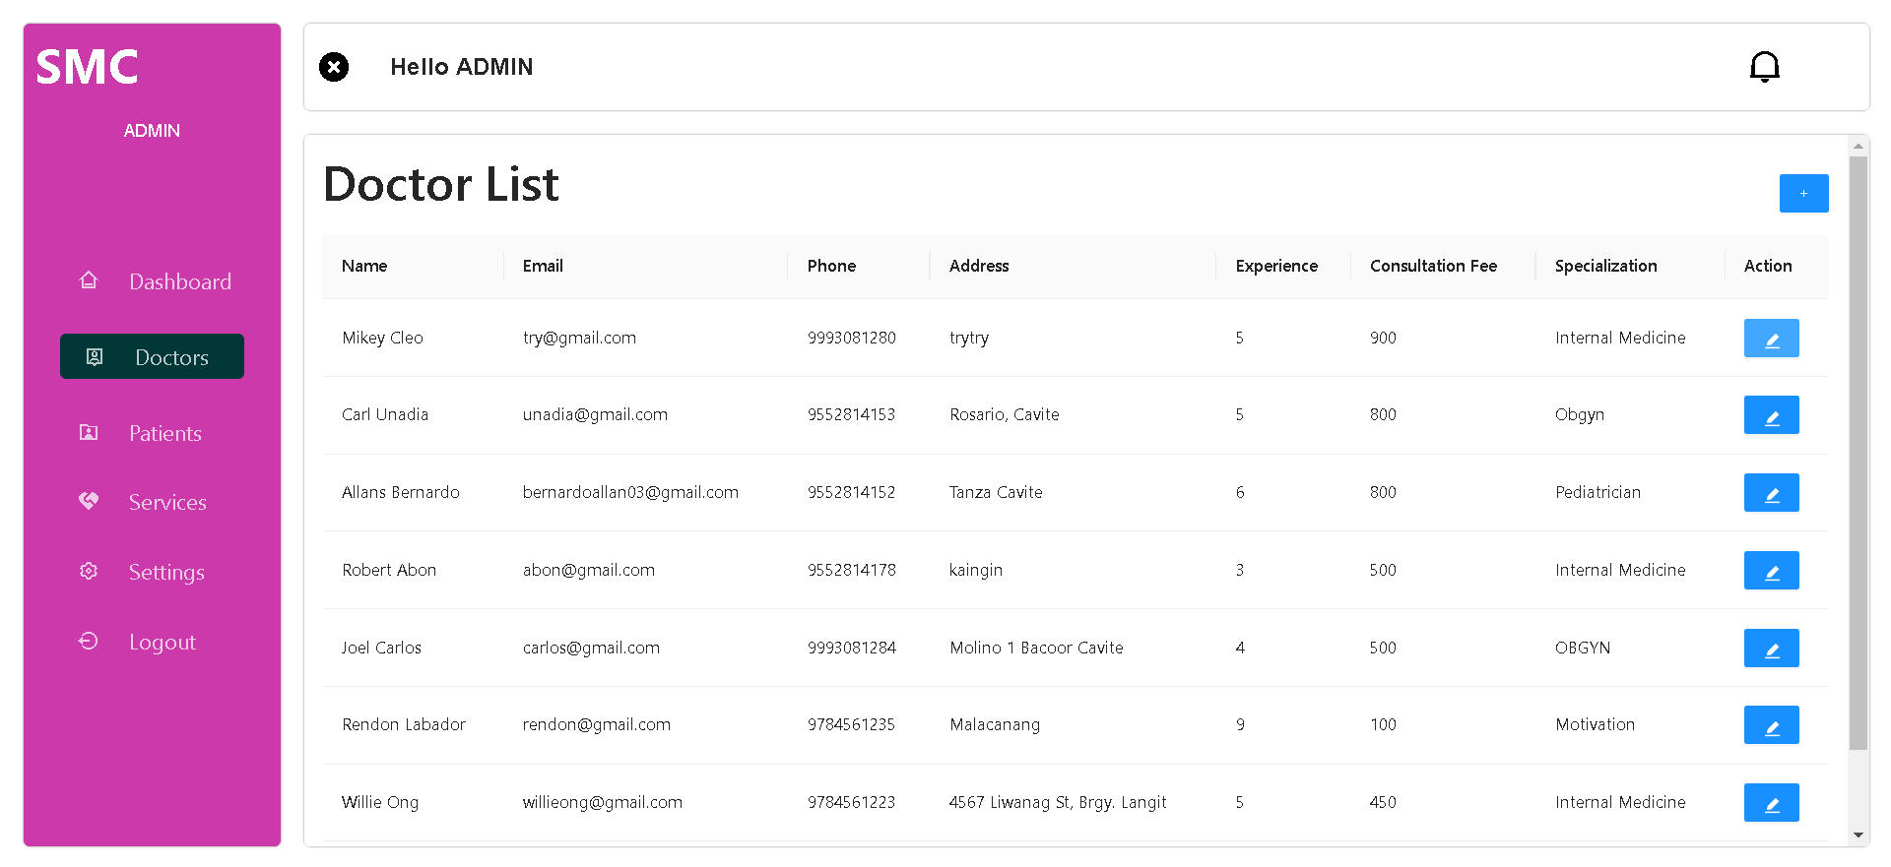

***Figure 17.*** Doctor accounts screen.

On Figure 17 the screen where the admin can edit the doctor accounts are shown also, this is where the admin creates doctor accounts by clicking the plus icon on top of the table.

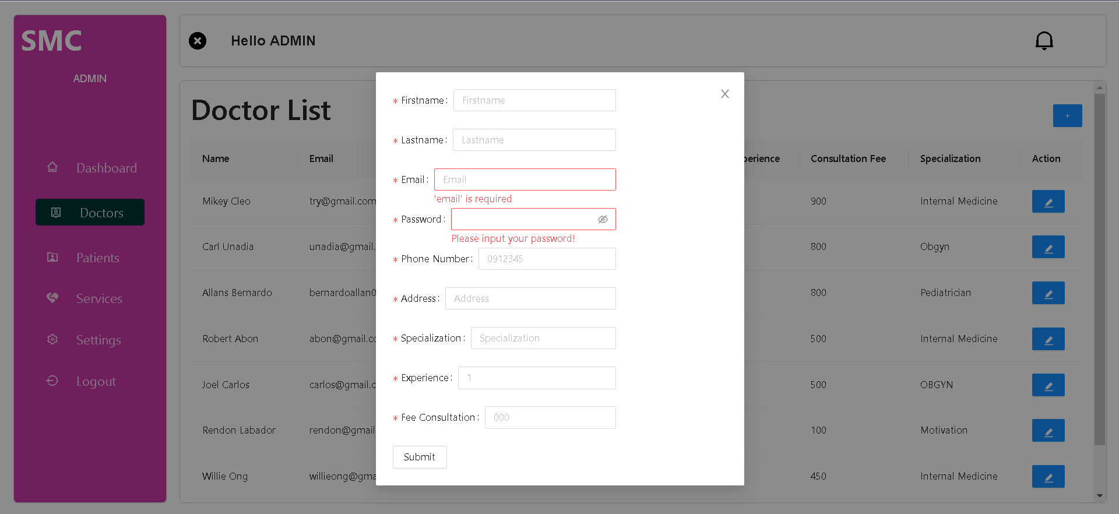

***Figure 18*** Doctor Accounts Screen Doctor account Creation modal.

The modal that shows what happens when clicking the plus icon on the top of the table is shown here, admin inputs the new doctors account required information here in figure 18.

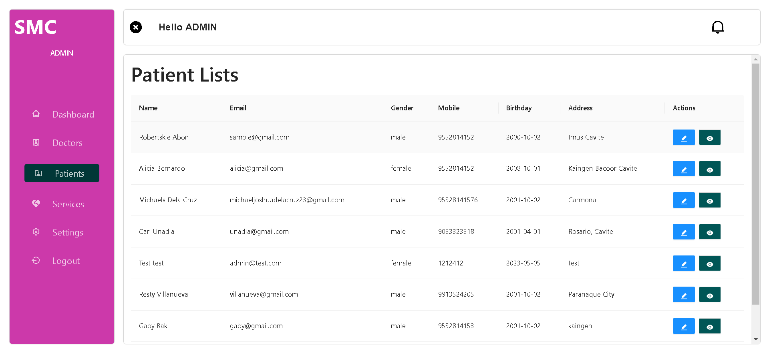

***Figure 19*** Users list screen.

Figure 19 shows where the admin can edit, view consultation history and see the number of users (Patients) and their information for the clinic.

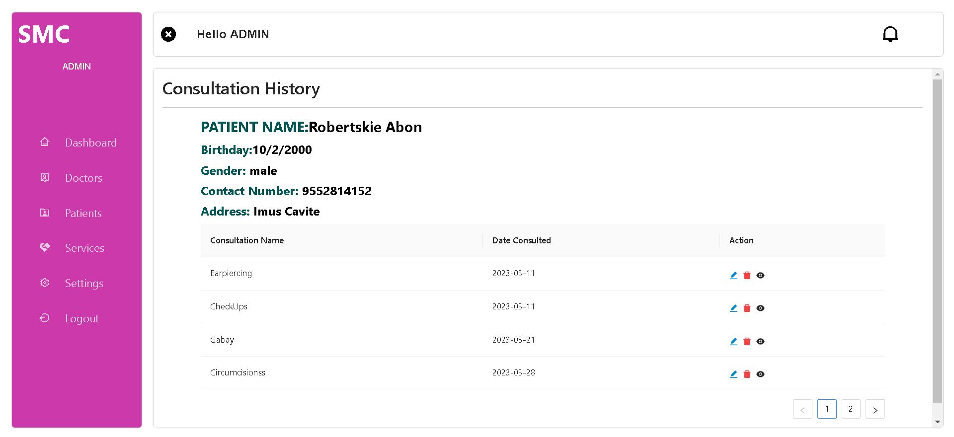

***Figure 20***. Consultation History screen

Figure 20 shows where admin can edit, delete and view details of consultation of the chosen patient.

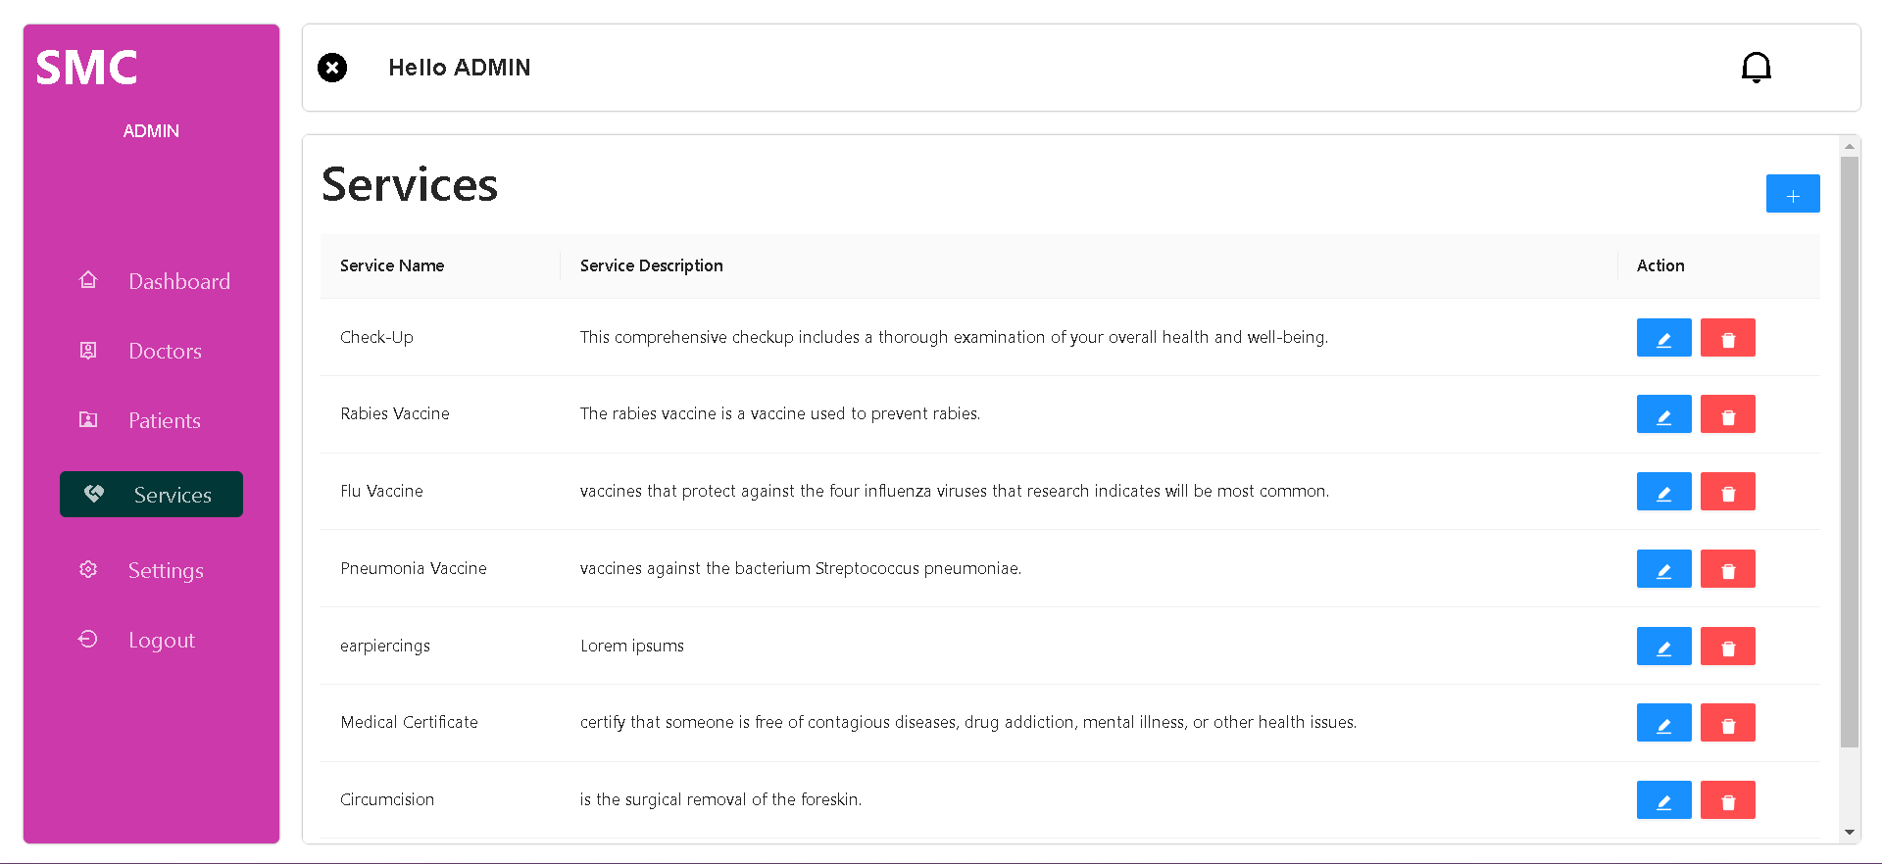

***Figure 21.*** Clinic service screen

Figure 21 displays where the admin can edit the clinic's offered services here admin can also add new services with the button on top of the table.

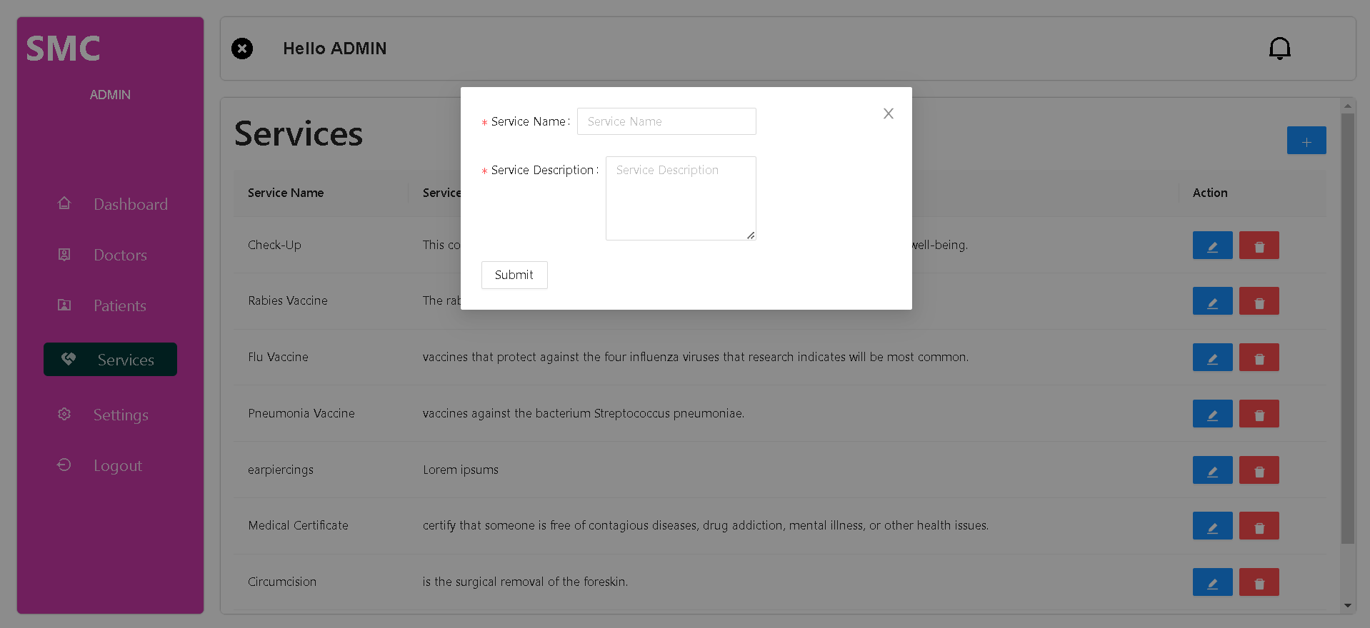

***Figure 22.*** Clinic Service Screen Add Clinic Service Modal.

Figure 22 shows the modal that shows when the plus icon on the top of the table is clicked, here is where the admin inputs new clinic services.

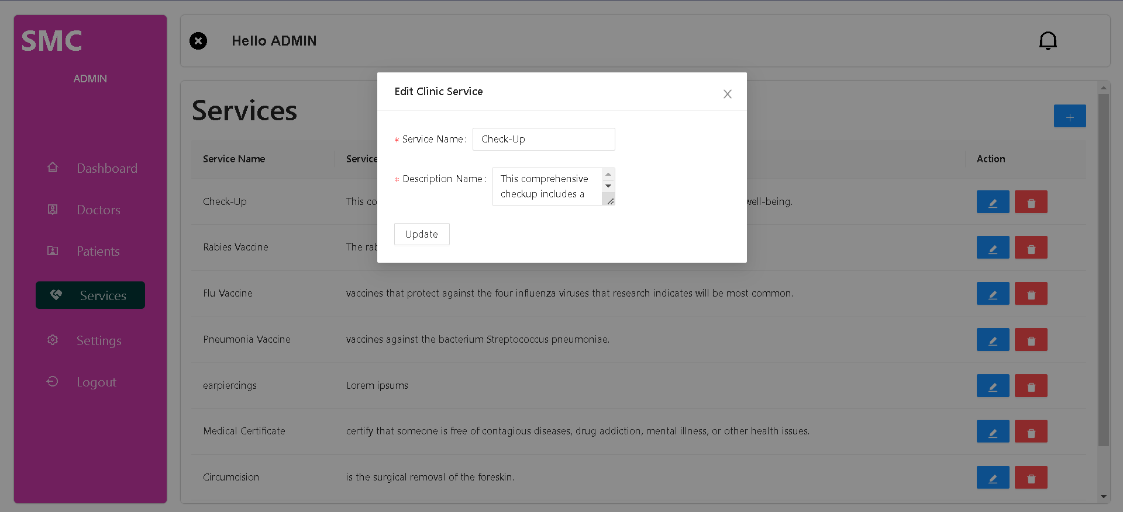

***Figure 23.*** Clinic Service Screen Edit Clinic Service Modal.

A modal where admin can edit Clinic services pop ups when clicking the edit button is shown in figure 23.

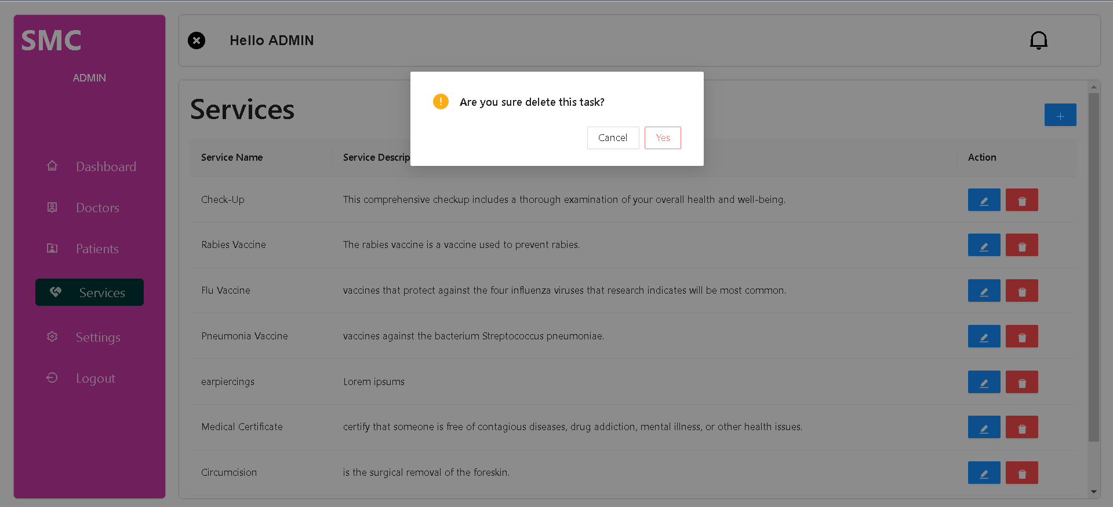

***Figure 24.*** Clinic Service Screen Delete Confirmation Modal.

Figure 24 shows a delete confirmation modal when admin clicked the delete button to avoid accidental erasure of services.

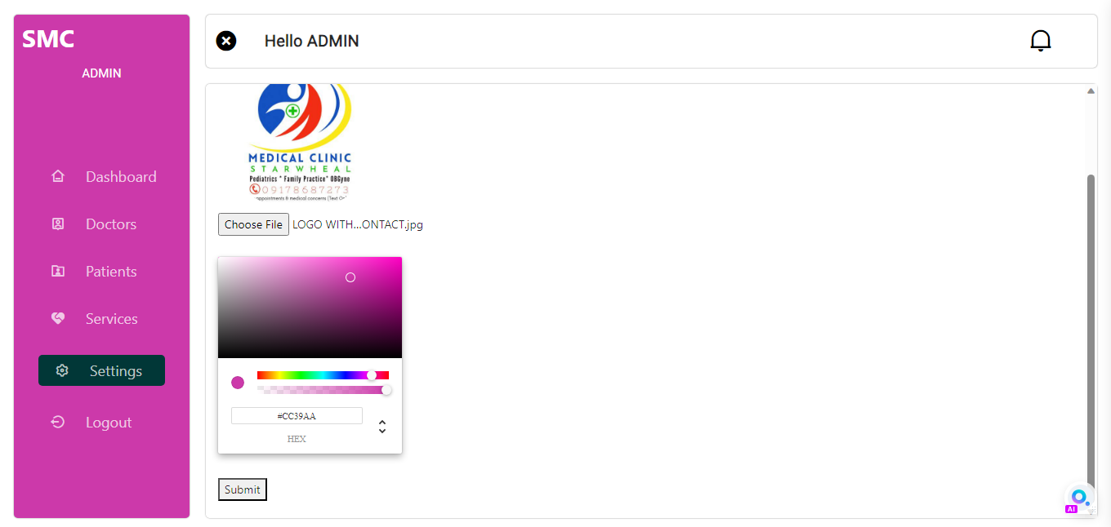

***Figure 25.*** SettingCustomization screen.

The admin can customize the system appearance like the logo and colors that can be seen in this figure 25.

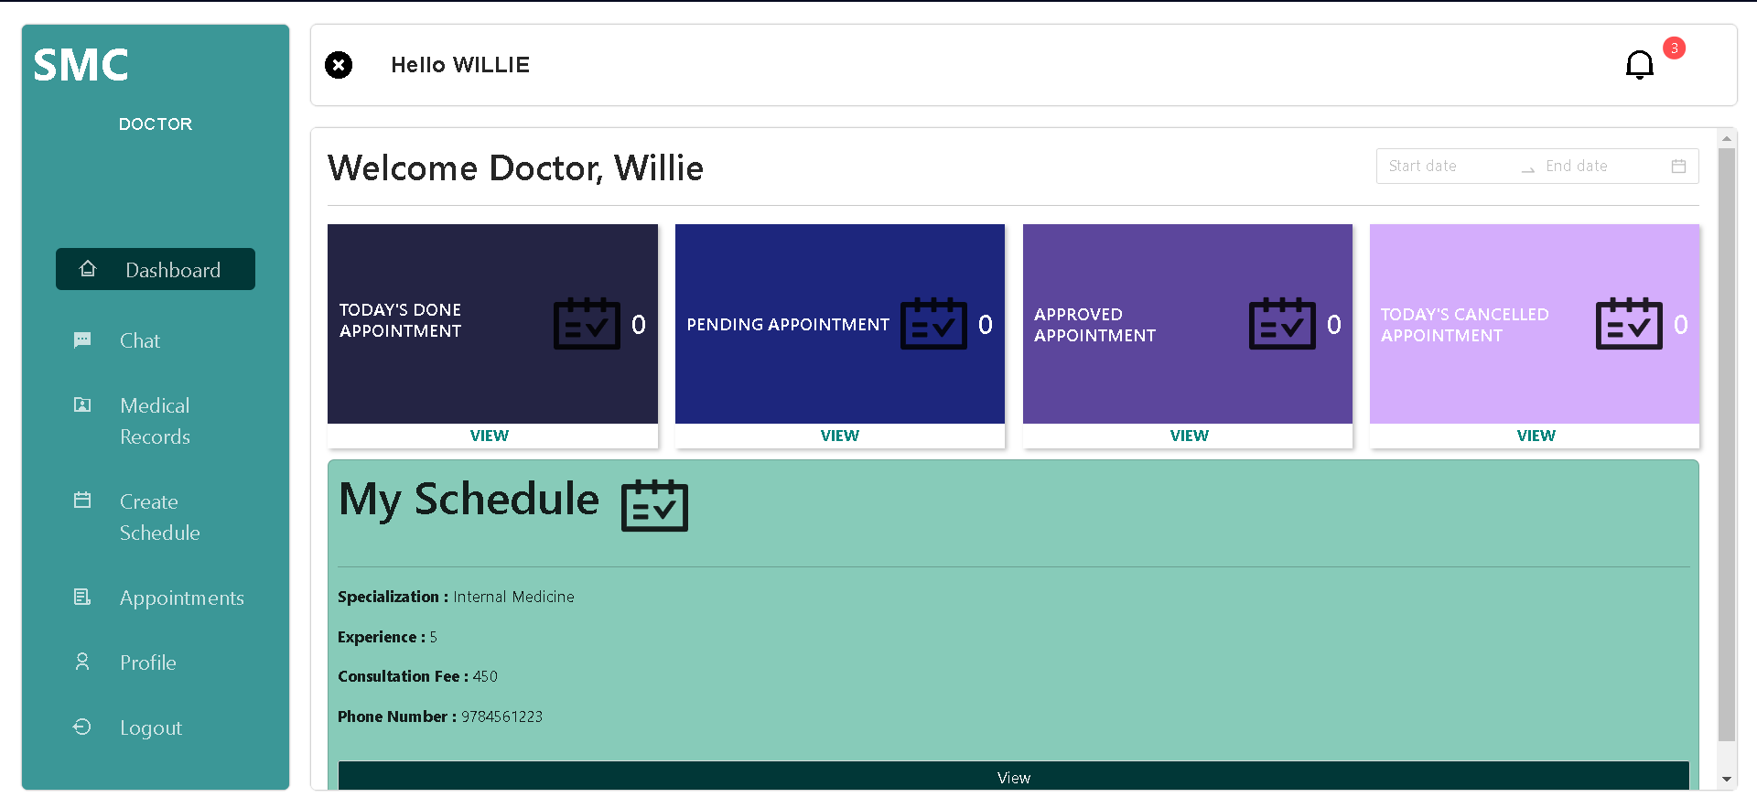

***Figure 26.*** Doctor Account Homepage.

Here in this figure 26 displays the doctor account dashboard where the status of the day’s appointments is shown.

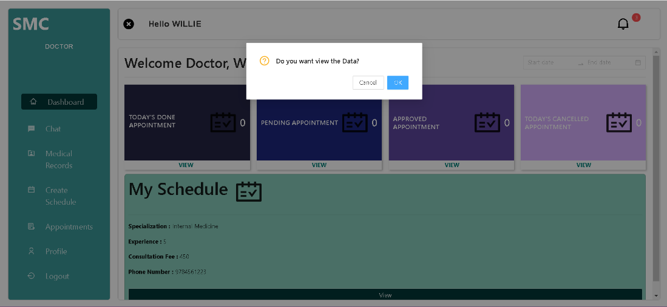

***Figure 27.*** Doctor Account Homepage View more Modal for Today’s Done Appointment, Pending Appointment, Approved Appointment, and Today’s Canceled appointment.

In Figure 27 the modal for clicking view more can be seen, here the user can choose to export the data or close the modal.

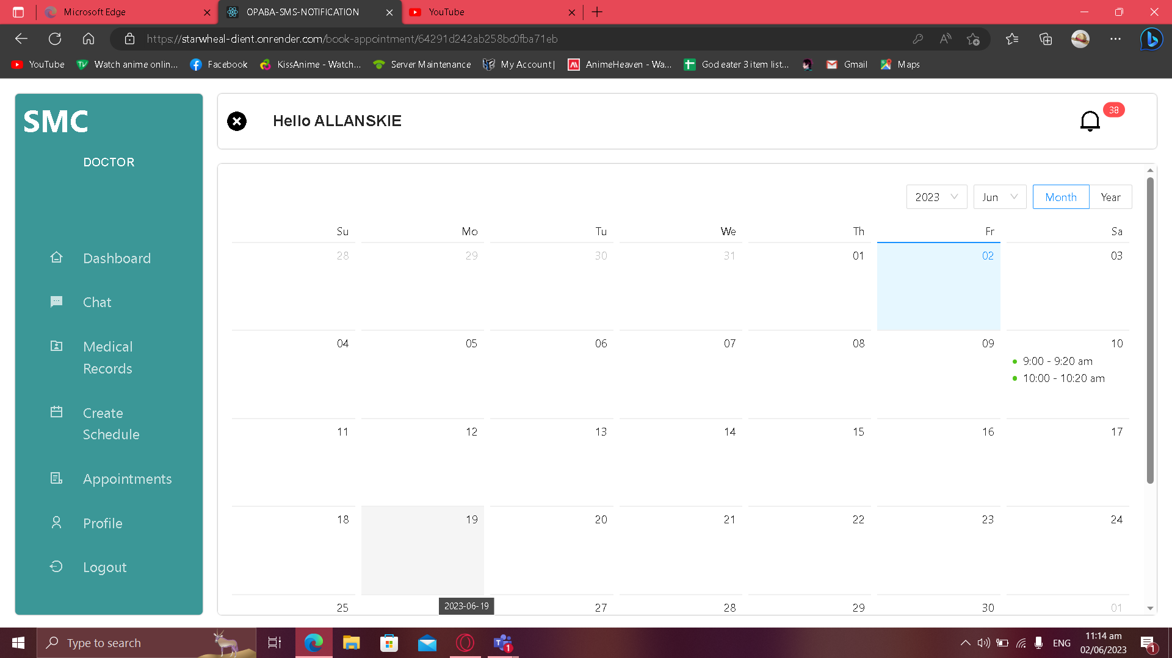

***Figure 28.*** Doctor Schedule Calendar Screen.

Figure 28 shows the Doctor’s own schedule in calendar format so that the doctor can review his available schedules.

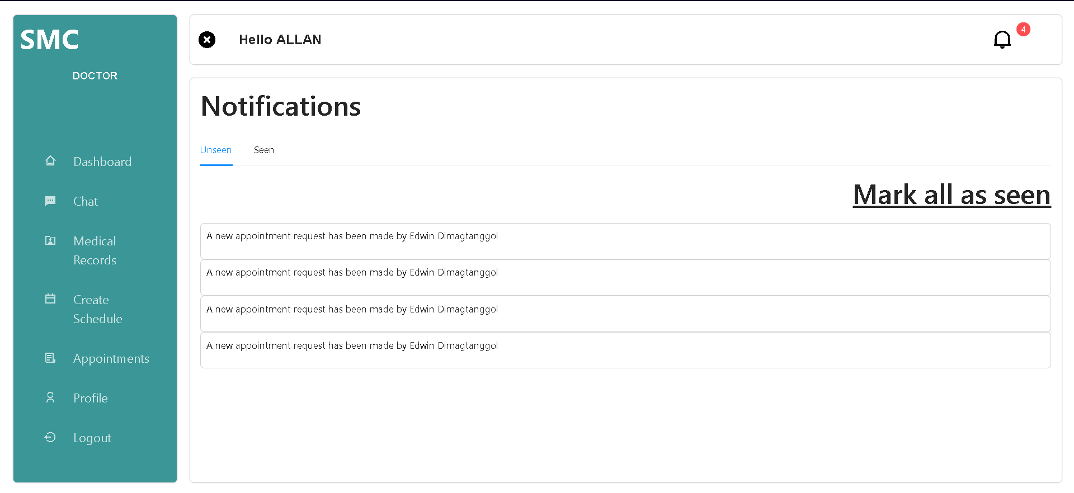

***Figure 29.*** Doctor Notification Screen.

The Figure 29 Exhibits Notification page of doctor accounts where appointment changes are notified.

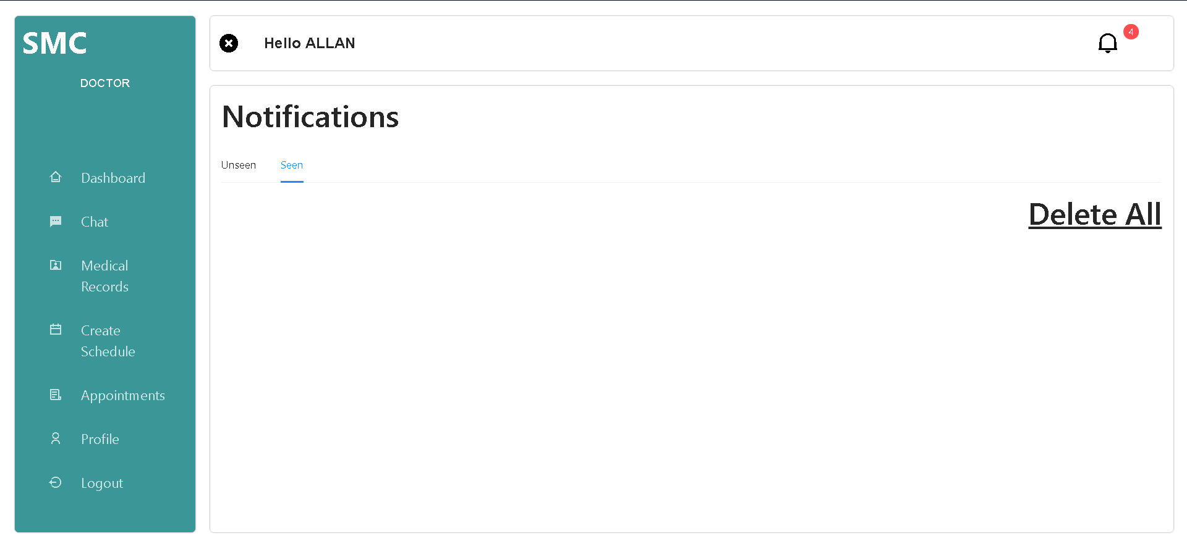

***Figure 30.*** Doctor Notification Seen Screen.

Figure 30 shows where notifications are seen. users can also delete notifications.

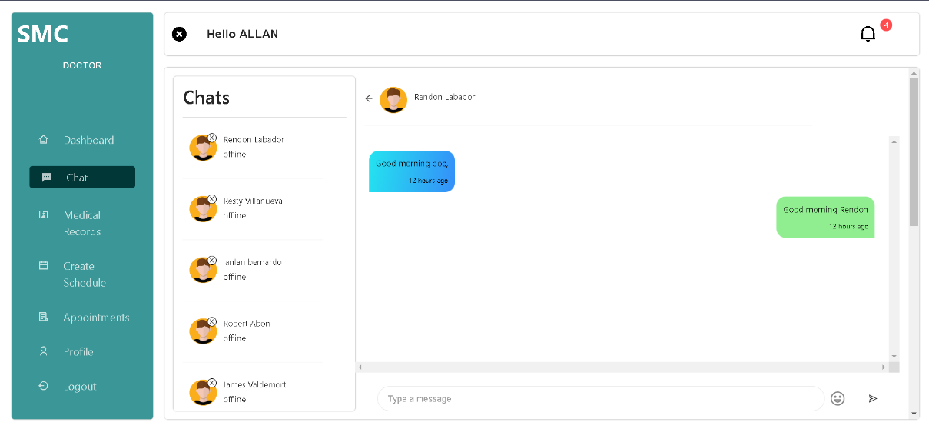

***Figure 31.*** Doctor Chat Screen.

Doctor chats, Patients replies, and their conversation are shown on figure 31 here the doctor can see when patients chat with them.

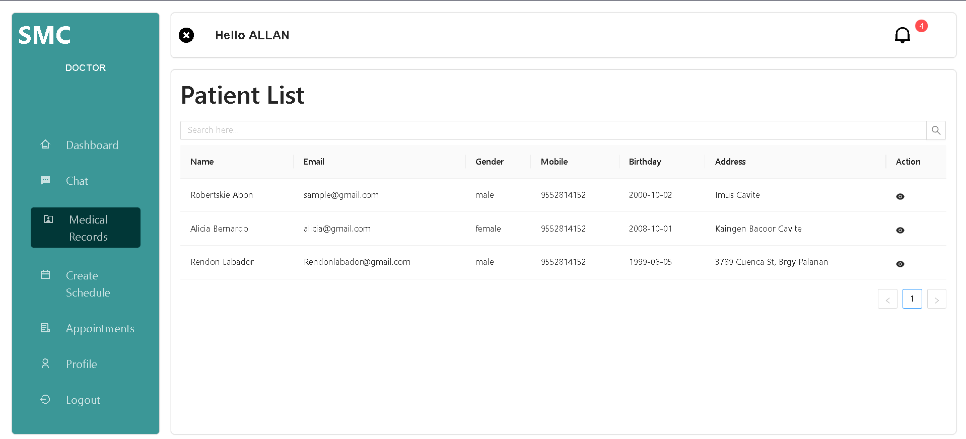

***Figure 32.*** Medical Records Screen.

Here is where the patient history and patient data can be seen in this figure 32 there is an eye icon for each patient to redirect to their history.

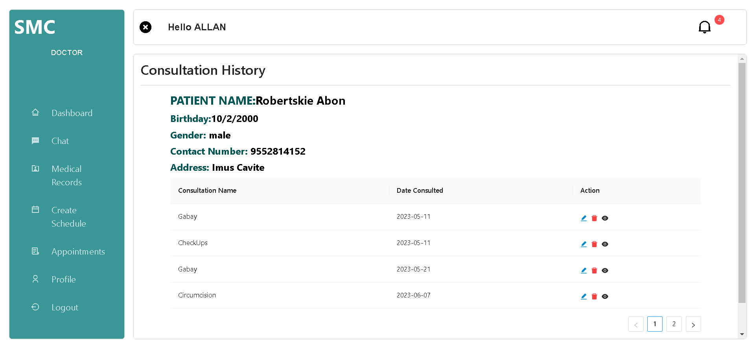

***Figure 33.*** Patient Record Screen.

The Figure 33 shows the consultation history of a specific patient admin can add, view, delete, edit the patient's consultation history.

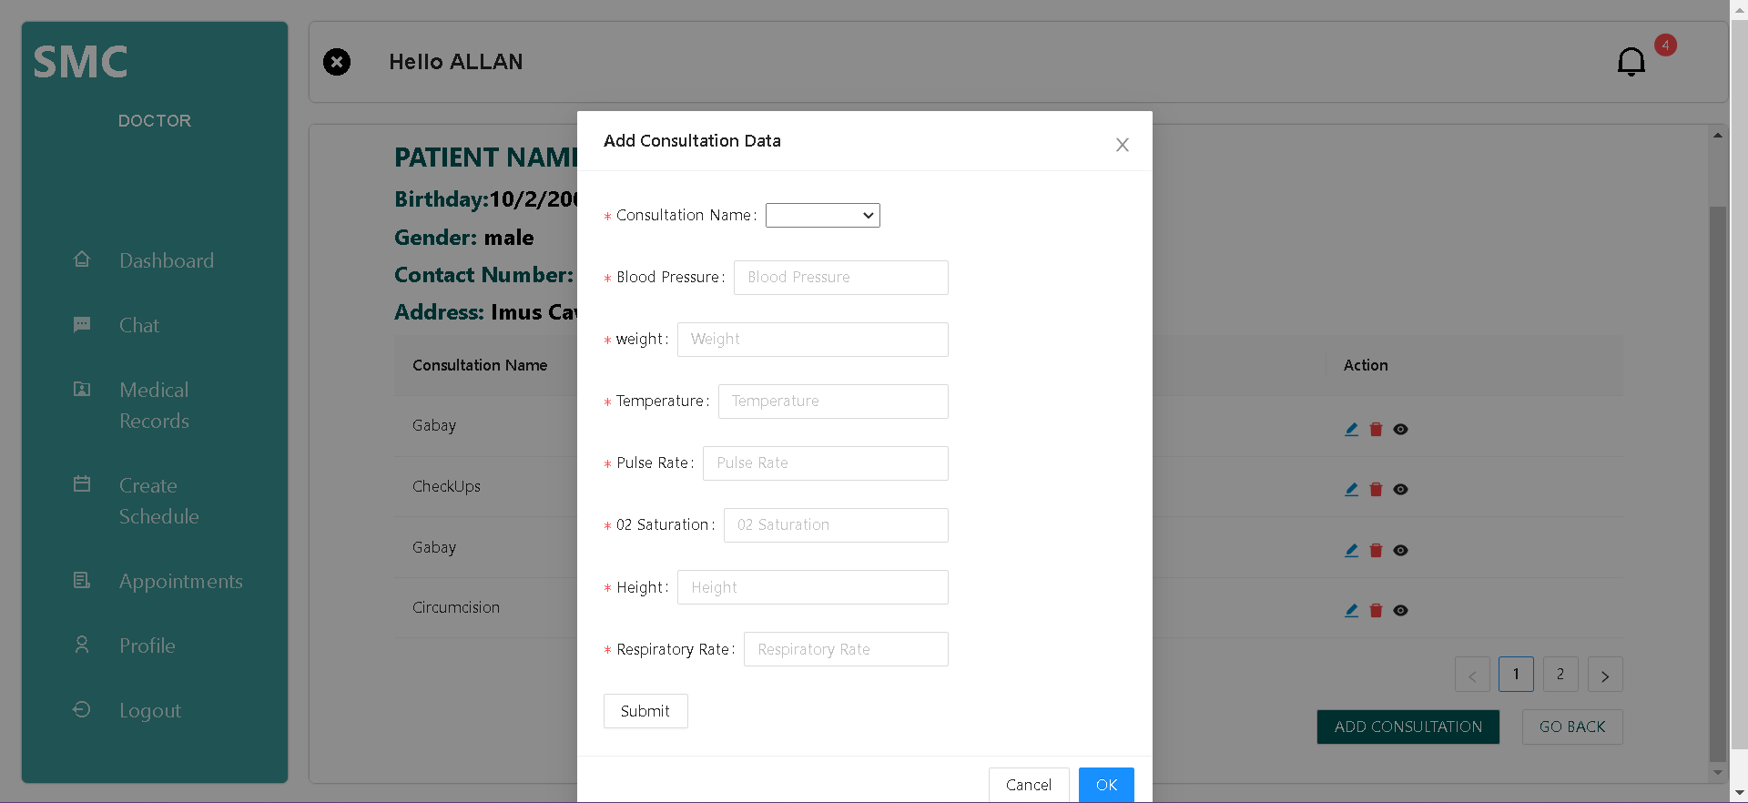

***Figure 34.*** Patient Record Screen Add Consultation Data Modal.

Adding new Consultation History can be made in this modal as shown in Figure 34.

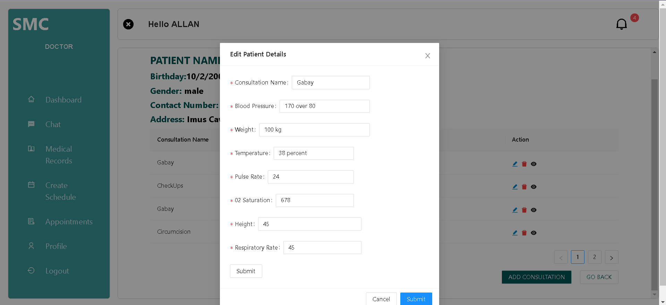

***Figure 35.*** Patient Record Screen Edit Consultation Details Modal.

Editing existing consultation data is shown in the modal in this figure 35.

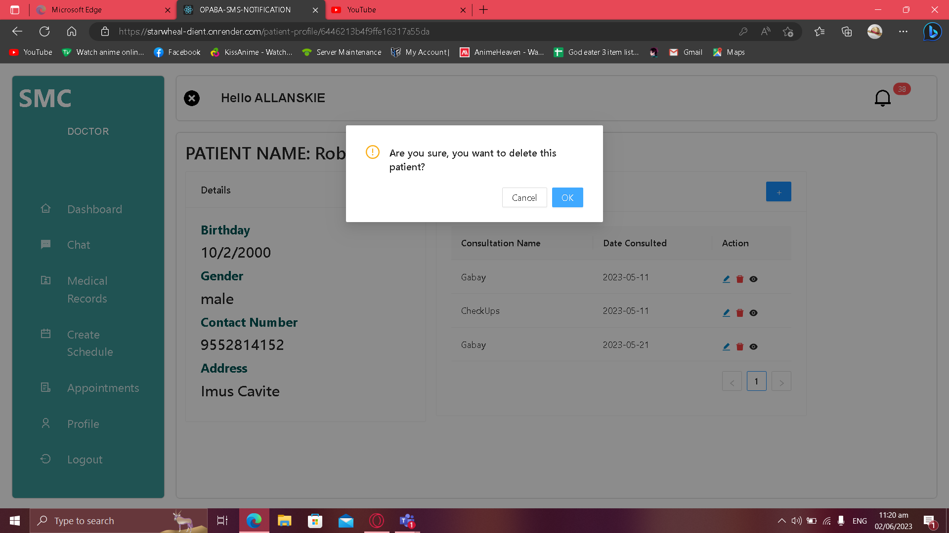

***Figure 36.***  Patient Record Screen Delete Confirmation Modal.

Figure 36. Shows a modal for confirming deletion of consultation data to avoid accidental deletion.

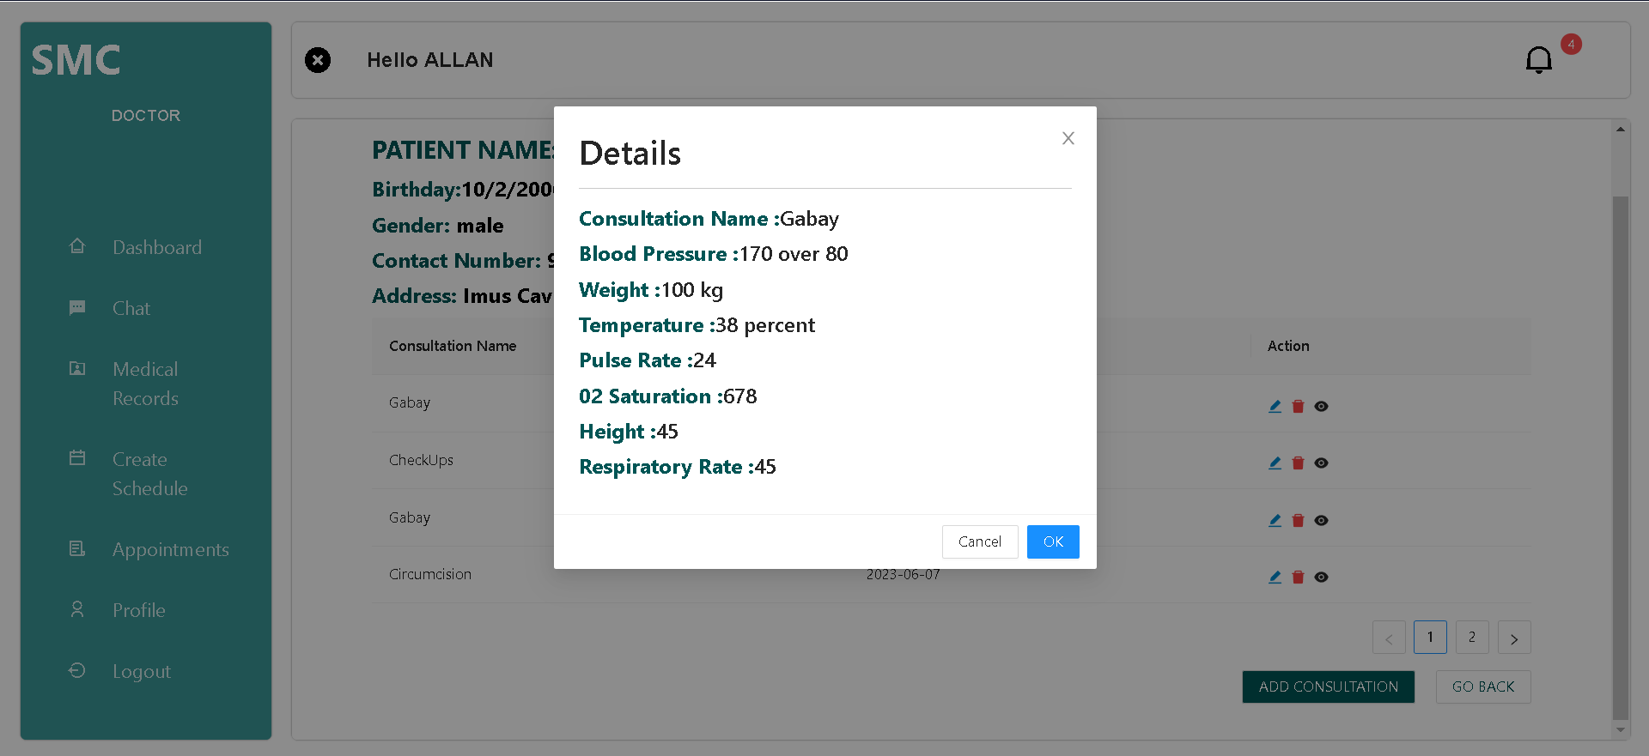

***Figure 37.*** Patient Record Screen Consultation Details Modal.

The patient’s Vital Statistics are displayed in the modal as shown in figure 37.

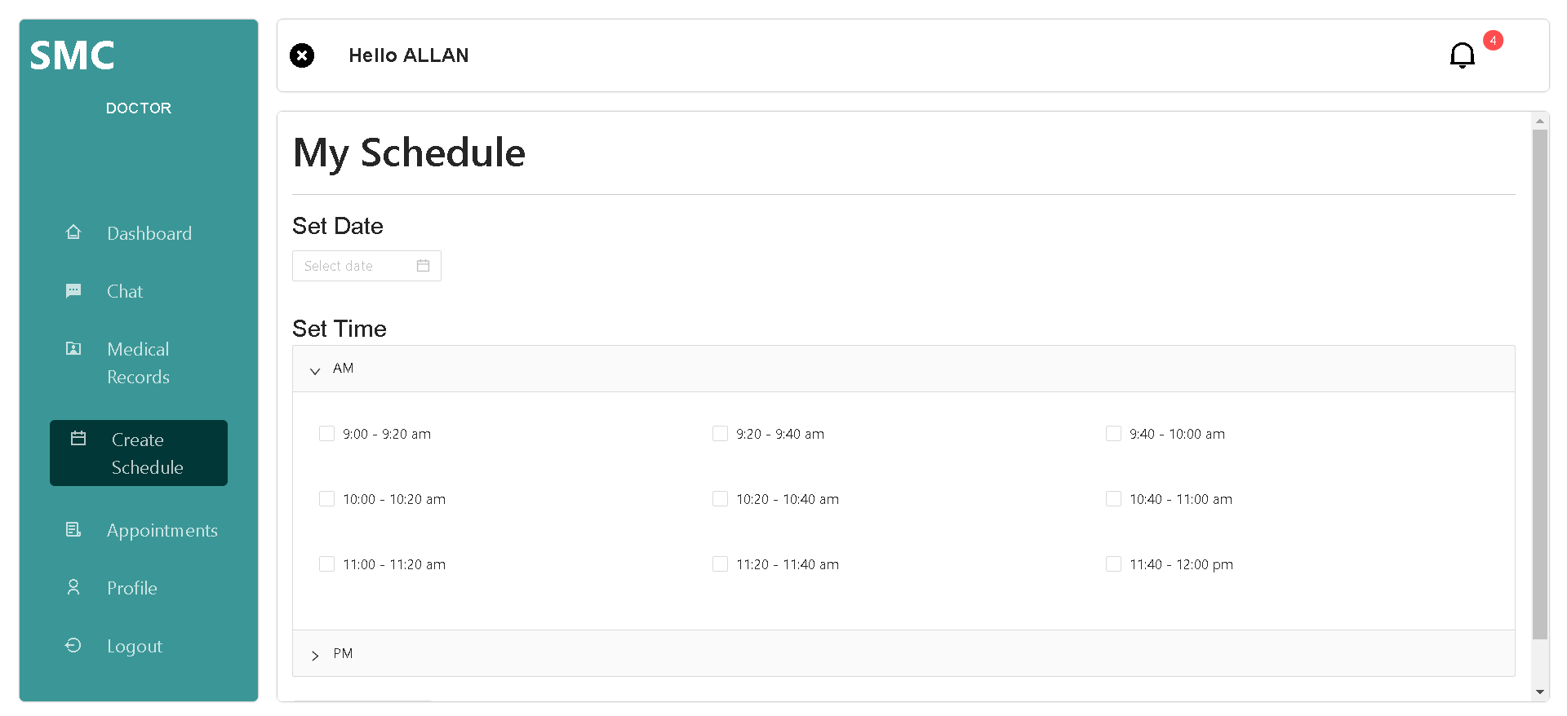

***Figure 38*.** Doctor Schedule screen.

This Figure 38 shows where the doctors can create their own schedule and they can choose the time and date of their preference.

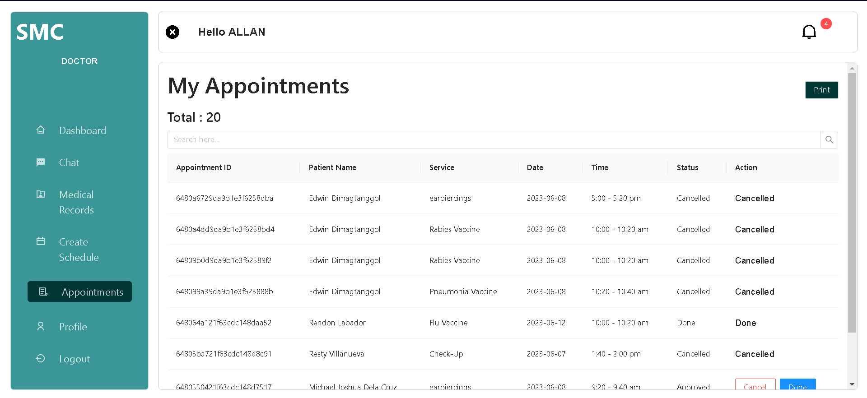

***Figure 39.*** Appointments History screen.

Figure 39 displays the history of appointments and data about those appointments made by the patients in that doctors’ account.

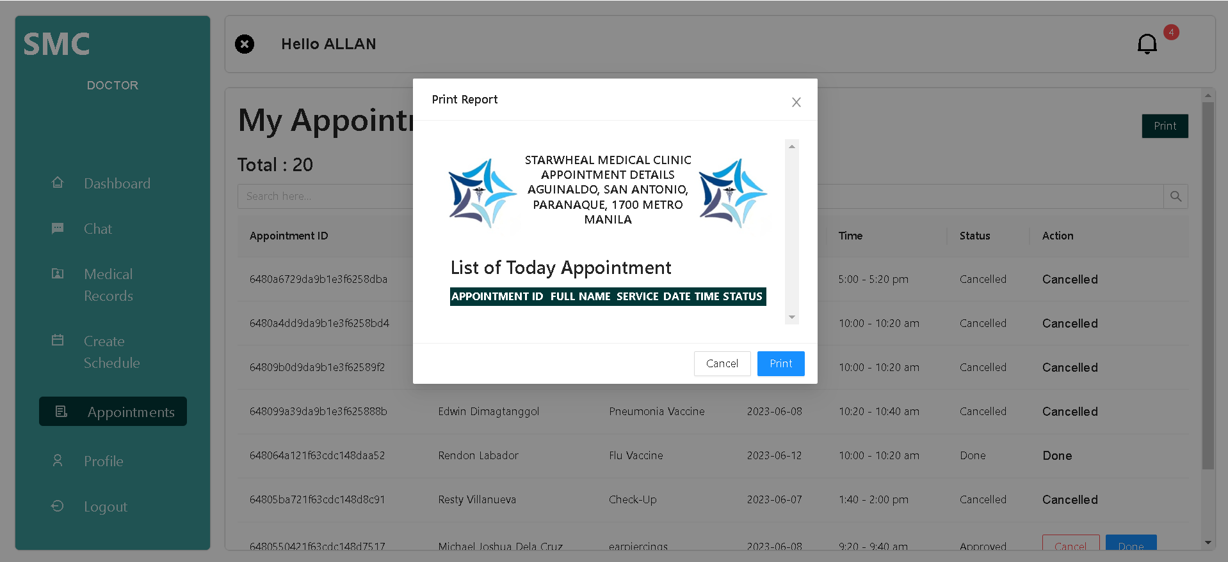

***Figure 40.*** Appointments History Screen Export Modal.

In figure 40 the export modal that shows when the export button is clicked can be seen, here the user can choose form printing the report or close the modal.

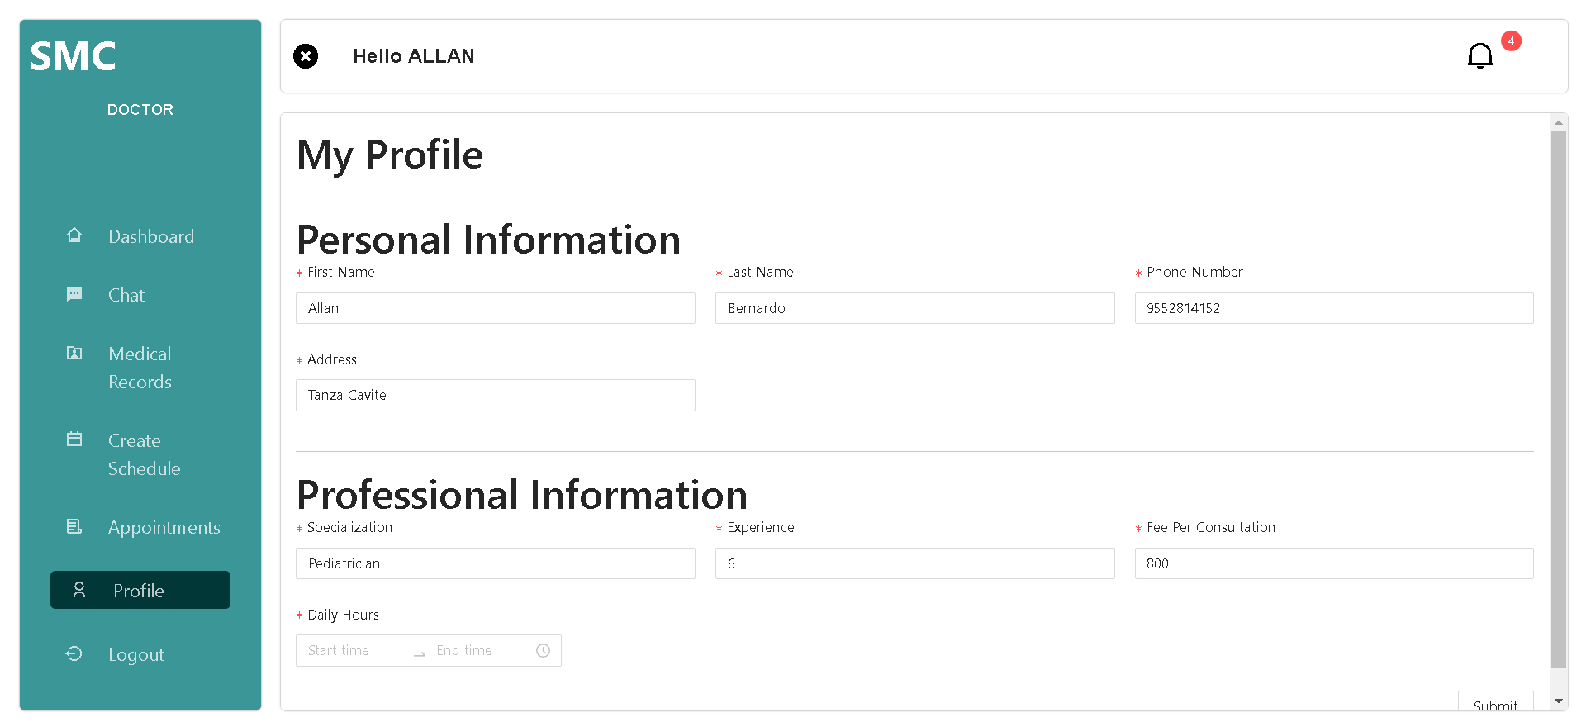

***Figure 41.*** Doctor Profile screen.

Figure 41 exhibits where the doctors can edit their account information like name, phone number or their Professional information like specialization and their fee.

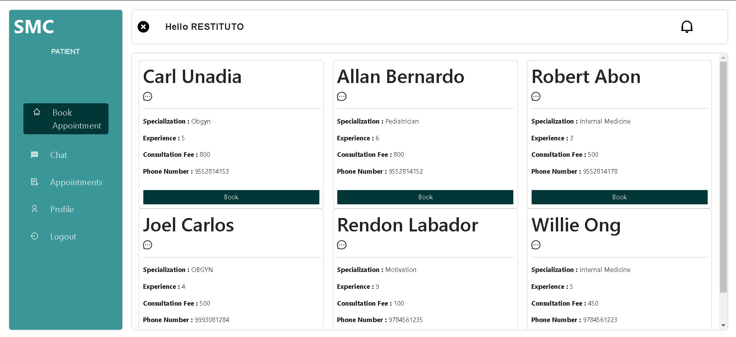

***Figure 42.*** Patient Home Screen.

This is where the patient can choose the doctor for their appointment with doctor information in figure 42.

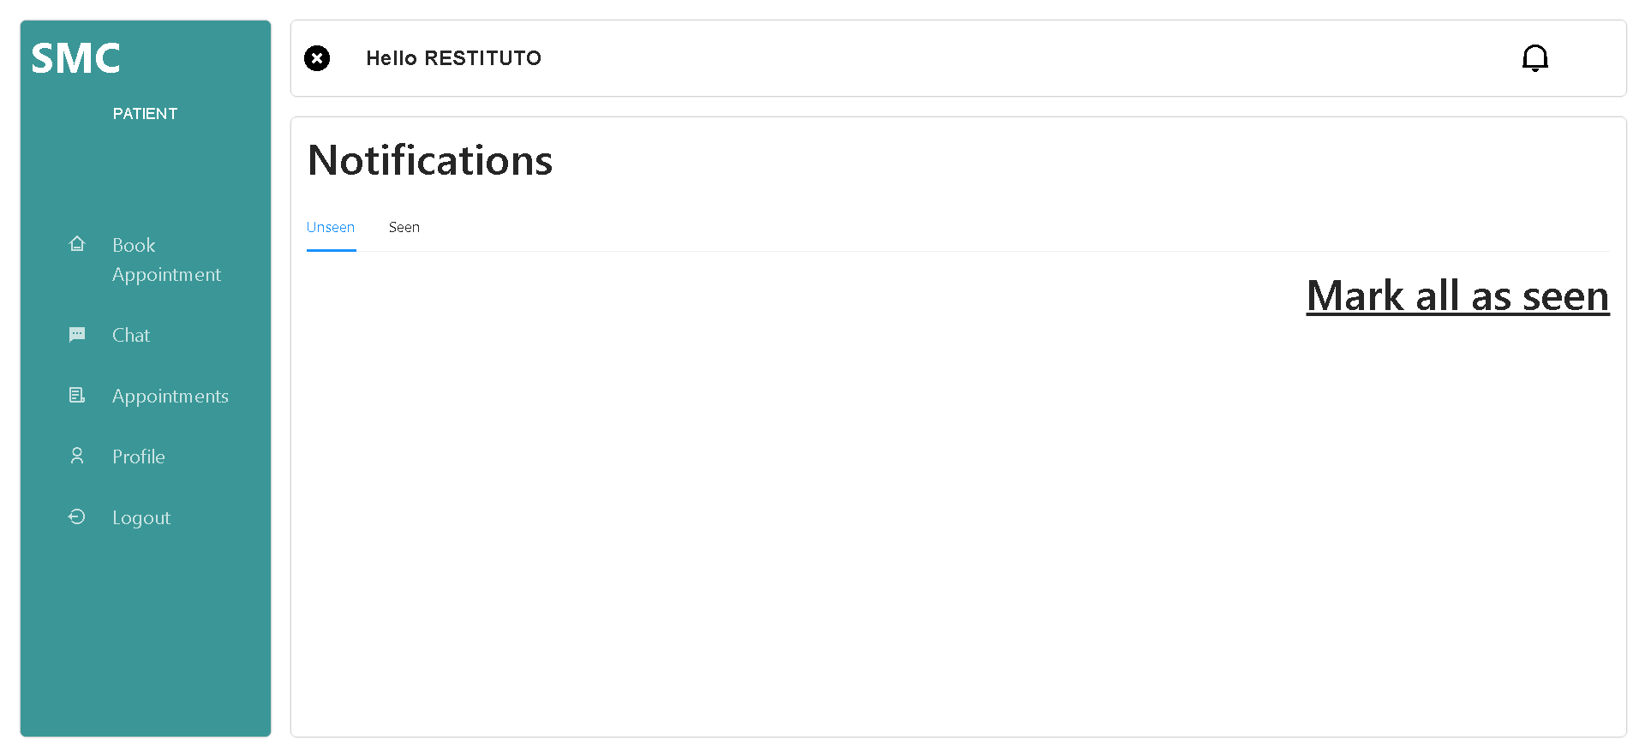

***Figure 43.*** Patient Notification Screen.

Figure 43 shows important notifications and latest updates about the appointments made by the current user.

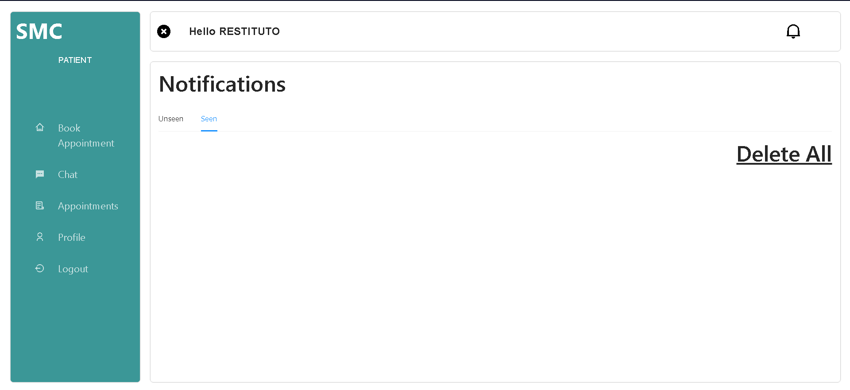

***Figure 44***. Patient Notification Seen Screen.

Seen notifications are displayed here; users can also delete the notifications here in figure 44.

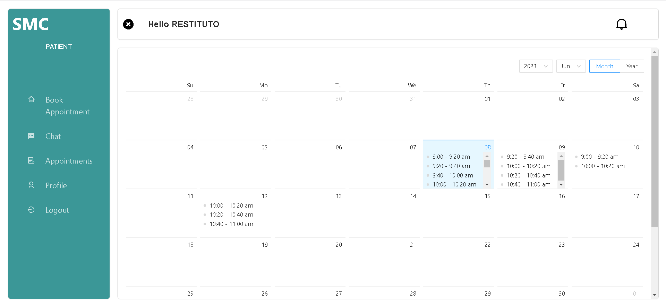

***Figure 45.*** Calendar Book Appointments screen.

Figure 45 shows a calendar which has information of when an Appointment can be made.

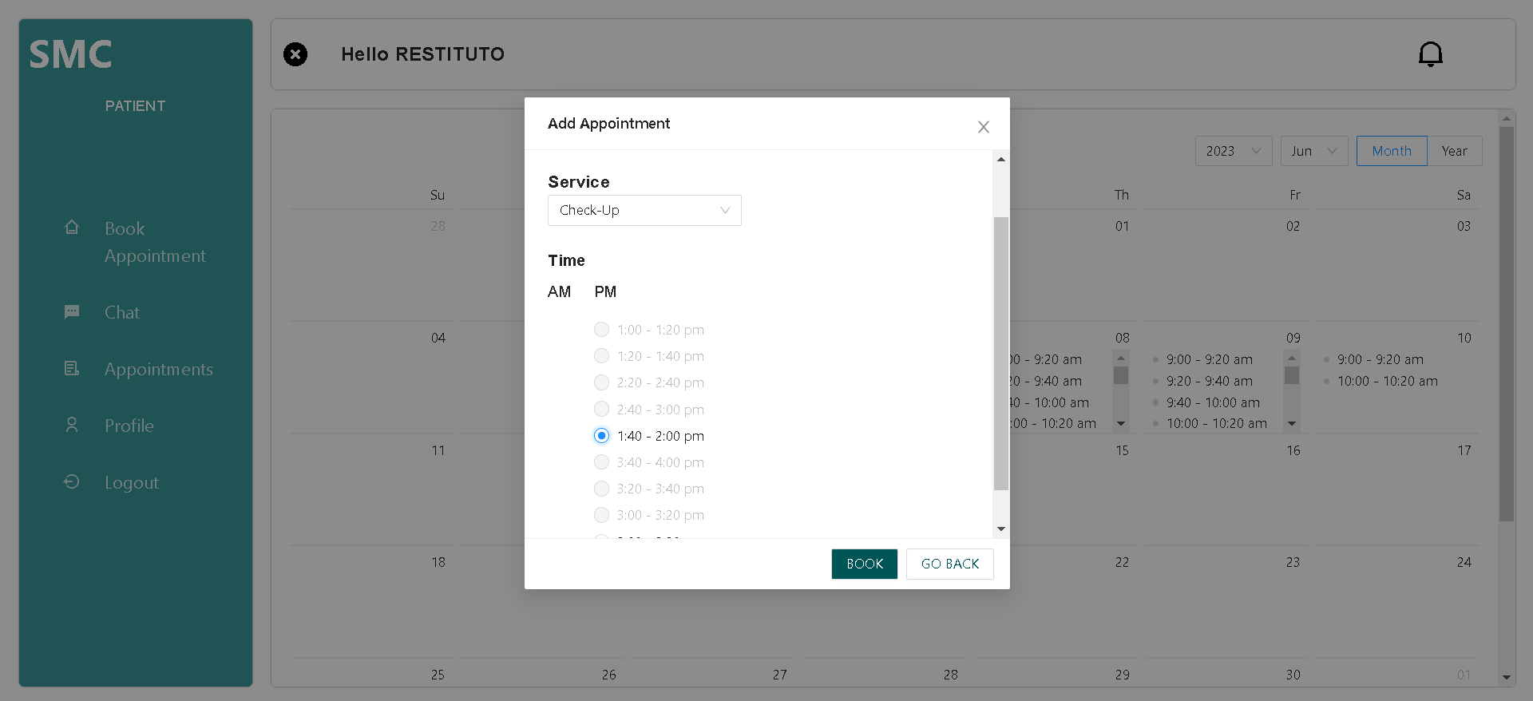

***Figure 46.*** Appointment Creation Modal.

After clicking the specific date, Figure 46 shows a popup where the patients can book what service they want and what time.

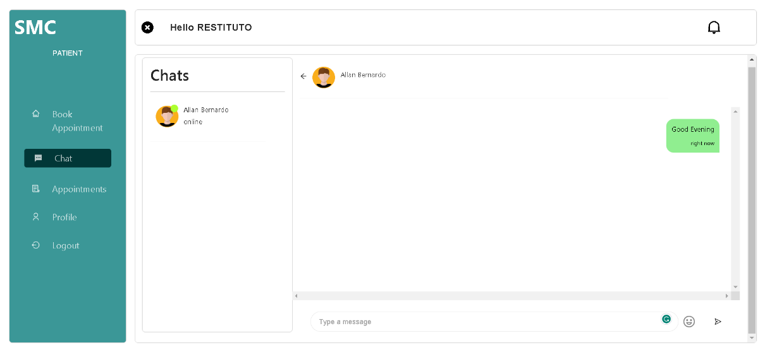

***Figure 47.*** Patient Chat Screen.

Figure 47 is about where patients can chat with the doctors and create a conversation.

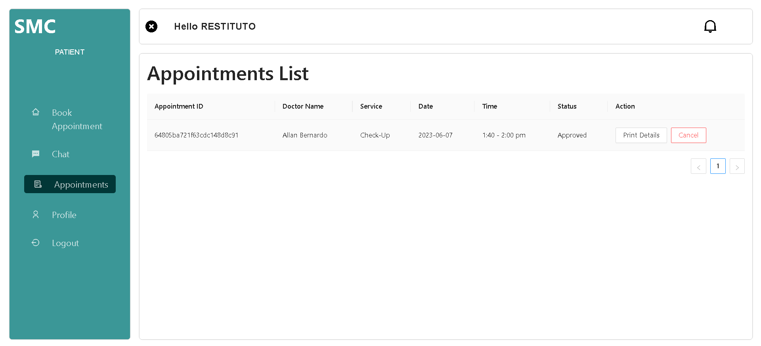

***Figure 48.*** Patient Appointment Status screen.

Figure 48 shows the status of patient created appointments here, the user can see the status of their appointment also, patients can cancel appointments by clicking the cancel button under the action column.

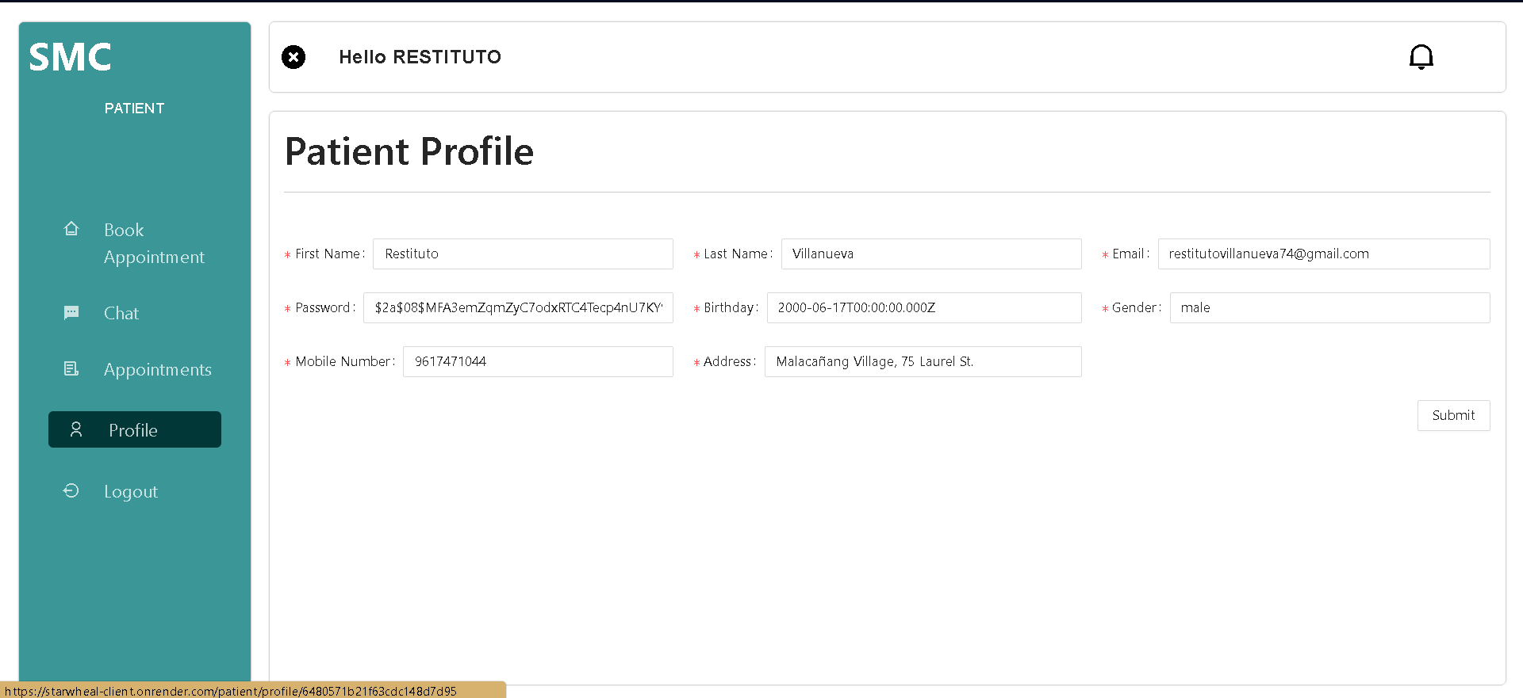

***Figure 49.*** Patient Profile screen.

Figure 49 shows where the patient users can update their profile information like personal data.

**Project Capabilities**

The following are the capabilities of the system:

1. The project application can book an appointment
2. The application can be accessed online through computer and mobile devices.
3. The application is capable of appearance customization.
4. The application is capable of managing doctor accounts.
5. The application is capable of sending SMS notifications before the actual appointment schedule.
6. The patients can create conversations with doctors using the chat feature of the system.
7. The application can create a schedule for the doctor’s appointment.
8. The application can store consultation history in medical records.

**Test Results**

This section summarizes the test results executed and the data collected based on the functionality and usability testing.

***Table 11.***

*Functionality and Usability Test Result*

**For Patient User**

|  |  |  |
| --- | --- | --- |
| **Modules** | **Steps to be taken** | **Observed Results** |
| 1. Register   (Functional Completeness)  (learnability) | 1. In login, click the register link.  2. Enter credentials. | New users and credentials are created and saved in the database. |
| 1. Login   (Functional Completeness)  (learnability) | 1. Enter the email and password. | System allows login if the entered credentials are correct |
| 1. Book Appointment   (Functional Correctness)  (operability) | 1. In the book appointment tab, click the “Book” button on specific doctors.  2. Choose a schedule and service.  3. Click book  4. Click “Proceed” | The screen is redirected to a calendar which displays available schedules.  Users choose their schedule and service.  Modal for appointment confirmation will show. |
| 1. Chat   (Functional Correctness)  (operability) | 1. In the appointment book tab, click the chat icon on specific doctors.  2. Click the textbox area and start a conversation.  3. Click the send button. | The screen will be redirected to the chat menu tab.  Users can create messages.  A conversation with a doctor has been made |
| 1. Appointments   (Functional Correctness)  (operability) | 1. Click the “Appointment” tab.  2. If the doctor approves the book appointment, “Print Details” will be shown.  3. Click the “Print Details” button. | Appointment details can be seen.  a pdf will be printed if the user clicked the print button. |
| 1. Profile   (Functional Appropriateness)  (appropriateness) | 1. Click the “Patient Profile” tab.  2. if the user wants to edit input the changes the user wants to change. | The screen will change to the Patient profile edit tab.  Users can input and edit patient information.  Patient Information is edited. |
| 1. Notifications   (Functional Completeness)  (operability) | 1. Click the bell icon in the upper right.  2. In the Unseen tab, click the “Mark all as seen” link.  3. In the Seen tab, click the “Delete All” link. | Users will be redirected to the notifications page to see notifications.  Notifications will be moved to the scene tab.  Notifications are deleted |
| 1. Logout   (Functional Completeness)  (learnability) | 1. Click the “Logout” tab | Users will be logged out. |

**For Doctor Users**

|  |  |  |
| --- | --- | --- |
| **Modules** | **Steps to be taken** | **Expected Output** |
| 1. Login   (Functional Completeness)  (learnability) | 1. Enter email and password provided by admin. | The user will be logged in and the screen will be changed to the doctor dashboard. |
| 1. Create Schedule   (Functional Correctness)  (operability) | 1. Click the “Create Schedule” tab.  2. Click the “Select date” and under the “Set time” check the boxes.  3. Click the submit button. | The schedule created will be displayed in the system calendar. |
| 1. Appointments   (Functional Correctness)  (operability) | 1. Click the Appointment tab.  2. In the end of the column named Action, click “Approve” or “Reject”.  2. Approved appointments can be marked as done or canceled. | Clicking approve or reject will change the appointment status to corresponding status.  Clicking Done will change the appointment to “Done” status and clicking cancel will cancel the appointment. |
| 1. Medical Records   (Functional Correctness)  (operability) | 1. Click the “Medical Records” tab.  2. Click the eye icon on the action's column.  3. Click the add icon on top of the list.  4. In the action column, click edit, delete, and view icon. | The screen will be changed to the medical records tab.  Record information will be seen.  New records are added.  existing records are either deleted, edited or seen. |
| 1. Notifications   (Functional Completeness)  (appropriateness) | 1. Click the bell icon in the upper right.  2. In the Unseen tab, click the “Mark all as seen” link.  3. In the Seen tab, click the “Delete All” link. | Users will be redirected to the notifications page, where they can see notifications.  Notifications will be moved to the seen tab.  Notifications are deleted |
| 1. Chat   (Functional Correctness)  (operability) | 1. Click the “Chat” tab.  2. Click the textbox area.  3. Click the send button. | Doctor users will see the patients that have conversations with them.  Doctors can create a reply.  Reply is sent. |
| 1. Profile   (Functional Appropriateness)  (appropriateness) | 1. Click the “Profile” tab.  2. Doctor users can change their account information.  3. Click submit. | It will redirect to the doctor's account and information is updated if the doctor users made changes. |
| 1. Logout   (Functional Completeness)  (operability) | 1. Click the “Logout” tab. | the doctor will be logged out. |

**For Admin**

|  |  |  |
| --- | --- | --- |
| **Modules** | **Steps to be taken** | **Expected Output** |
| 1. Login   (Functional Completeness)  (learnability) | 1. Enter default email and password. | Admin is logged into the system and the screen will change to homepage. |
| 1. Admin Dashboard   (Functional Completeness)  (navigation) | 1. Clicking View for more information on each listed database.  2. Hover in Patient demographic | Doctors will be redirected to Users list, doctor page, services page, by looking at the Patient demographics it will be able to show a list of today’s appointments, number of males, female senior, and child patients. |
| 1. Doctor Accounts   (Functional Correctness)  (operability) | 1. Click the “Doctors” tab.  2. Click the plus icon. | The screen will change to the Doctor accounts tab.  Modal will pop up for account creation. |
| 1. Patients Record   (Functional Correctness)  (operability) | 1. Click the “Patients” tab.  2. Click the “Edit” button  3. Click the “view” button | Patient’s accounts can be seen.  Modal will pop up for editing the patient information  Patient consultation history will be seen |
| 1. Clinic Services   (Functional Correctness)  (operability) | 1. Click the “Clinic Services” tab.  2. Click the plus icon.  3. Click the edit and trash icon in the last column named Action. | Screen changes to Clinic services tab.  Modal will pop up for service creation.  a new service is created.  edit modal will pop up.  existing service is edited.  delete modal will pop up.  a service will be deleted. |
| 1. System Customization   (Functional Correctness)  (accessibility) | 1. Click the “Customization” tab.  2. In the settings tab, click the “Choose file” and choose color from color picker. | user will be redirected to the customization tab.  users can choose an image to replace the logo.  logo is replaced.  the menu will change color. |
| 1. Logout   (Functional Completeness)  (learnability) | 1. Click the “Logout” tab. | admin will be logged out and will be redirected to the login page. |

**Project Evaluation**

The evaluation procedure was conducted using the standard criterion of ISO 25010 for quality software. The evaluation process involved 10 Information Technology professionals or developers, 10 StarWheal Medical Clinic Patients, 3 Doctors, and 2 Clinic staff. The following are the results of the evaluation of the WEB-BASED APPOINTMENT BOOKING SYSTEM WITH SMS FOR THE STARWHEAL MEDICAL CLINIC Application.

*ISO 25010 Overall Evaluation Results*

|  |  |  |
| --- | --- | --- |
| **Criteria** | **Mean** | **Qualitative Interpretation** |
| 1. Functional Suitability 2. Functional Completeness 3. Functional Correctness 4. Functional Appropriateness   *Criteria weighted mean* | 3.63  3.67  3.7  3.67 | Very Acceptable  Very Acceptable  Very Acceptable  Very Acceptable |
| 1. Performance Efficiency 2. Time Behavior 3. Accuracy 4. Capacity   *Criteria weighted mean* | 3.33  3.29  3.88  3.5 | Very Acceptable  Very Acceptable  Very Acceptable  Very Acceptable |
| 1. Compatibility 2. Coexistence 3. Interoperability   *Criteria weighted mean* | 3.46  3.67  3.57 | Very Acceptable  Very Acceptable  Very Acceptable |
| 1. Usability 2. Learnability 3. Operability 4. Appropriateness 5. User error protection 6. User interface aesthetics 7. Accessability   *Criteria weighted mean* | 3.58  3.71  3.67  3.96  3.71  3.67  3.72 | Very Acceptable  Very Acceptable  Very Acceptable  Very Acceptable  Very Acceptable  Very Acceptable  Very Acceptable |
| 1. Reliability 2. Maturity 3. Fault tolerance 4. Recoverability 5. Availability   *Criteria weighted mean* | 3.54  3.5  3.58  3.63  3.56 | Very Acceptable  Very Acceptable  Very Acceptable  Very Acceptable  Very Acceptable |
| 1. Maintainability 2. Analyzability 3. Modifiability   *Criteria weighted mean* | 3.5  3.42  3.46 | Very Acceptable  Very Acceptable  Very Acceptable |
| 1. Portability 2. Portability 3. Installability   *Criteria weighted mean* | 3.58  3.25  3.42 | Very Acceptable  Very Acceptable  Very Acceptable |
| 1. Security 2. Confidentiality 3. Integrity 4. Accountability   *Criteria weighted mean* | 3.46  3.33  3.54  3.44 | Very Acceptable  Very Acceptable  Very Acceptable  Very Acceptable |
| Overall | 3.54 | Very Acceptable |

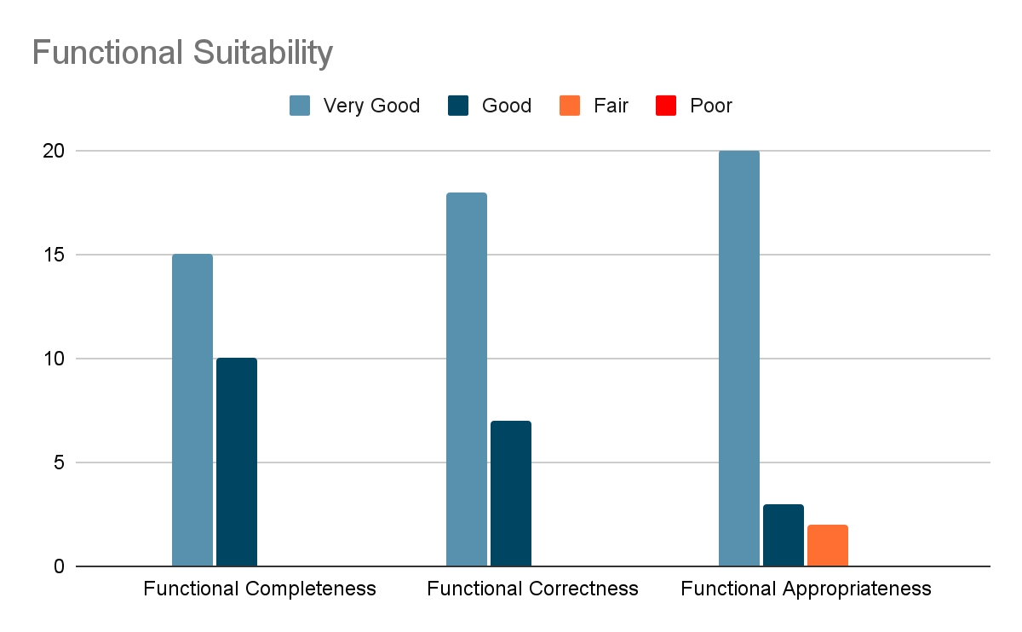

***Figure 50.*** Functional Suitability.

Figure 50 holds the graph for the result of functional suitability with 3.67 as the mean the application is evaluated as good which means that the application meets the standard stated by the ISO 2510.

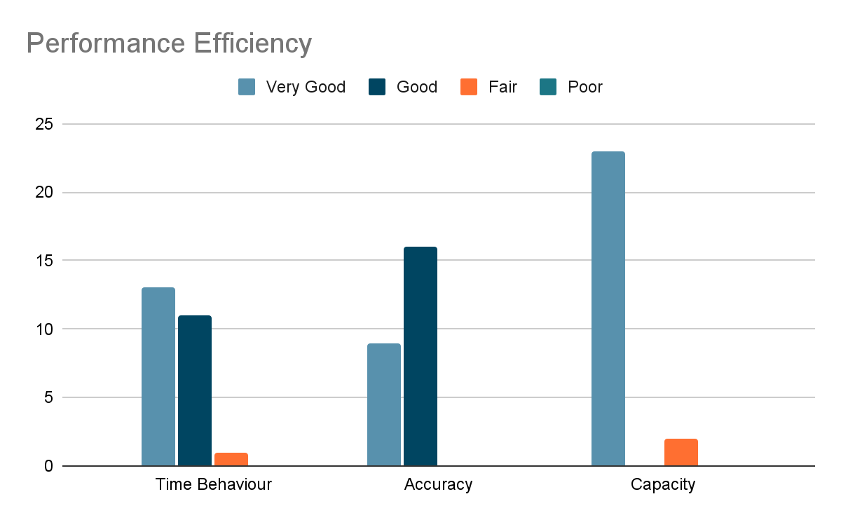

***Figure 51.*** Performance Efficiency.

Figure 51 shows the results of survey on performance efficiency it has a mean of 3.5 which means “Very Acceptable” in the evaluation and indicates that the application is accurate and has no lag issues.

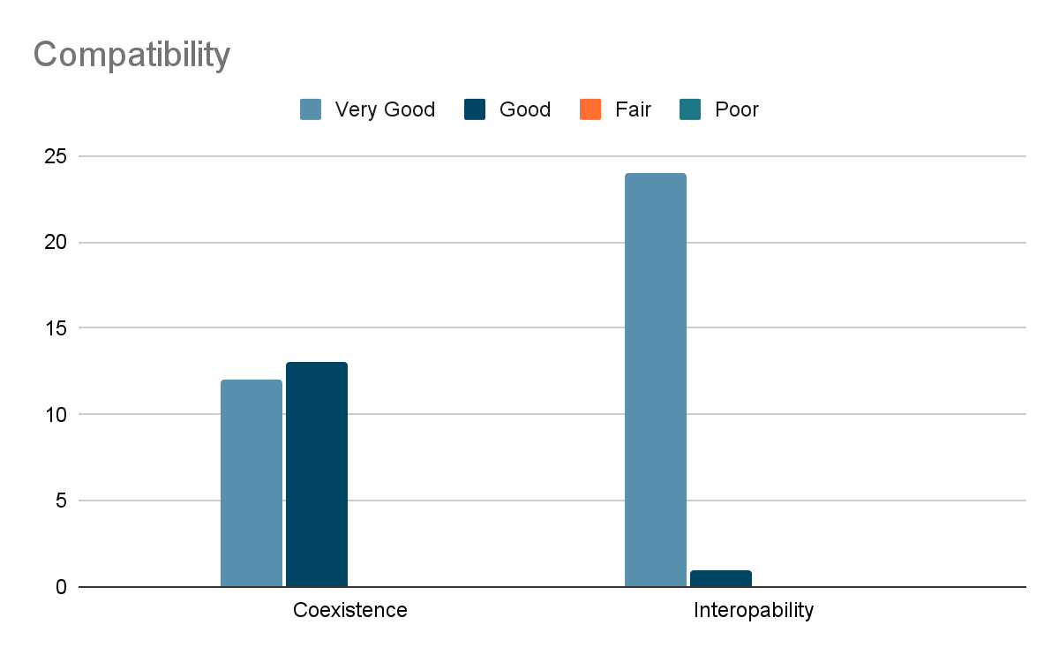

***Figure 52.*** Compatibility.

Figure 52 shows the result of compatibility. It has a mean of 3.73 which indicates that the application has good compatibility with the current system of the clinic.

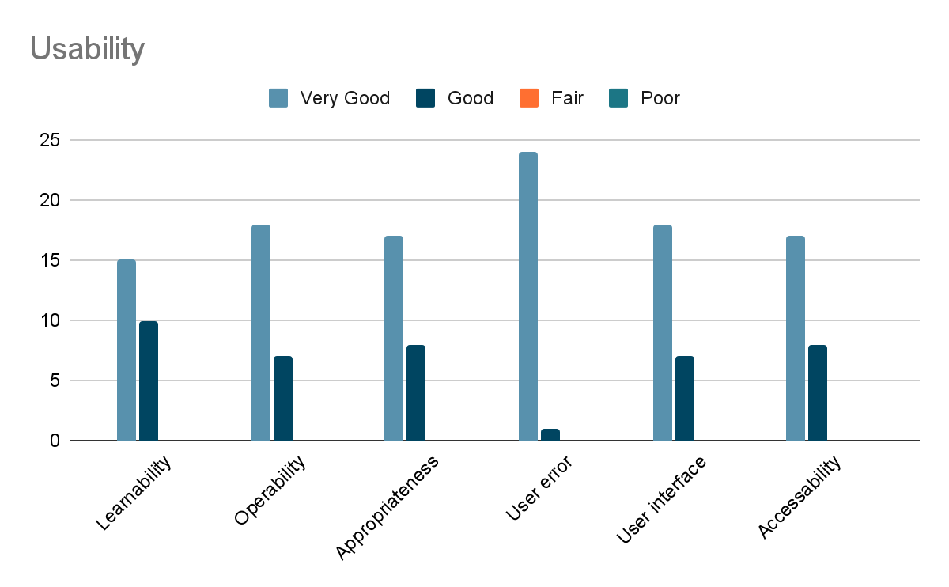

***Figure 53.*** Usability.

Figure 53 shows the usability graph results from the survey conducted. The results show 3.69 in mean and it indicates that it has Very Acceptable rating as per in Final Evaluation.

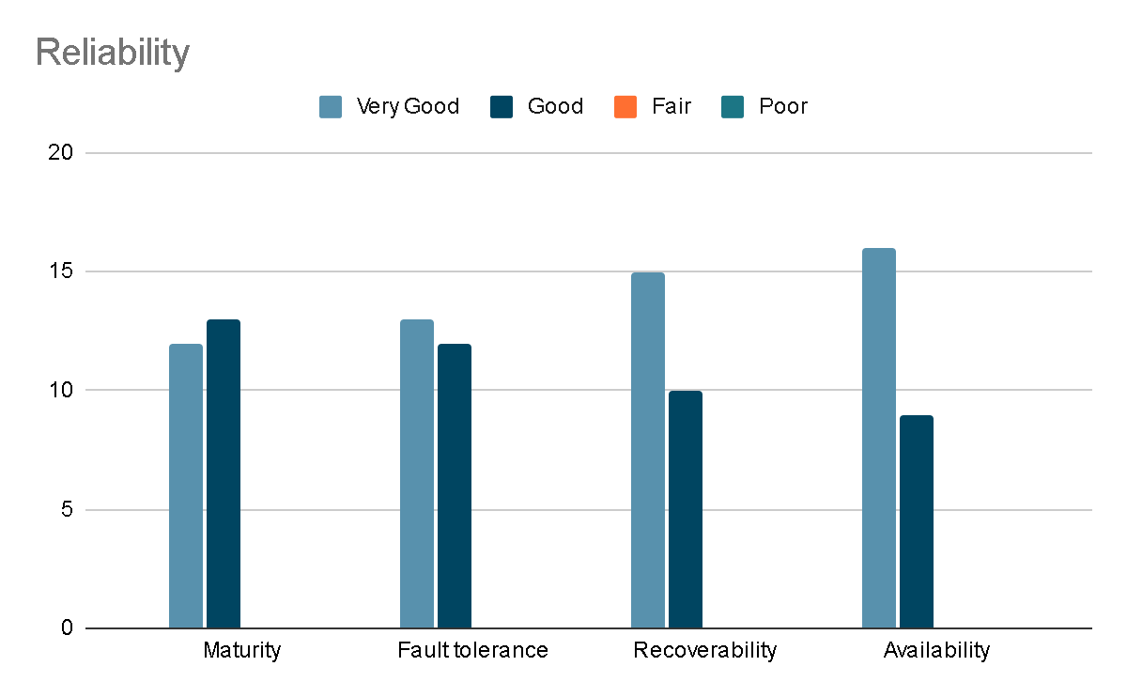

***Figure 54.*** Reliability

This figure shows the reliability graph from the survey done. It shows that the results are 3.56 in mean and that indicates that it has a Very Acceptable rating.

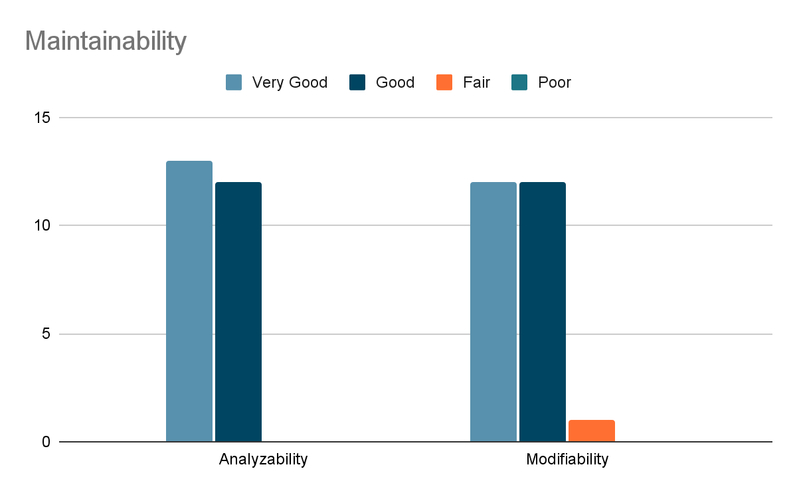

***Figure 55.*** Maintainability.

Figure 54 displays the result of the maintainability test on the system which has a mean of 3.42. This shows that the system can adapt to the changes it can face in the future.

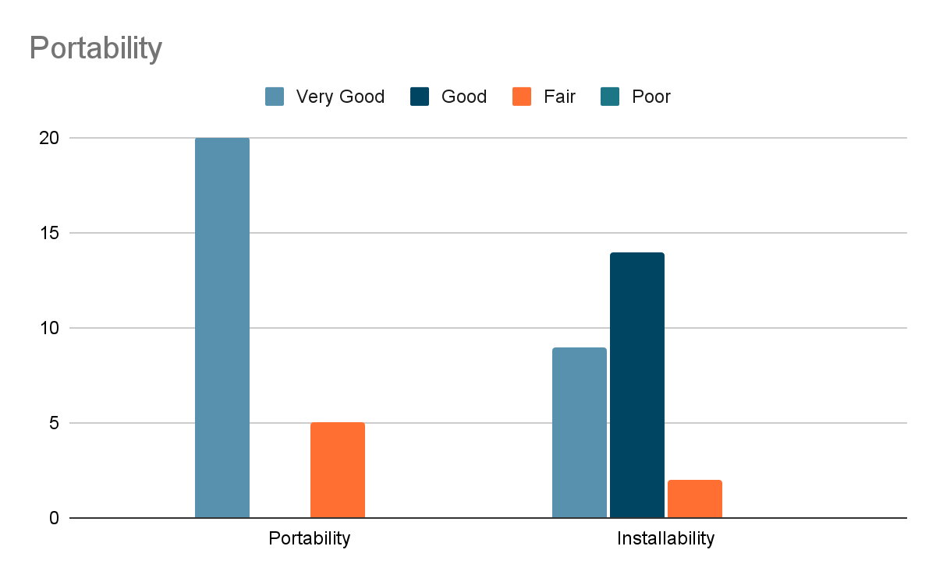

***Figure 56.*** Portability

Figure 55 contains the portability results. it has a mean 3.42 that indicates that the application can be used on many devices and runs normally.

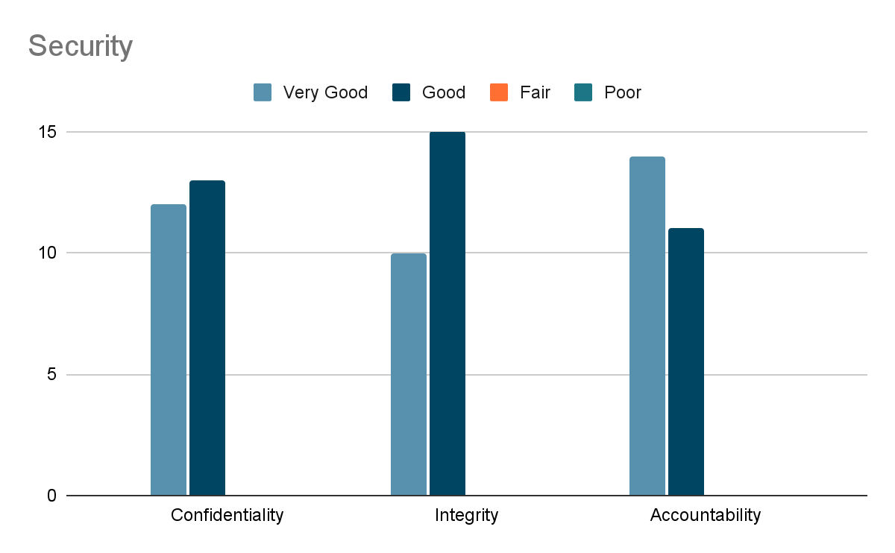

***Figure 57.*** Security.

Figure 56 has the results from security testing on the system which has the mean of 3.4 and it means that the user feels secured with the account features.

**Chapter 5**

**SUMMARY OF FINDINGS, CONCLUSION, AND RECOMMENDATION**

This chapter presents the summary of findings, conclusions, and recommendations based from the results of the evaluation, comments and suggestions.

**Summary of Findings**

According to the results of the tests that has been conducted to determine the Functional suitability and usability of the system the following were the findings of the study:

The Web-based application was developed with the intended tools and accomplished its intended features. the application enables patient users to book an appointment with the schedule created by the doctor users, the admin can create and control doctor accounts, services of the clinic and customize the appearance of the application. patients can also chat with doctors to ask questions. SMS are sent to patients on the day of their chosen appointment time. dashboards display the essential information. The application was tested with ISO 25010 and passed according to the survey.

On the basis of the data gathered in the ISO-25010 based evaluation, the study got the mean of 3.67 with a high rating of “Very Acceptable” specifically the study obtained:

* for functionality stability the study rated at the mean of 3.66 and rated Very Acceptable which means that the intended functionality has been met and is suitable.
* for usability, the application has the mean of 3.69, meaning that the users find the application easy to use and learn to use.

**Conclusions**

In consideration of the objectives of the study and results of the testing and evaluation undertaken, the following conclusions were derived:

1. The Web-based Booking Appointment System with SMS for the Starwheal Medical Clinic is being successfully designed with the following features:
   1. Login and Register feature.
   2. Display appointment list of doctors and patients.
   3. SMS notification for notifying patients of the day’s appointment.
   4. View and export appointment details.
   5. Clinic services management.
   6. Patient record management.
   7. Patient consultation History.
   8. Chat system.
   9. Dashboard for list of doctors, patients, clinic services, user accounts.
   10. Mobile Responsive
2. The system is being created using the following software development tools:
   1. ReactJS as scripting language
   2. NodeJS is the primary framework for creating a web-based system
   3. MongoDB for web-based system database
   4. SMS API for sending notification
   5. Bootstrap for user interface/experience designing
   6. CSS as primary tools for styling
   7. GitHub for code hosting platform and version control
   8. Postman for API testing
   9. VSCode as the primary integrated development environment
3. The functional suitability and usability of the system were tested and successfully improved.
4. The application performance was evaluated using ISO 25010 criteria, yielding an overall mean of 3.67.

**Recommendations**

The following suggestions for the improvement of the application are hereby provided for future enhancement in light of the study's findings and conclusions:

1. Record family members mostly if a baby or toddler (Pediatric Care) add info for parents.
2. Reminder setting to patient and doctor informing both A options like 1 day before etc.

**REFERENCES**

Friedman. V, (2018, August 11) *Responsive Web Design: What It Is And How To Use It.*

https://www.smashingmagazine.com/2011/01/guidelines-for-responsive-web-design/

Angelica, L. (2020, October 25). *What is Responsive Web App*. Mockitt Wondershare.

https://mockitt.wondershare.com/app-design/responsive-web-app.html#:~:text=A%20responsive%20web%20app%20refers,flexible%20layouts%2C%20grids%20and%20images.

Eysenbach, G. (2017, April 26). *Web-Based Medical Appointment Systems: A Systematic*

*Review* https://www.ncbi.nlm.nih.gov/pmc/articles/PMC5425771/

Labis, X. (2021, September 20). *What Can A Clinic Management System Do For Your*

*Business?* https://www.pxtrack.tech/clinic-management-system-business/

Mondayblog.com. (2021, May 20).*How management systems drive value in business operations.* https://monday.com/blog/project-management/management-systems/

Zola, A. (2022, November). *system of record (SOR).* https://www.techtarget.com/whatis/definition/system-of-record-SOR#:~:text=What%20is%20a%20system%20of%20record%20(SOR)%3F,multiple%20locations%20with%20remote%20access.

Lin, P. (2022, July 29) *The Complete Guide to Records Management System.* https://blog.timify.com/what-is-records-management-system/

Lemzy, A. (2021, February 9). SMS Notifications and Push Notifications: What’s the Difference? https://www.textmagic.com/blog/sms-notifications-and-push

-notifications/

Mahnaz S. (2018, March). *Assessing the Online Outpatient Booking System. https://brieflands.com/articles/semj-60249.html*

Ismail N. (2017, October). *MEDICAL APPOINTMENT APPLICATION.* https://www.actaelectronicamalaysia.com/archives/AEM/2017-issue2/2aem2017-05-09.pdf

Zadeh N. (2021, July 06). *How Online Medical Appointment Booking System Can Help Clinics Survive?* https://www.booknetic.com/blog/online-medical-appointment-booking-system

Jebamani, J, R. Murugeswari, P. Nagaraj. (2021, 0ctober). *Online Appointment Management System in Hospitals Using Distributed Resource Allocation Algorithm. https://link.springer.com/chapter/10.1007/978-981-16-5157-1_23*

Alaa Q , Trevor B.nd*. Online Appointment Management System.* http://worldcomp-proceedings.com/proc/p2011/EEE4303.pdf

Surve, S. (2021, February 18). *Why You Should Use React.js For Web Development.* https://www.freecodecamp.org/news/why-use-react-for-web-development/

Seferian, D (2022, October 22). *SMS Notifications: A Quick Look.* https://dexatel.com/blog/sms-notification/

Herbert, D. (2022 , June 27). *What is React.js? (Uses, Examples, & More).* https://blog.hubspot.com/website/react-js

Miles, S. (2022, October 31.). *What are the benefits of a quality management system?* https://www.ideagen.com/thought-leadership/blog/what-are-the-benefits-of-a-quality-management-system-the-do-s-and-don-ts-to-keep-in-mind

MDN Web Docs, 2022. CSS. Retrieve from 22, https://developer.mozilla.org/en-US/docs/Web/CSS

MDN Web Docs, 2022. ExpressJs. Retrieve from 2022, https://developer.mozilla.org/en-US/docs/Learn/Server-side/Express_Nodejs

MDN Web Docs, 2022. NodeJS. Retrieve from 2022, https://developer.mozilla.org/en-US/docs/Learn/Server-side/Express_Nodejs/Introduction

MongoDB. MongoDB. https://www.techtarget.com/searchdatamanagement/definition/MongoDB

Rauch, G. (2021). Socket.IO and Express.js. In: Pro Express.js. Apress, Berkeley, CA. https://doi.org/10.1007/978-1-4842-0037-7_16

Semaphore. (2023, May 15). Retrieve from https://blog.semaphore.co

Picincu, A. (2020, July 27). *What Are the Advantages of a Good Records Management System?.*https://smallbusiness.chron.com/introduce-records-management-organization-40026.html

Laukkonzen, J. (2022, October 30). *What Is a Notification System?.* https://www.easytechjunkie.com/what-is-a-notification-system.html

Nock, B. (2017, May 31). *What Is a Medical Practice Management System?.* https://www.gebauer.com/blog/medical-practice-management-system

Joseph, B., Gadzama, W., and Ngubdo, M (2020, March). *Design and Implementation of a Secured Web based Medical Record Management System: A Case Study of Federal University Wukari (FUW) Clinic*. International Journal of Computer Applications (0975 – 8887)Vol 177–No.41,. https://www.researchgate.net/profile/Bitrus-Joseph/publication/339986311_Design_and_Implementation_of_a_Secured_Web_based_Medical_Record_Management_System_A_Case_Study_of_Federal_University_Wukari_FUW_Clinic/links/5e82ec3c458515efa0bc1779/Design-and-Implementation-of-a-Secured-Web-based-Medical-Record-Management-System-A-Case-Study-of-Federal-University-Wukari-FUW-Clinic.pdf

Teke, A., Londh, S., Oswal, P (2019, February). Online Clinic Management System. INTERNATIONAL JOURNAL OF ADVANCE SCIENTIFIC RESEARCH AND ENGINEERING TRENDS. http://www.ijasret.com/VolumeArticles/FullTextPDF/317_1.Online_Clinic_Management_System.pdf

Indeed Editorial Team (2022, October 13). *What Is Records Management? (With Benefits and Life Cycle).* https://www.indeed.com/career-advice/career-development/records-management

Stephens, T. (2020, July 16). *The Importance of Electronic Health Records.* https://jindal.utdallas.edu/blog/importance-electronic-health-records/

Rotmensch, M., Halpern, Y., Tiamat, A., et al (2017, July). *Learning a Health Knowledge Graph from Electronic Medical Records.* Scientific Reports. https://link.springer.com/content/pdf/10.1038/s41598-017-05778-z.pdf

Zhao, Y., Liu, L., Qi, Y. et al (2019, November 16). *Evaluation and design of public health information management system for primary health care units based on medical and health information. Journal of Infection and Public Health.* https://reader.elsevier.com/reader/sd/pii/S1876034119303429?token=6F0BB4520246FA407356E21A5A133CF4C39D71CEBEFE8C6B78413C7DFDFCB7BAF0502742C618E6280AF2B643E725E393&originRegion=us-east-1&originCreation=20221211064126

Nilsson E, Sverker A, Bendtsen P, Eldh A (2021, October). *A Human, Organization, and Technology Perspective on Patients’ Experiences of a Chat-Based and Automated Medical History–Taking Service in Primary Health Care: Interview Study Among Primary Care Patients.* J Med Internet Res 2021;23(10):e29868

URL: https://www.jmir.org/2021/10/e29868

DOI: 10.2196/29868

C. Cressler. (2021, June 14). Understanding The Architecture & System Design Of A Chat Application. https://www.cometchat.com/blog/chat-application-architecture-and-system-design

C. Robinson. (2022, December 17). What is Live Chat Software? Analysis of Features, Benefits and Pricing. https://financesonline.com/live-chat-software-analysis-features-benefits-pricing/#benefits

**Appendix A**

**SAMPLE EVALUATION TEST**

**SOFTWARE EVALUATION INSTRUMENT OF ISO 25010**

**WEB-BASED APPOINTMENT BOOKING SYSTEM WITH SMS FOR THE STARWHEAL MEDICAL CLINIC**

Email: ______________________________________________________________

Name: ______________________________________________________________

Occupation: __________________________________________________________

Date today: __________________________________________________________

Good day! We are the students from BSIS - 4A STEM and we will conduct this survey questionnaire to determine the satisfaction of the users from using our Web-based Appointment Booking System with SMS for the Starwheal Medical Clinic.

**4 -** Excellent **3** - Good **2** - Bad **1** - Worst

|  |  |  |  |  |
| --- | --- | --- | --- | --- |
| 1. **Functional Suitability** | | | | |
| Questionnaire | **4** | **3** | **2** | **1** |
| The Application attained the intended functionalities by making setting up an appointment easier, recording the patients appointments, creating schedule for doctors customizing system appearance for admin . |  |  |  |  |
| The application performs the functions intended like for the login and log out and dashboards. |  |  |  |  |
| The application meets the need of the patients and the clinic through the intended features. if it indeed meet the specific need please type "none" and if there is need to improve please state the suggestions |  | | | |

|  |  |  |  |  |
| --- | --- | --- | --- | --- |
| 1. **Performance Efficiency** | | | | |
| Questionnaire | **4** | **3** | **2** | **1** |
| The application's response and process runs smooth and have no delay. |  |  |  |  |
| The application process, data and reponses are accurate |  |  |  |  |
| The user is not experiencing an performance if there is no issues type "None" and if there is any please state so. |  | | | |

|  |  |  |  |  |
| --- | --- | --- | --- | --- |
| 1. **Compatibility** | | | | |
| Questionnaire | **4** | **3** | **2** | **1** |
| The users can use the application anytime and anywhere or whenever they need it. |  |  |  |  |
| The application can be integrated to the clinic's current system. |  |  |  |  |
| The application can completely replace the system of the clinic. |  |  |  |  |

|  |  |  |  |  |
| --- | --- | --- | --- | --- |
| 1. **Usability** | | | | |
| Questionnaire | **4** | **3** | **2** | **1** |
| The application is simple and easy to learn. |  |  |  |  |
| The application is easy to navigate trough its different modules. |  |  |  |  |
| The application is user friendly and users does not experience any hardships in using the application. |  |  |  |  |
| The application does not require any technical skills or training in order to operate. |  |  |  |  |
| The application's visuals and designs delivers satisfaction to users experience. |  |  |  |  |
| Depending on how they utilize the mobile application, people with varied abilities can use it to achieve a certain goal. |  |  |  |  |

|  |  |  |  |  |
| --- | --- | --- | --- | --- |
| 1. **Reliability** | | | | |
| Questionnaire | **4** | **3** | **2** | **1** |
| The application is attaining the needs of reliabilty during operation |  |  |  |  |
| the users can use the application even in the event that issues arrises during operating time. |  |  |  |  |
| In event of failure the system can recover the data affected in time of the failure. |  |  |  |  |
| The users can use the application anytime and anywhere or whenever they need it. |  |  |  |  |

|  |  |  |  |  |
| --- | --- | --- | --- | --- |
| 1. **Maintainability** | | | | |
| Questionnaire | **4** | **3** | **2** | **1** |
| The application can adapt to any updates like improvements and changes. |  |  |  |  |

|  |  |  |  |  |
| --- | --- | --- | --- | --- |
| 1. **Portability** | | | | |
| Questionnaire | **4** | **3** | **2** | **1** |
| The application can be used in different devices. |  |  |  |  |
| The Application runs smoothly even in different devices. |  |  |  |  |

|  |  |  |  |  |
| --- | --- | --- | --- | --- |
| 1. **Security** | | | | |
| Questionnaire | **4** | **3** | **2** | **1** |
| The users data is secured and kept confidential in the system is attained by features like login and register and also the doctor account creation |  |  |  |  |
| The Application is secured against unauthorized access |  |  |  |  |
| The users data is secured and kept confidential in the system is attained by features like login and register and also the doctor account creation. |  |  |  |  |

**Appendix B**

**DOCUMENTATION**

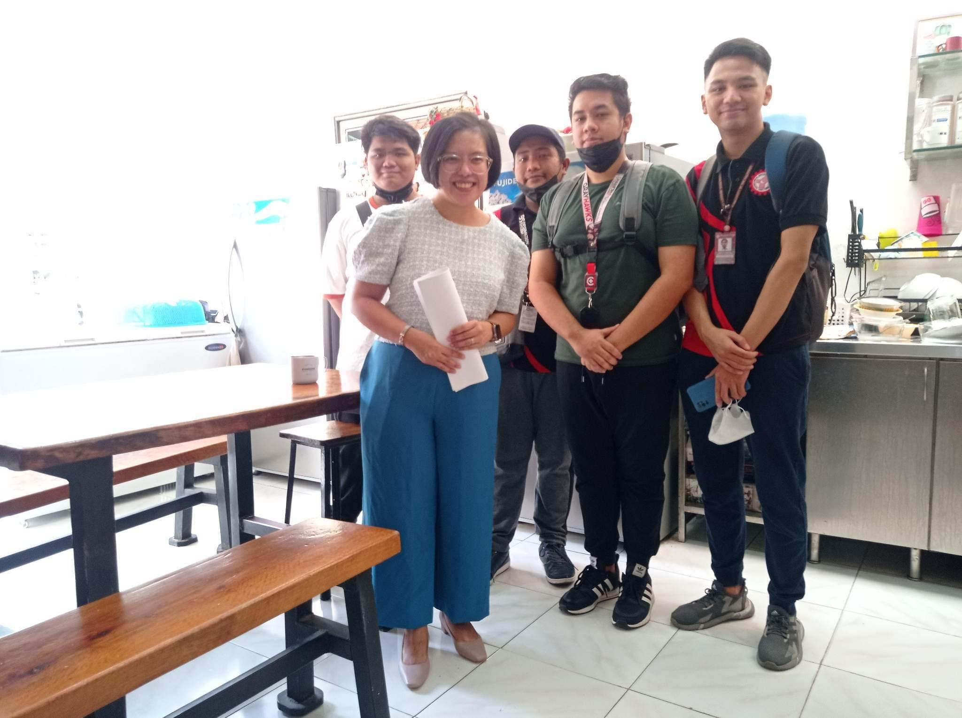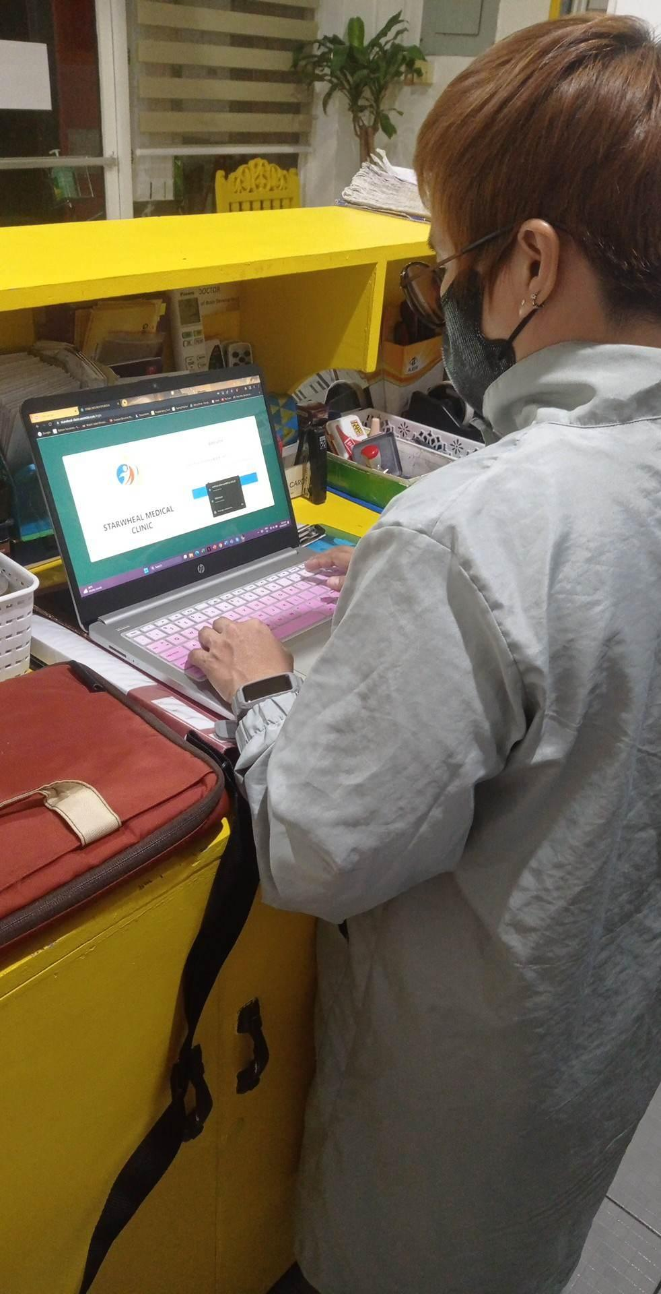

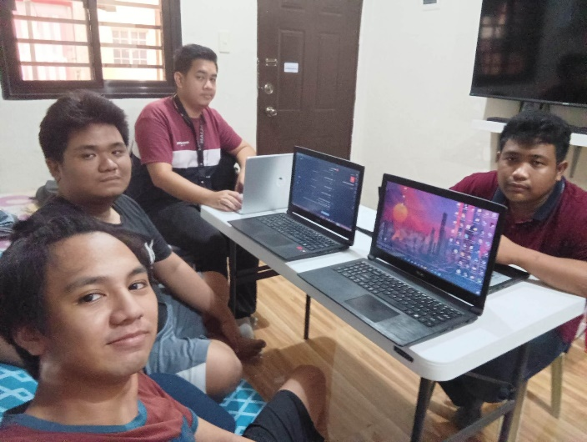

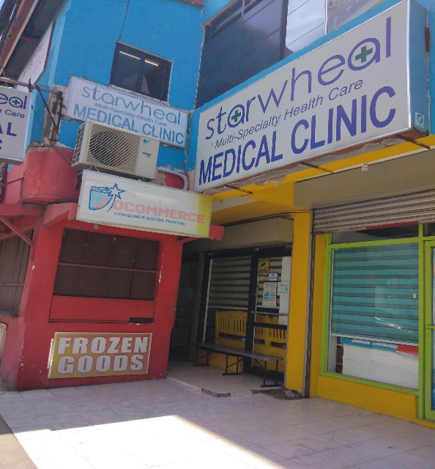

**Appendix C**

**CORRESPONDENCE**

June 6, 2023

Dear Respondent

I hope this letter finds you in good health. I am writing to express our sincere appreciation for your participation as a respondent in the development of the web-based appointment booking system with SMS for the Starwheal Medical Clinic. Your valuable insights and feedback have been instrumental in shaping the system to meet the specific needs of the clinic and its patients.

We are delighted to inform you that the development of the appointment booking system has been successfully completed. The system is designed to streamline the appointment scheduling process, improve patient experience, and enhance the overall efficiency of the clinic's operations.

With the web-based appointment booking system, patients will have the convenience of accessing the clinic's schedule online and selecting their preferred appointment slots. The system also incorporates SMS notifications, ensuring that patients receive timely reminders and updates regarding their appointments.

We would like to extend an invitation to you as a valued respondent to be among the first users of the system. Your involvement will provide us with valuable insights into the system's usability and effectiveness, allowing us to make any necessary refinements before its official launch.

To facilitate your transition to the new system, we would like to schedule a training session exclusively for you. During this session, our team will guide you through the features and functionalities of the web-based appointment booking system, ensuring that you are comfortable and confident in utilizing its capabilities.

We deeply appreciate your commitment and collaboration throughout the development process. Your expertise and input have significantly contributed to the success of the web-based appointment booking system, and we are excited to have you as one of our early users.

Thank you once again for your valuable participation. We look forward to hearing from you soon and scheduling the training session at your earliest convenience.

Warm regards,

**RESTITUTO JR G. VILLANUEVA**

**Appendix D**

**PROFILE OF RESPONDENTS**

|  |  |  |
| --- | --- | --- |
| **Respondent**  **No.** | **Name** | **Profession** |
| 1 | Arsenio Cortez, Jr. | Doctor |
| 2 | Jepoy Catangay | Patient |
| 3 | Jennelyn Nonato | Clinic Staff |
| 4 | Francisco Gualin | Patient |
| 5 | Restituto Villanueva | Clinic Staff |
| 6 | Eisenn Diego | Patient |
| 7 | Reynier John | IT Professional |
| 8 | Rhui Vega | Patient |
| 9 | Rommuel Cruz | Patient |
| 10 | Arvin M. San Miguel | IT Professional |
| 11 | Christine Munar | IT Professional |
| 12 | Neil Castro | IT Professional |
| 13 | Leal Liwanag | IT Professional |
| 14 | Jenalyn Clemente | Doctor |
| 15 | Fagee Cortez | Doctor |
| 16 | Camille Torres | IT Professional |
| 17 | Via Nicole | IT Professional |
| 18 | Karen Cruz | Patient |
| 19 | Clifford Sanchez | IT Professional |
| 20 | Kevin hacildo | Patient |
| 21 | Marco Vikorovski | IT Professional |
| 22 | Carl Acejo | IT Professional |
| 23 | Rigel Aragon | Patient |
| 24 | heidilyn gualin | Patient |
| 25 | Anabel Abon | Patient |

# **Appendix E**

**SAMPLE USABILITY TEST INSTRUMENTS**

WEB-BASED APPOINTMENT BOOKING WITH SMS FOR THE STARWHEAL MEDICAL CLINIC

**For Patient User**

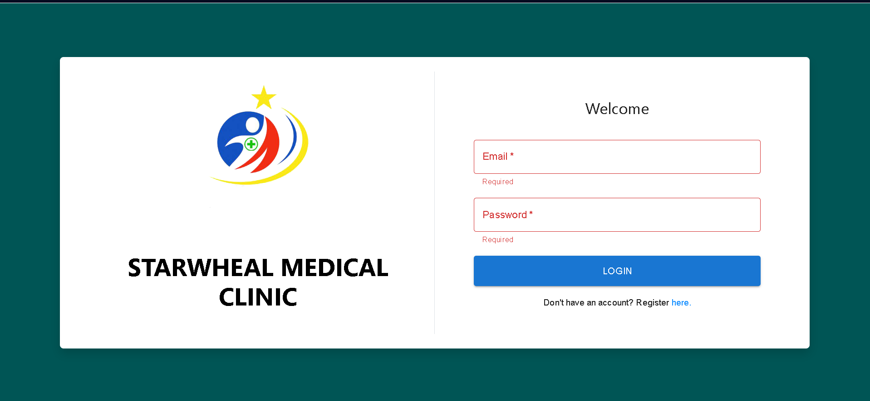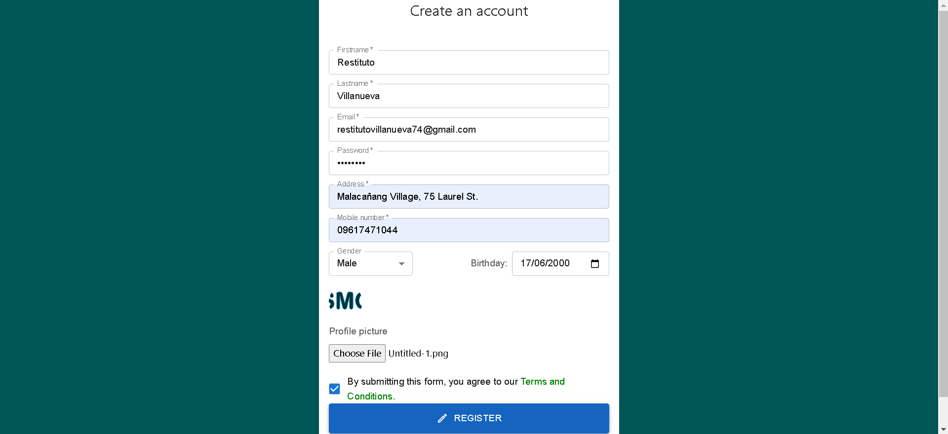 

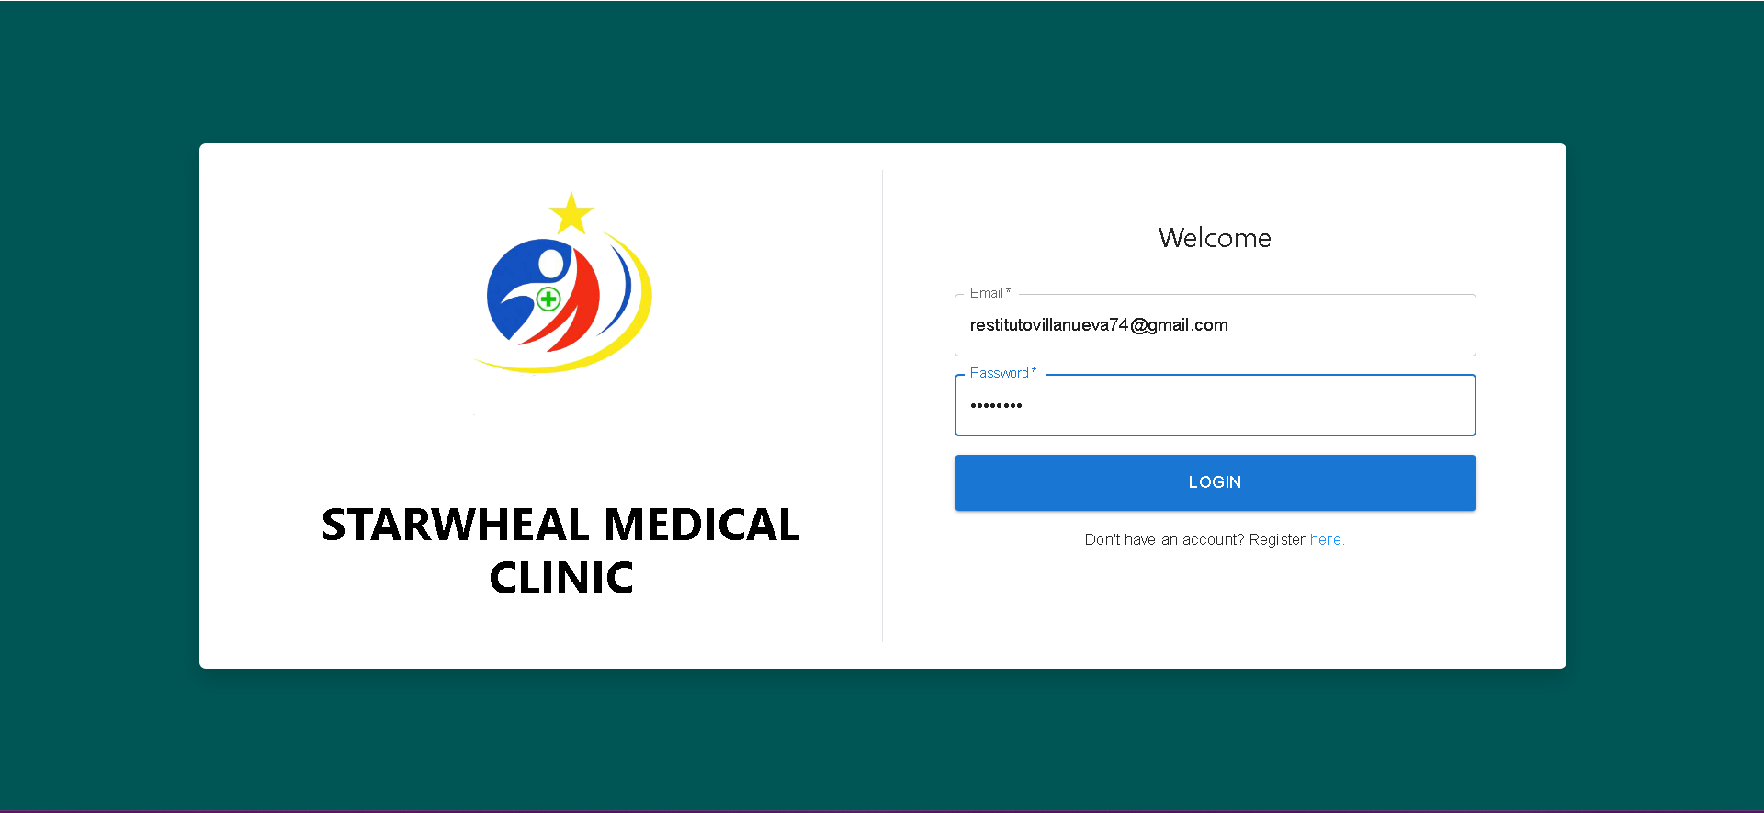



***Figure 58.*** Web application usability test result on Login Page



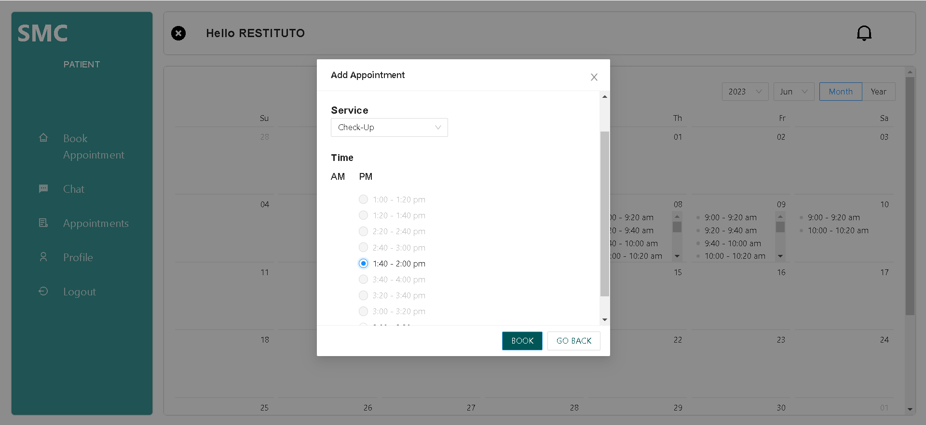

***Figure 59.*** Web application usability test result on Book Appointment page.

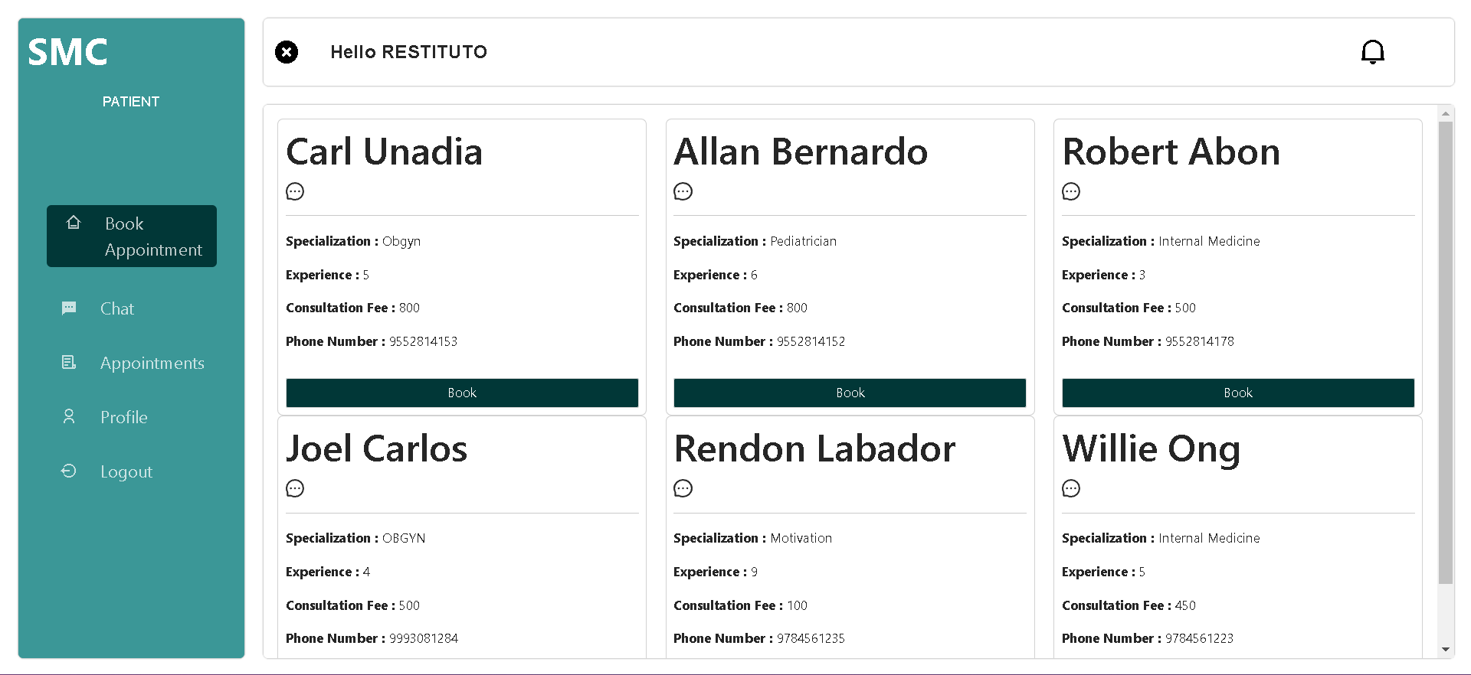

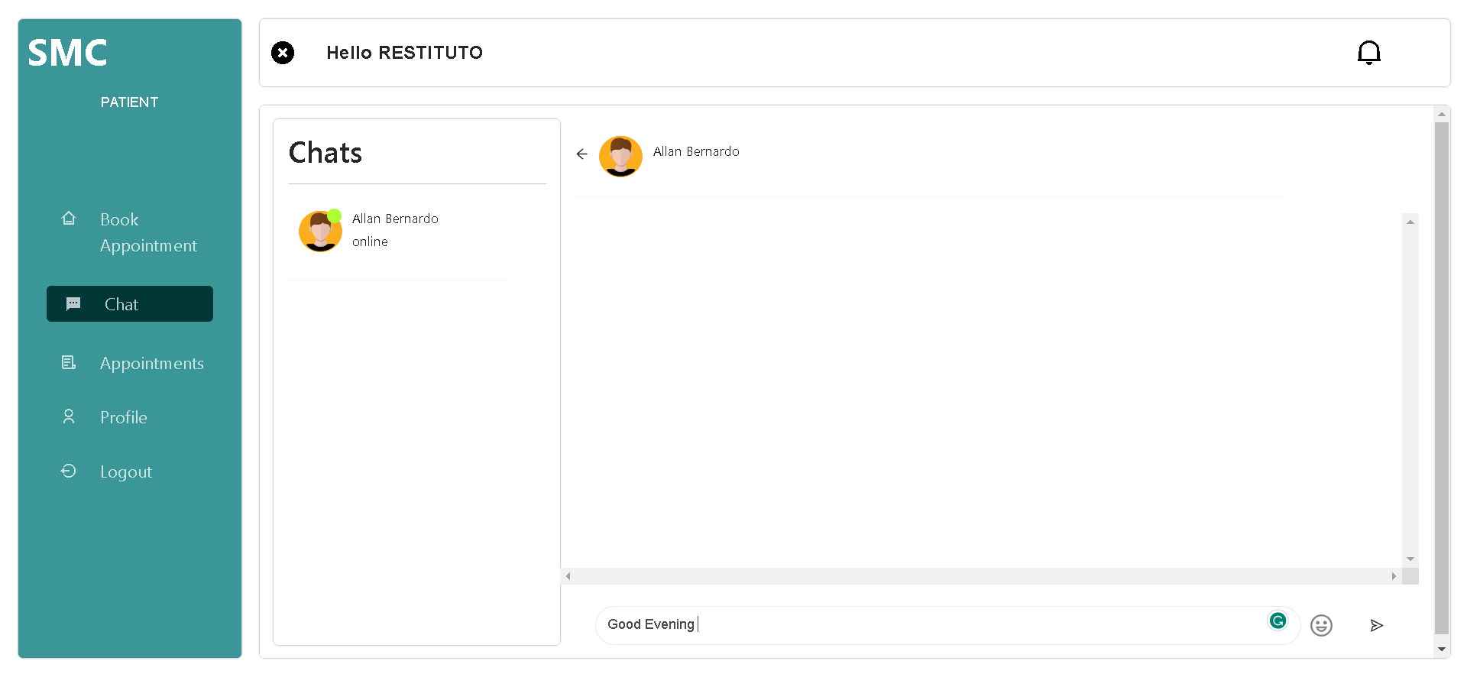

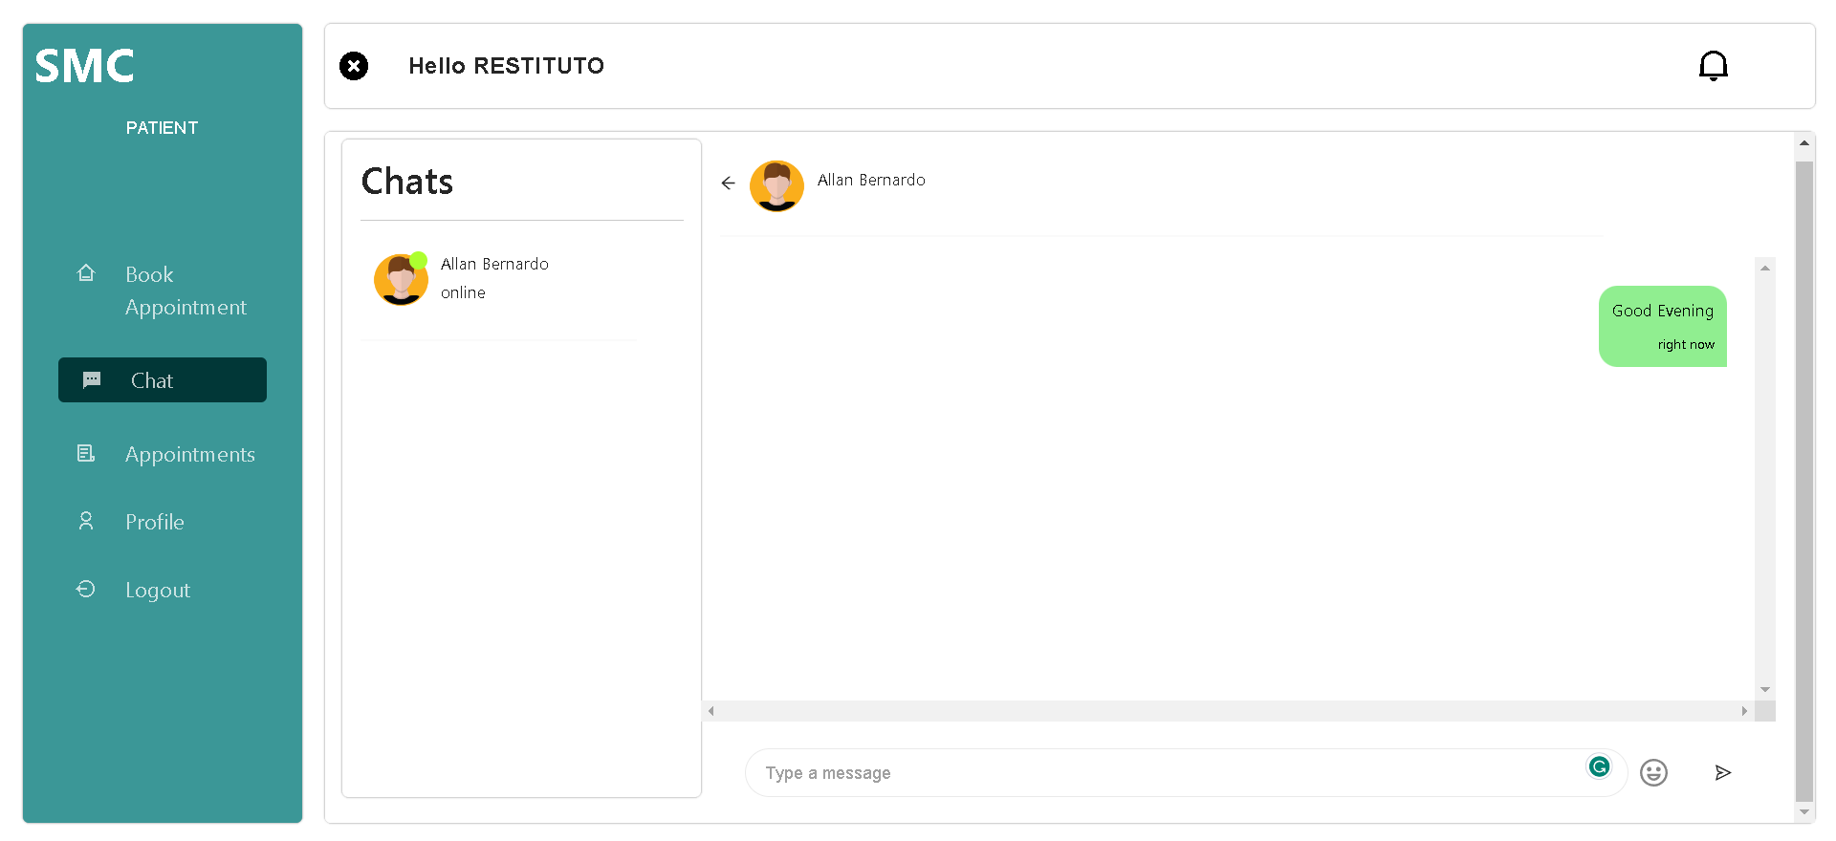

***Figure 60.*** Web application usability test result on Chat Page.

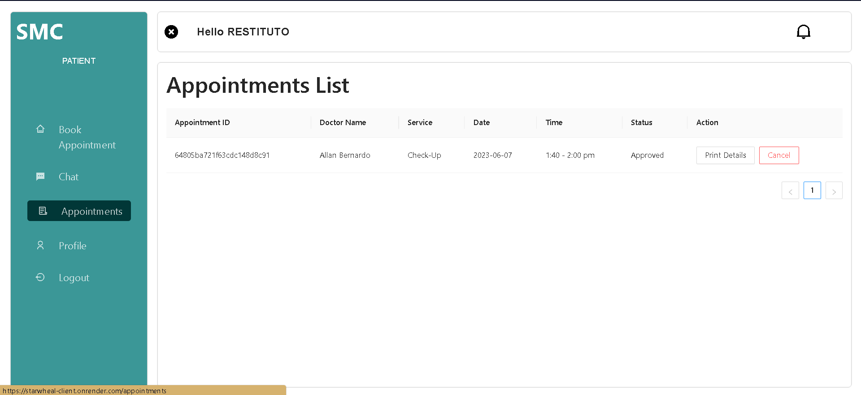

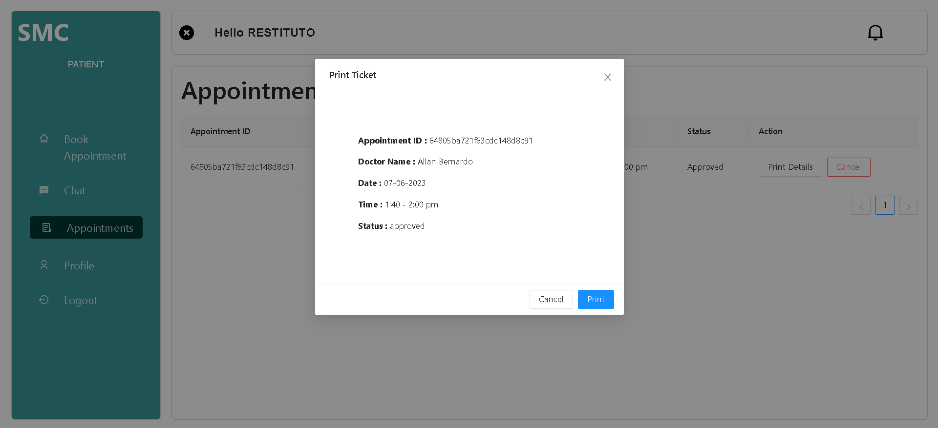

***Figure 61.*** Web application usability test result on Appointments List Page.



***Figure 62.*** Web application usability test result on Patient Profile page.

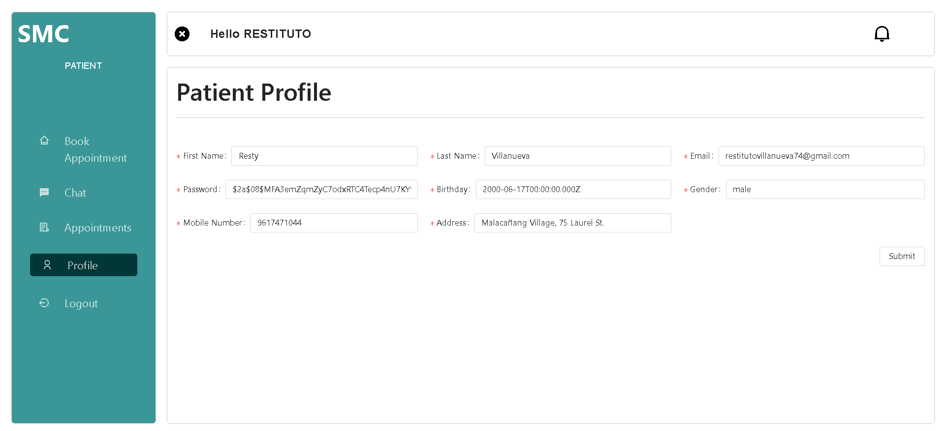





***Figure 63.*** Web application usability test result on Notification page.

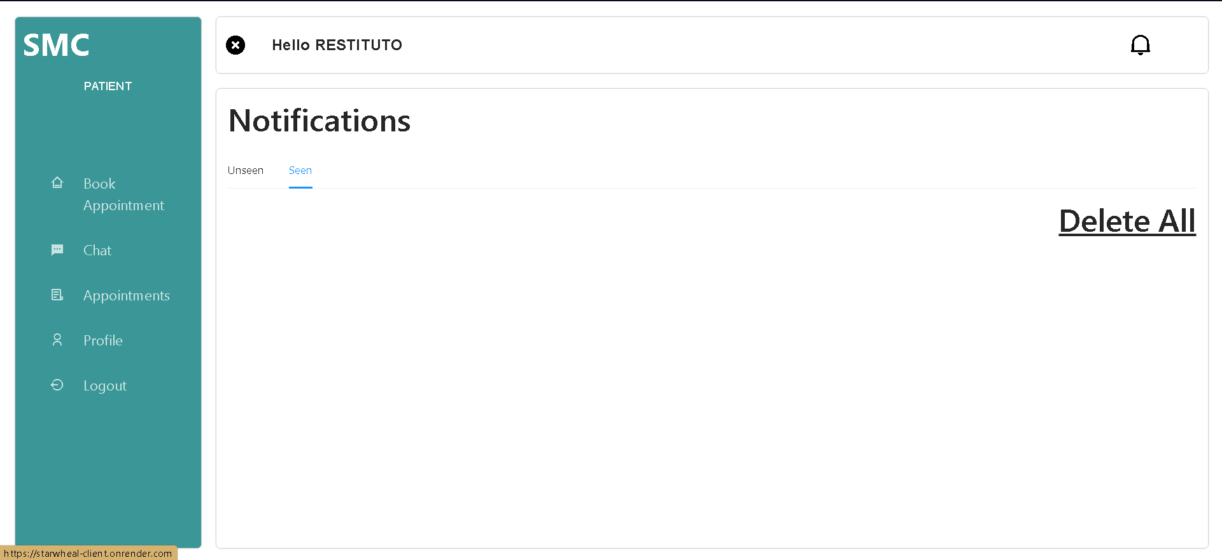

***Figure 64.*** Web application usability test result on Logout feature.

**For Doctor User**

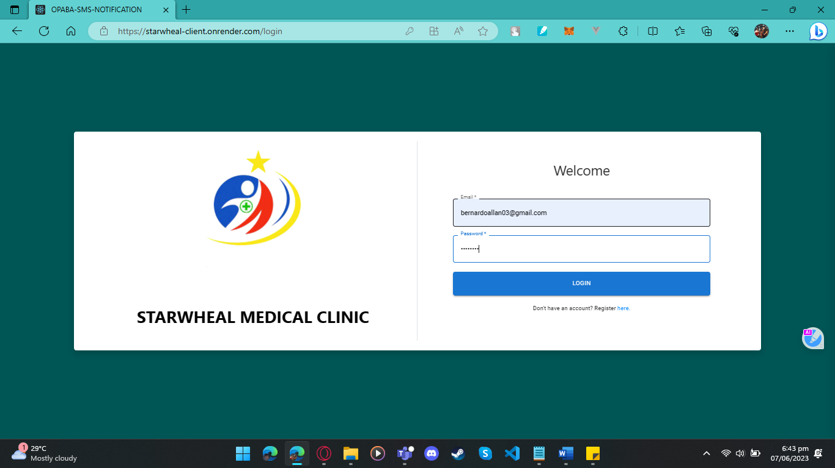

***Figure 65.*** Web application usability test result for doctor on Login page.

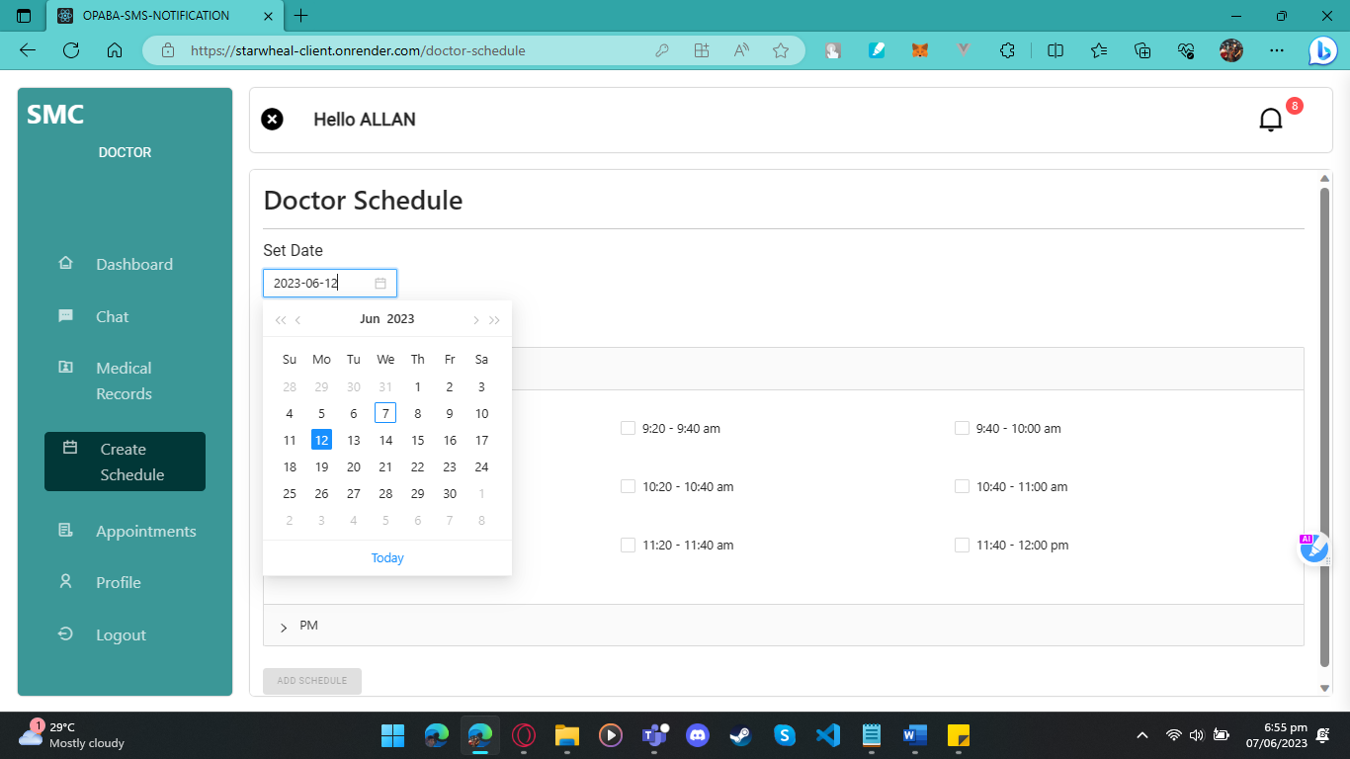

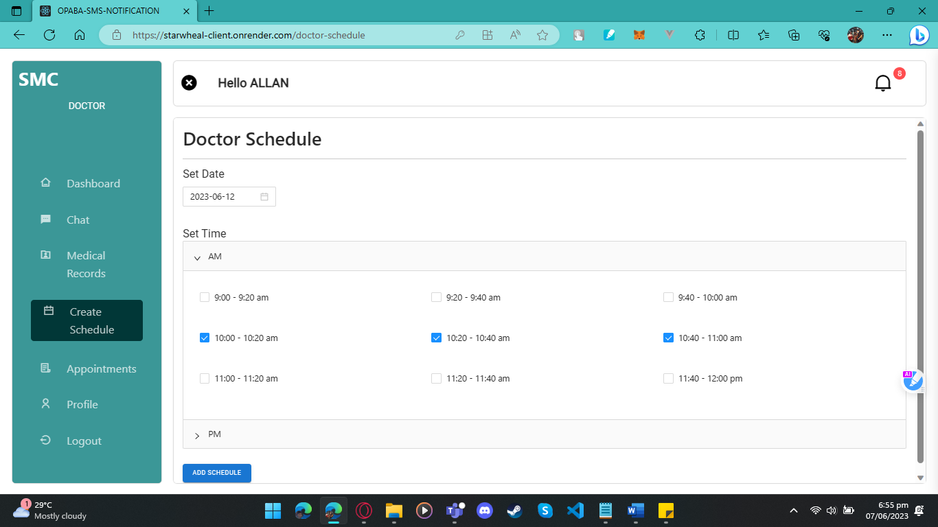

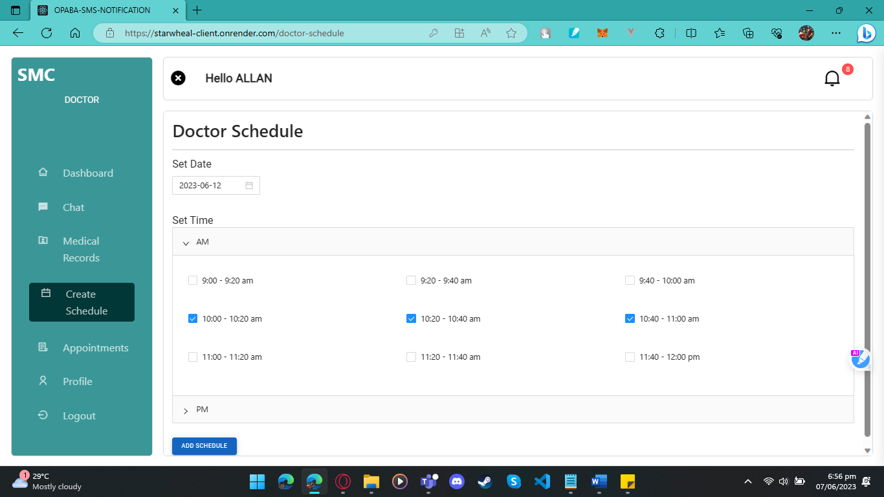

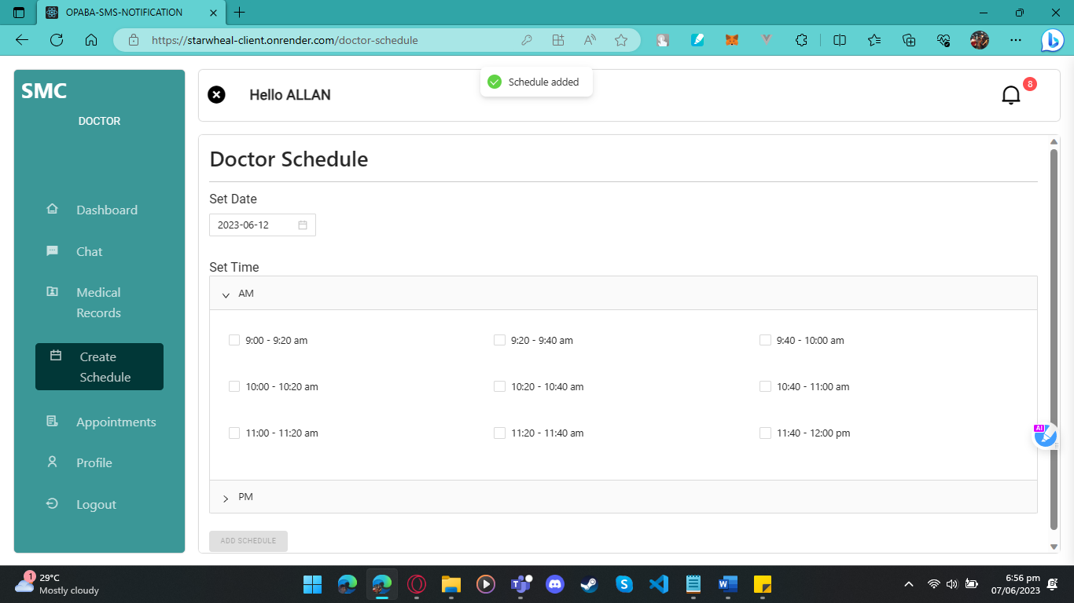

***Figure 66.*** Web application usability test result on Create page.

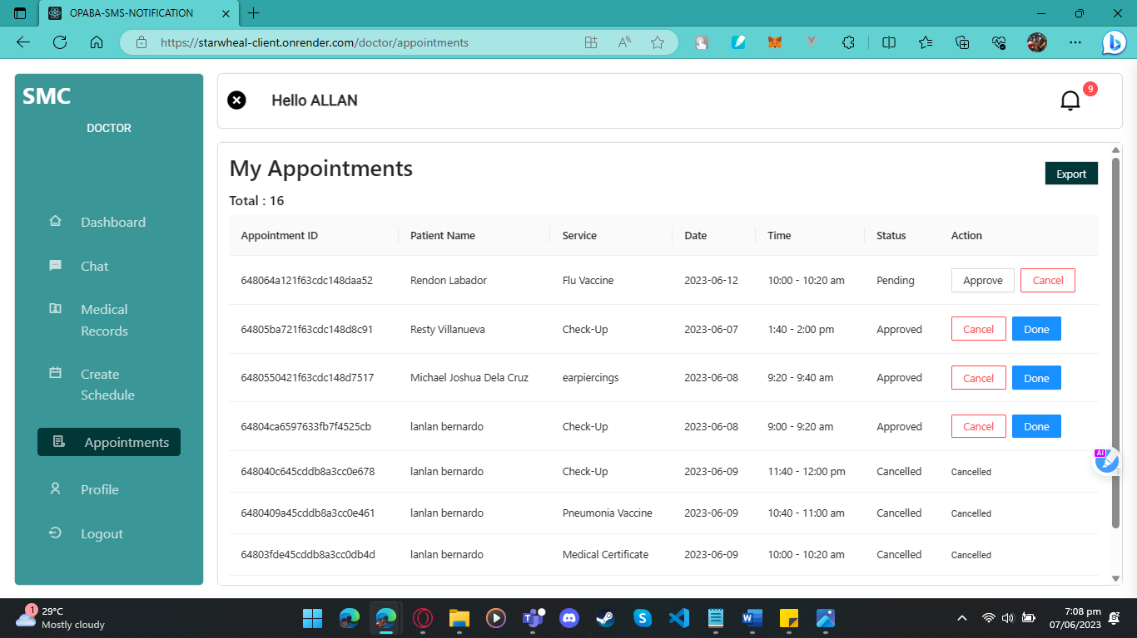

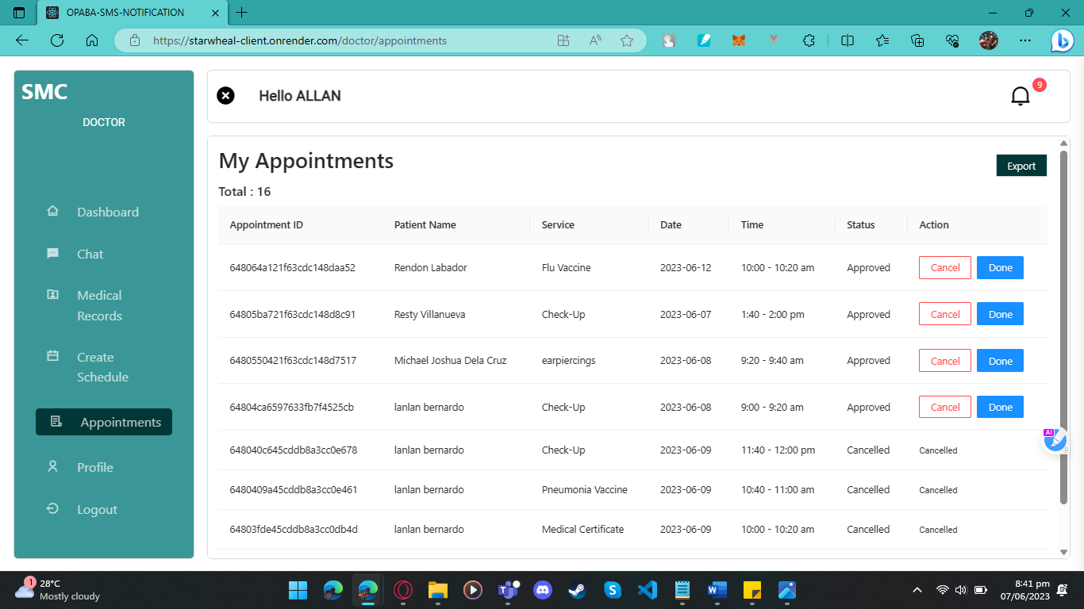

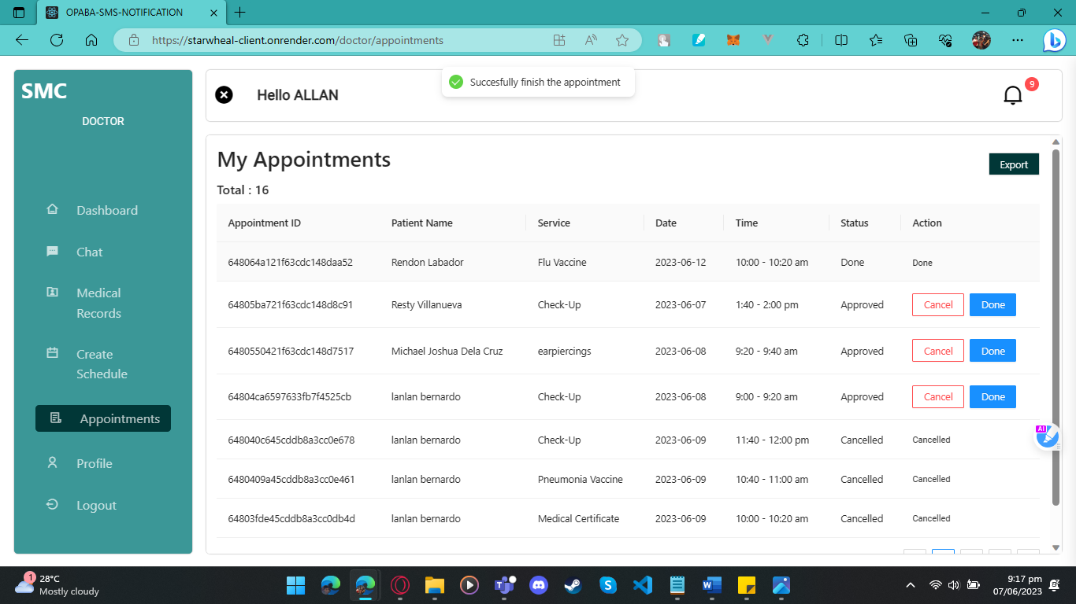

***Figure 67.*** Web application usability test result on My Appointments page.

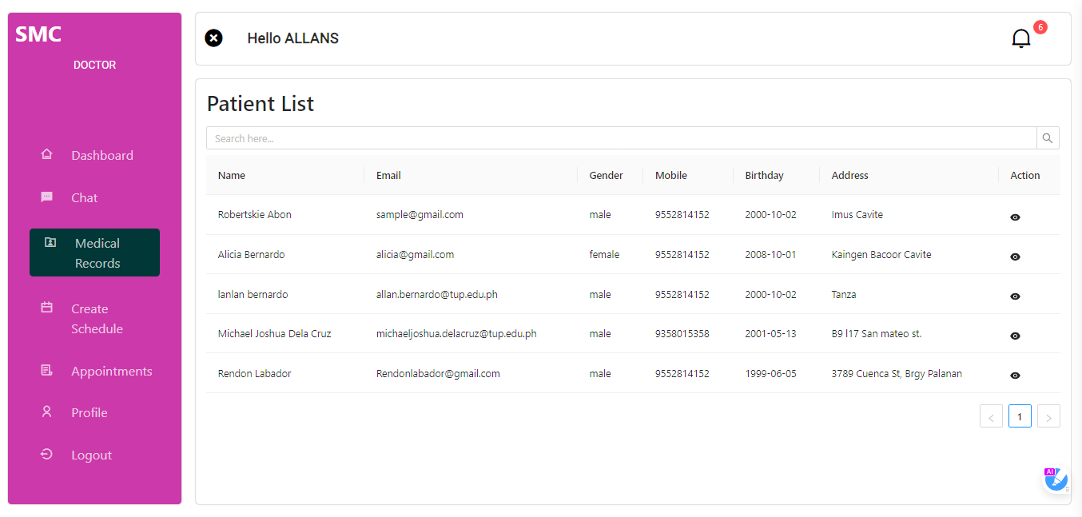

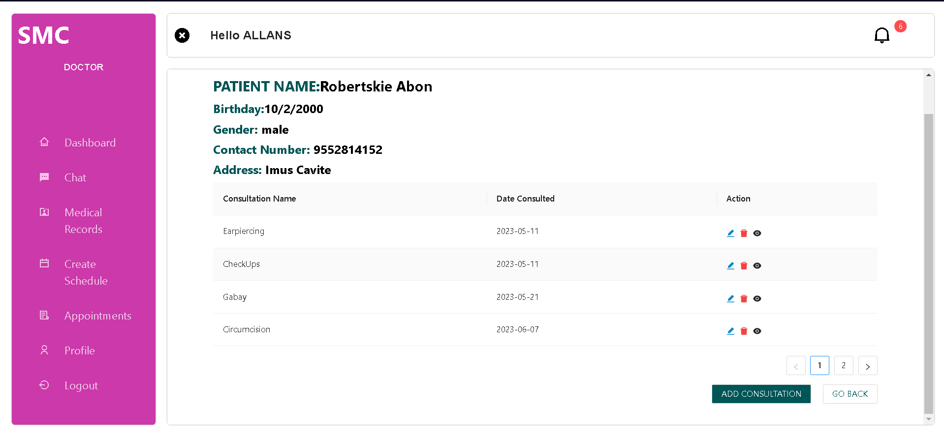

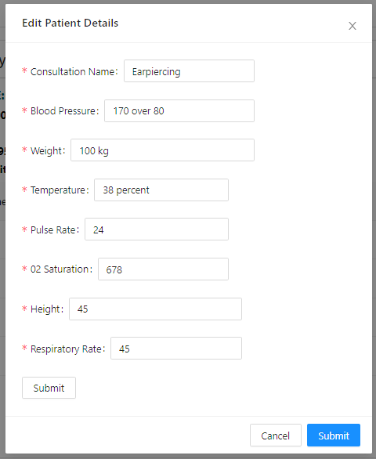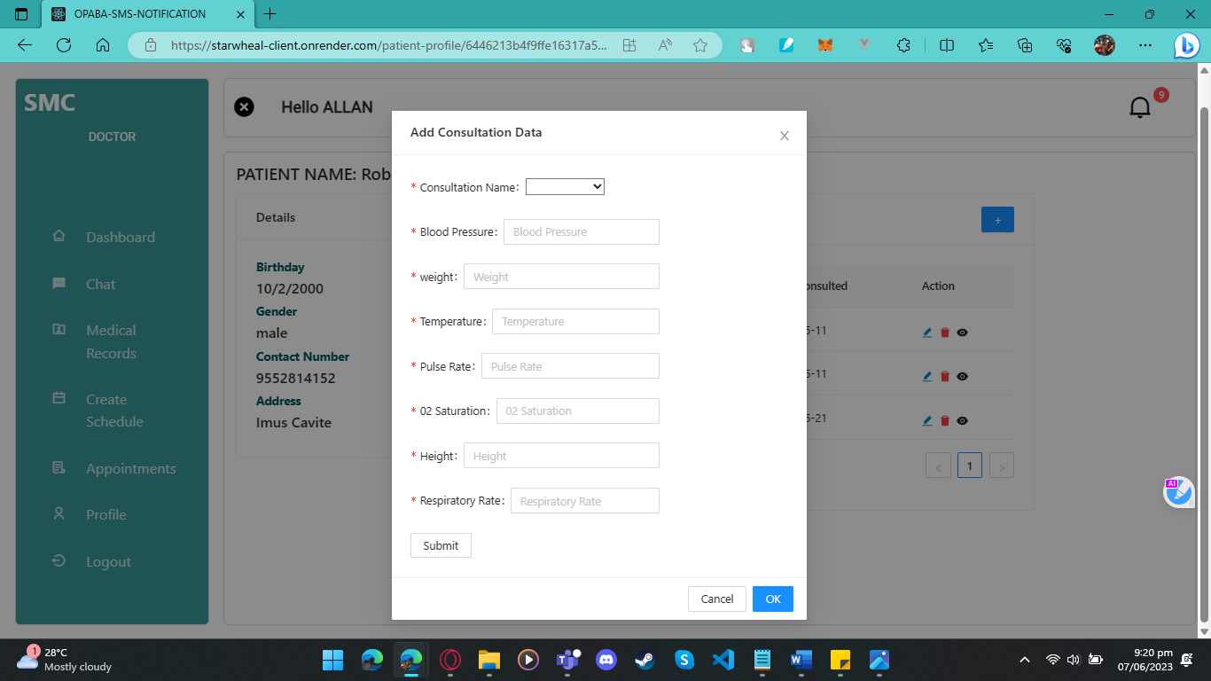



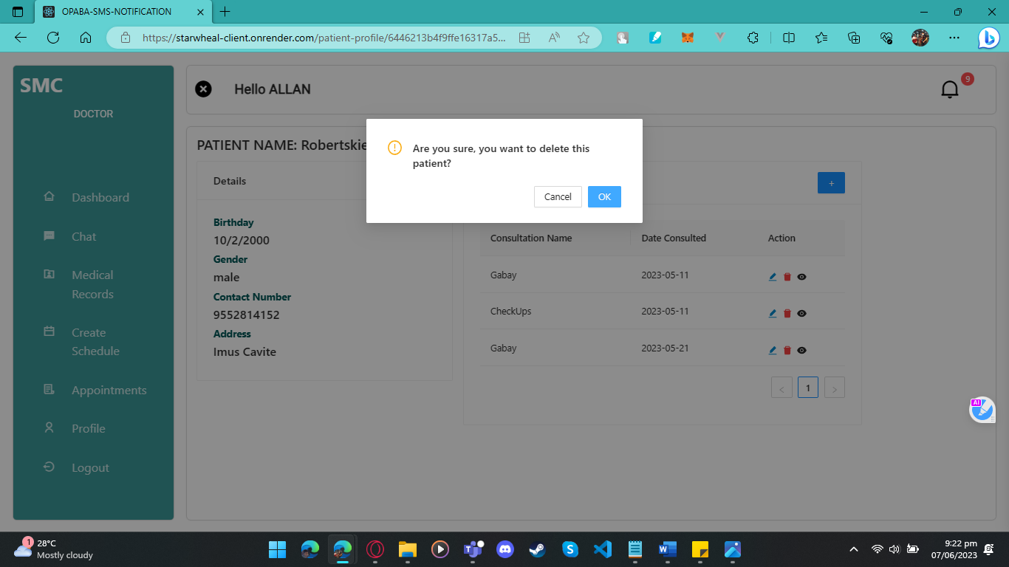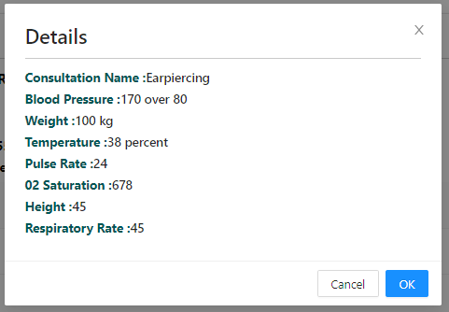

***Figure 68.*** Web application usability test result on Medical Records page.

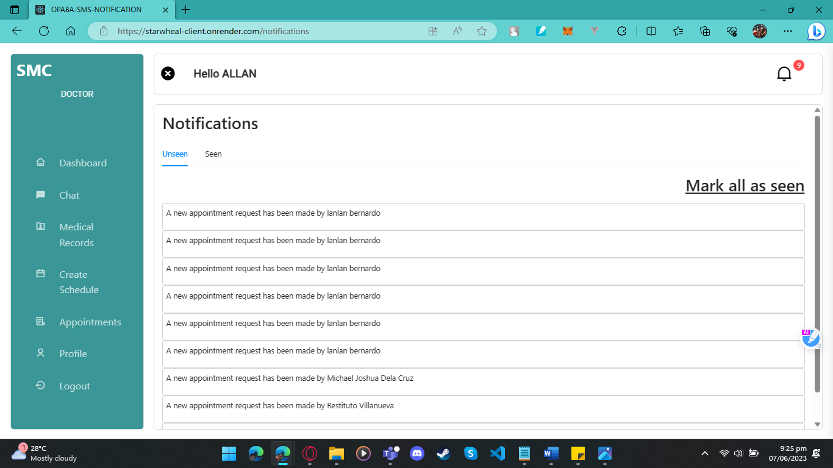

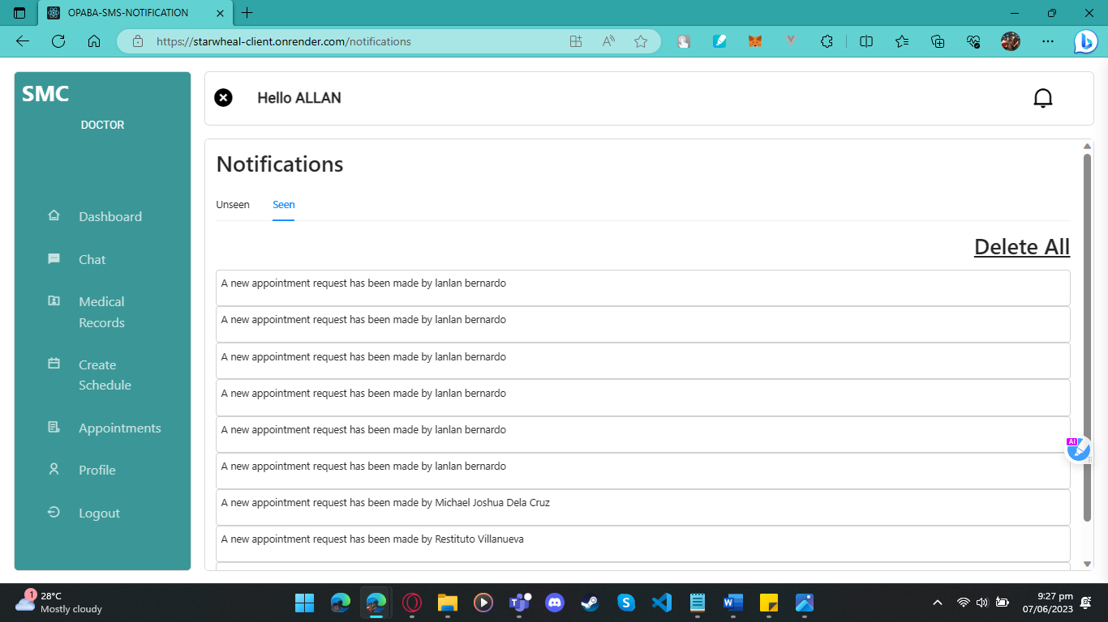

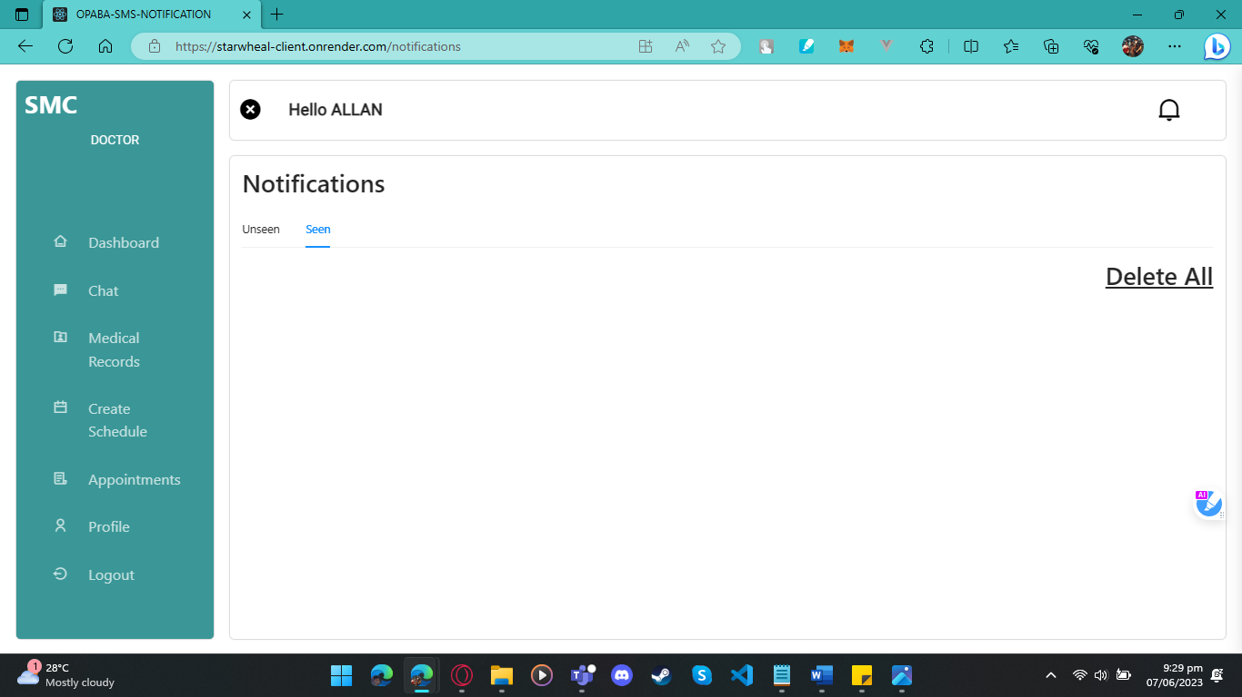

***Figure 69.*** Web application usability test result on Notification page.

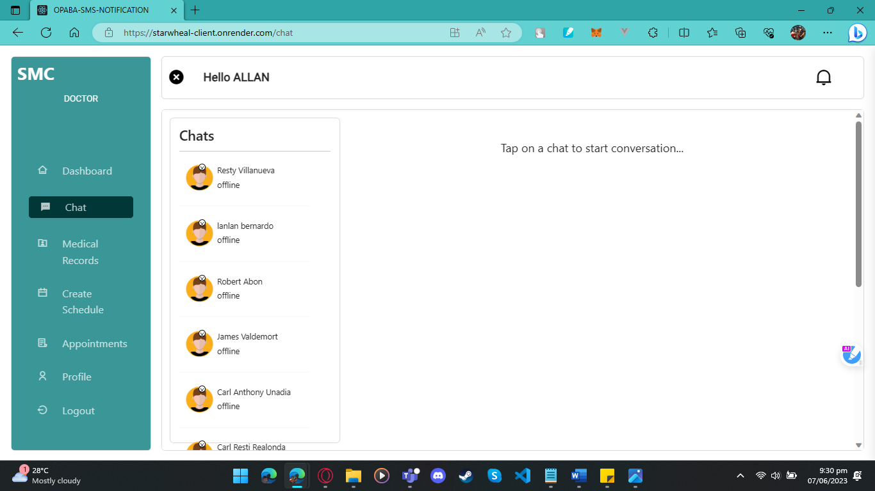

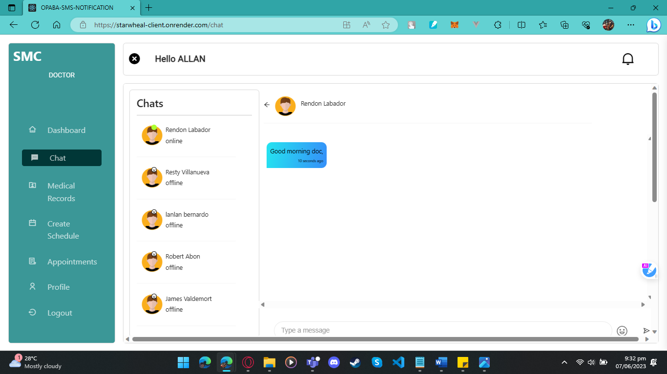

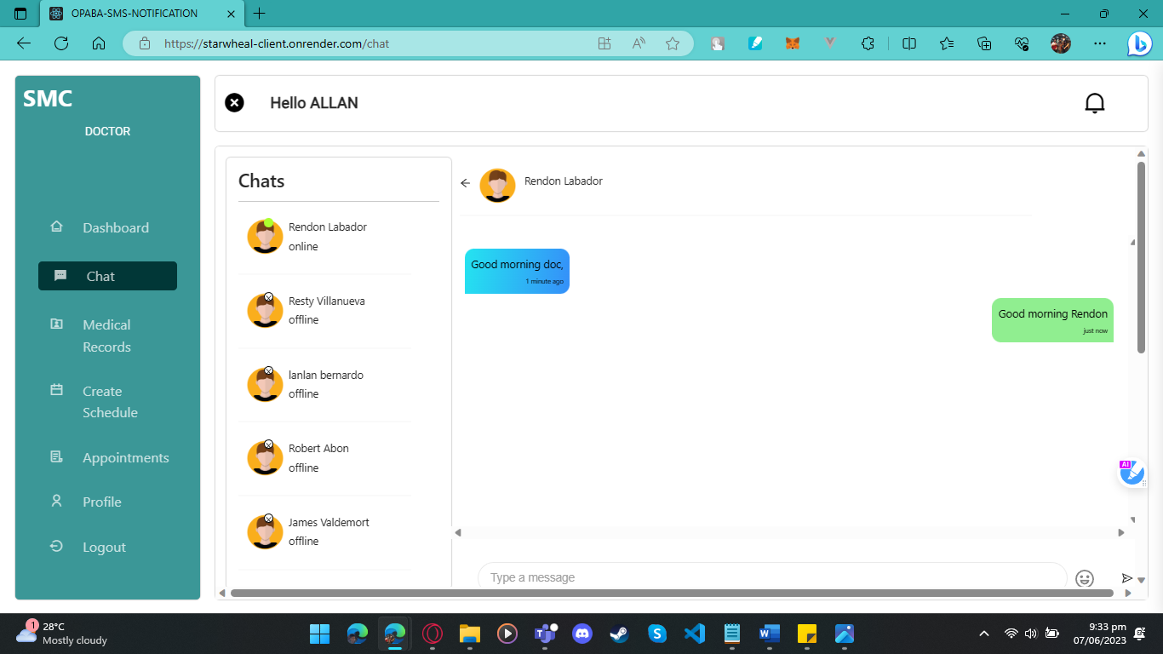

***Figure 70.*** Web application usability test result on Chat page.

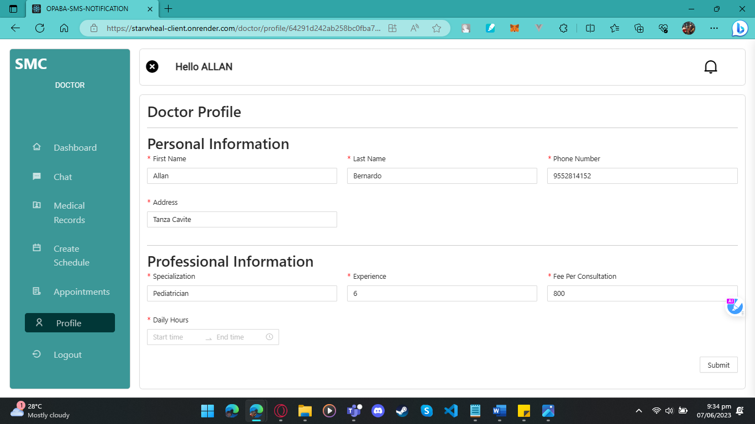

***Figure 71.*** Web application usability test result on Doctors Profile page.

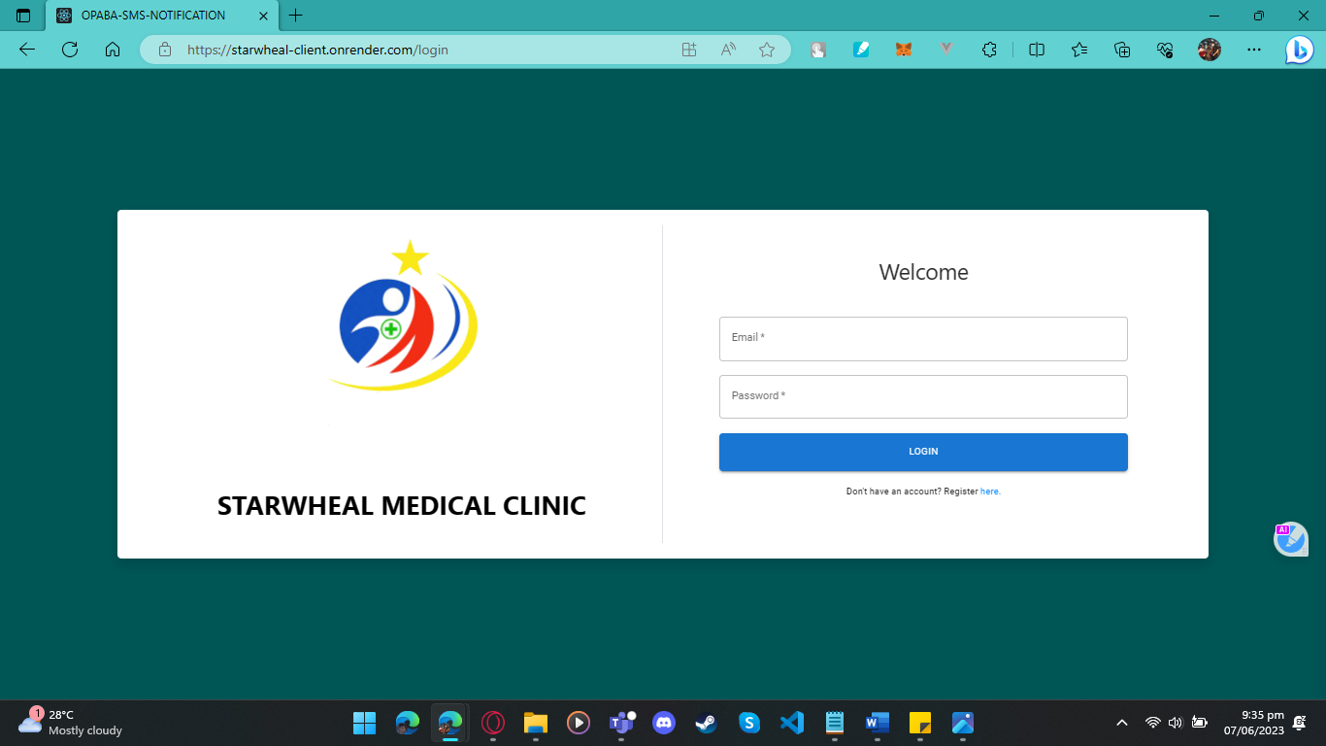

***Figure 72.*** Web application usability test result on Logout feature.

**For Admin User**

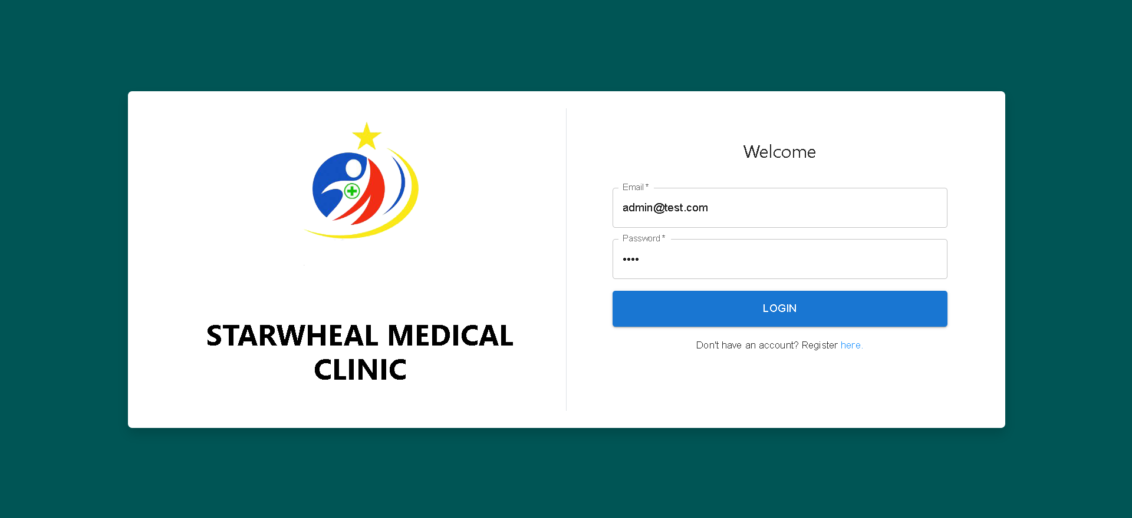

***Figure 73.*** Web application usability test result on Login page.



***Figure 74.*** Web application usability test result on Admin Dashboard page.







***Figure 75.*** Web application usability test result on Doctors List page.



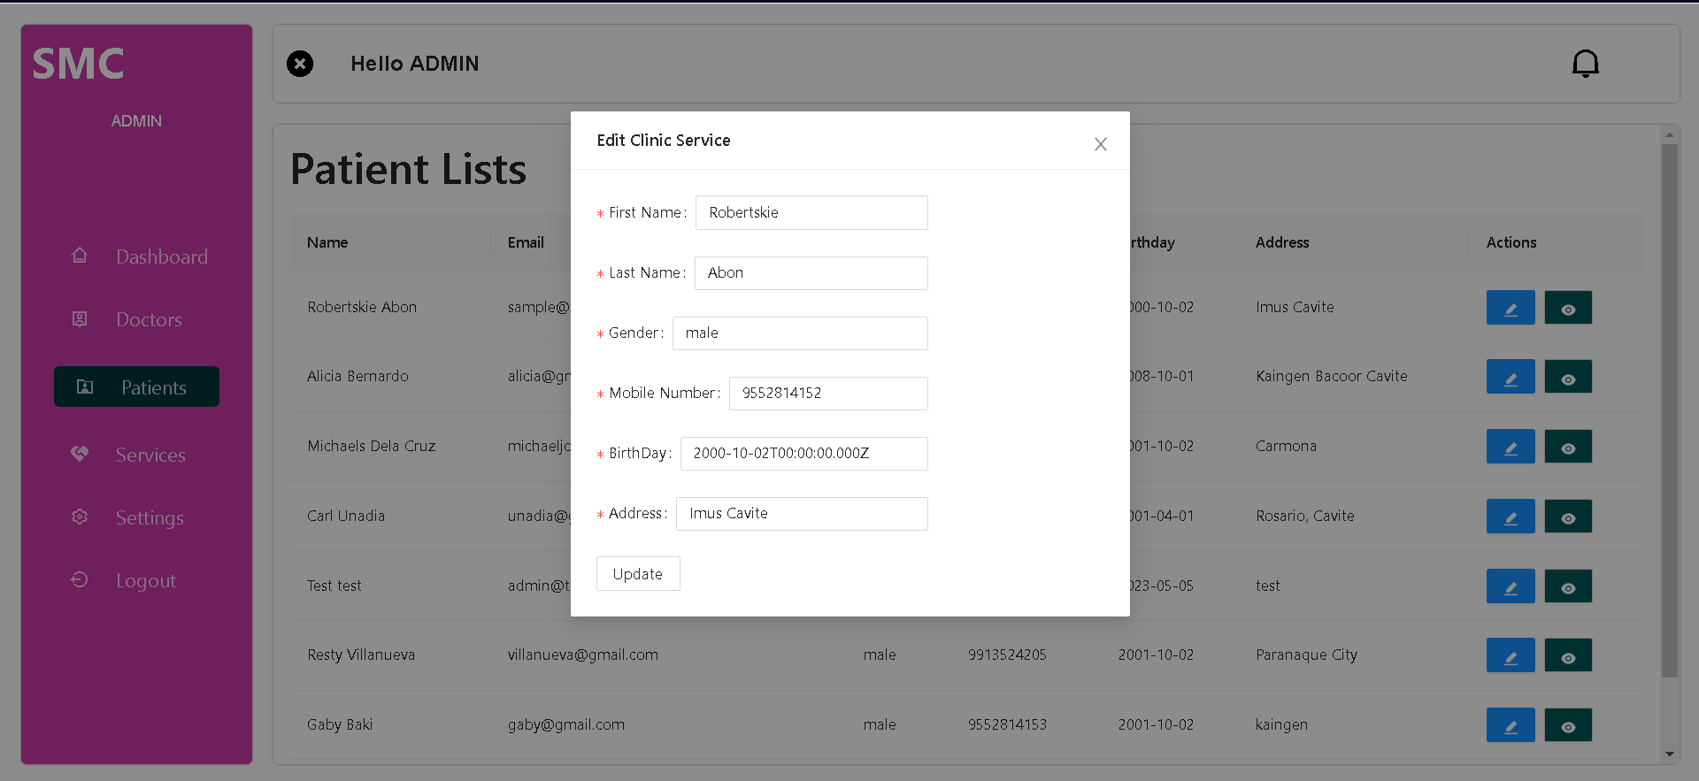



***Figure 76.*** Web application usability test result on Patient List page.







 ***Figure 77.*** Web application usability test result on Clinic Services page.

**Appendix F**

**PROFILE OF RESPONDENTS**

|  |  |  |
| --- | --- | --- |
| **Respondent**  **No.** | **Name** | **Mean Score** |
| 1 | Arsenio Cortez, Jr. | 3.8 |
| 2 | Jepoy Catangay | 3.75 |
| 3 | Jennelyn Nonato | 4 |
| 4 | Francisco Gualin | 4 |
| 5 | Restituto Villanueva | 3 |
| 6 | Eisenn Diego | 4 |
| 7 | Reynier John | 3 |
| 8 | Rhui Vega | 3.75 |
| 9 | Rommuel Cruz | 4 |
| 10 | Arvin M. San Miguel | 3.75 |
| 11 | Christine Munar | 3.5 |
| 12 | Neil Castro | 3.5 |
| 13 | Leal Liwanag | 4 |
| 14 | Jenalyn Clemente | 3 |
| 15 | Fagee Cortez | 3.2 |
| 16 | Camille Torres | 3 |
| 17 | Via Nicole | 3.5 |
| 18 | Karen Cruz | 3,75 |
| 19 | Clifford Sanchez | 4 |
| 20 | Kevin hacildo | 4 |
| 21 | Marco Vikorovski | 4 |
| 22 | Carl Acejo | 4 |
| 23 | Rigel Aragon | 3.5 |
| 24 | heidilyn gualin | 4 |
| 25 | Anabel Abon | 3.75 |

**Appendix G**

**Terms and Conditions for the Application**

**Terms and Conditions**

**Starwheal Medical Clinic is a medical consultation service that provides you with better health conditions and recommendations like check-ups, piercing, circumcision etc.**

**1. PRIVACY POLICY**

1.1 Information We Collect We may collect various information for our patients, including Personal Information: Information can be used to identify patient such as name, age, address, email address, and contact information. We may also collect your health information such as medical history, symptoms, and treatments when you provide it to us.

**Patient users:**

**For appointments:**

Patients can only book one appointment per doctor per session, the patient can book two or multiple doctors and appointments but not at the same time.

**For appointment approval**:

The patient must wait for the doctor to approve their requested appointment so that they can print appointment details to show as proof before coming to the clinic.

**For appointment cancellations:**

You can only cancel your appointment 24 hours before the actual appointment time.

**For late arrivals:**

If you, the patient, failed to arrive five to ten minutes before the requested appointment time you will be considered as a walk-in patient.

**For SMS notification:**

Patient receives an SMS reminder the day of the appointment to remind that she has an appointment.

**For Appointment time:**

The appointment that the patient booked will not be always punctual, sometimes other patients' appointments will exceed their allotted time and that will affect other appointments if this happens, please wait until the other appointment is done and please exercise patience and understanding.

**For Rescheduling:**

After cancelling an appointment, the patient is welcome to reschedule and book a new appointment at their convenience.

# 

# **RESEARCHERS’ PROFILE**



**ROBERT BRAGAIS ABON**

2341 A2, Leveriza St. Barangay 32, Pasay City

09913688280

Treborlars14@gmail.com

**Education:**

**Tertiary**

* Technological University of the Philippines Bachelor of Science in Information System 2019 to Present

**Secondary**

**Senior High**

* Manila Tytana Colleges Diosdado Macapagal Blvd. Pasay City

2017-2019

**Junior High**

* San Isidro National High School, Borneo St. San Isidro Makati

1. - 2017

**Primary**

* Palanan Elementary School Arellano St. Palanan Makati S.Y 2006 – 2013

**Technical Skill**

* Proficient in Programming Language Javascript. Skilled in web development using HTML5 and CSS3, with experience in VueJS. Experience in Computer Hardware like Desktop Computer Assemble and Disassemble, UI/UX Designing, Computer Troubleshooting and Knowledgeable in using Microsoft office apps.



**ALLAN CASTRO BERNARDO**

Sanja Mayor, Tanza Cavite

09552814152

allan.bernardo@tup.edu.ph

**Education:**

**Tertiary**

* Technological University of the Philippines Bachelor of Science in Information System 2019 to Present

**Secondary**

**Senior High**

* Senior High St. Michael’s Institute STEM – SHS Poblacion Bacoor City, Cavite S.Y 2017-2019

**Junior High**

* Bacoor National High School Molino 1 Bacoor City, Cavite S.Y 2013 - 2017

**Primary**

* Gov P.F Espiritu Elementary School Panapaan 2 Bacoor City, Cavite S.Y 2006 - 2013

**Technical Skill**

* Proficient in Programming Language Phyton, C, Javascript. Skilled in web development using HTML5 and CSS3, with experience in ReactJS. Experience in Computer Hardware like Desktop Computer and Disassembly, Computer Troubleshooting and Knowledgeable in using Microsoft office apps.

# 

**CARL ANTHONY JOSUE UNADIA**

Blk 2 Lot 24, 1f Hacienda St. Tejeros Convention Rosario, Cavite

09053323518

kaaru414@gmail.com

**Education:**

**Tertiary**

* Technological University of the Philippines Bachelor of Science in Information System Ermita, Manila 2019 to Present

**Secondary**

**Senior High**

* San Sebastian College Recoletos de Cavite STEM - SHS Manila Boulevard, Brgy. 11 (Lawin), 4100 Cavite City, Cavite, J.Felipe Blvd, Santa Cruz, Cavite City, Cavite 2017 – 2019

**Junior High**

* Science Technology Institute of Rosario, Cavite CV55+2F3, STI Bldg, Gen. Trias Dr, Rosario, 4106 Cavite 2013 to 2017

**Primary**

* St Francis School 9VMG+H9H, General Trias, 4107 Cavite 2006 to 2012

**Technical Skill**

* Possesses proficiency in Microsoft office apps, Computer Hardware like Desktop Computer Assembly, and Computer Troubleshooting. and Skills for software development like Web Development, UI/UX design, CSS, HTML, C, JavaScript



**RESTITUTO JR. GALANG VILLANUEVA**

Malacañang Village, 75 JP Laurel St, San Antonio Valley 1 Paranaque City

09617471044

restitutovillanueva08@gmail.com

**Education:**

**Tertiary**

* Technological University of the Philippines Bachelor of Science in Information System 2019 to Present

**Secondary**

**Senior High**

* Manila Tytana College Senior High School- STEM 2017-2019

**Junior High**

* Sun Valley National High School Junior High School 2013 - 2017

**Primary**

* San Antonio Elementary School 2006 - 2013

**Technical Skill**

* Possesses proficiency in Designing Software Apps like Photoshop, Canva, Figma, and Adobe Illustrator
* Possesses Proficiency in Hardwar Maintenance like Computer troubleshooting, and Computer assembly.
* Familiarity with Microsoft application such as Microsoft excel, Word, and PowerPoint